an
Affair Hidden in the
Leaves

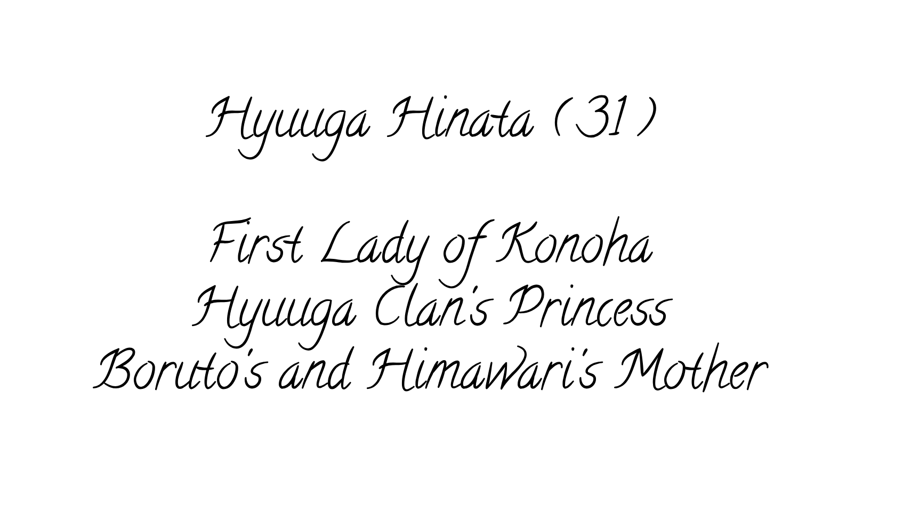
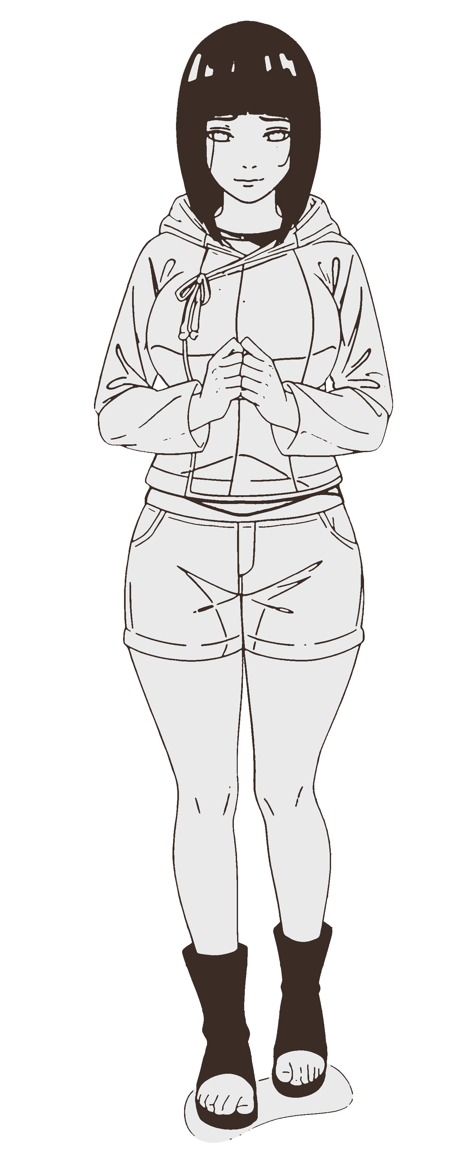
The Uzumaki household always seemed to breathe in a rhythm that matched Hinata’s own heartbeat. For her, peace wasn't an abstract concept; it was centered right here in her home. It was the scent of Naruto’s jacket hanging by the door, the faint, sweet smell of sunflowers drifting in from the garden, and the quiet humming of the kettle in the afternoon.
The house was a space filled with life. Hinata took deep satisfaction in the small, repetitive tasks of maintaining it—wiping down the kitchen counters, arranging fresh lilies in the vase by the entryway, and ensuring the wooden floors gleamed under the warm indoor lights. These weren't just chores; they were quiet acts of devotion that kept their world turning smoothly.
Mornings were a flurry of activity that she conducted with practiced ease. It was the rhythmic chopping of scallions for miso soup, the thumping of heavy feet as Boruto raced down the stairs late for the Academy, and Himawari’s bright chatter about her latest drawings. She loved the domestic noise; the clinking of silverware and the sleepy grunts of her family waking up were the music of a life fully lived.
Then there were the rare, quiet Sundays when the house settled into a lazy rhythm. Naruto would often drift asleep on the engawa, a half-read scroll forgotten on his chest, basking in the afternoon light. Hinata would sit nearby, mending a tear in a training vest or simply watching the dust motes dance in the sunlight. Sometimes he would shift, mumbling nonsense in his sleep, and she would reach out to fix the blanket over him. It was a simple, unhurried existence, filled with the warmth of shared space and the comfort of routine.
She was happy. She repeated this to herself often, a mantra against the loneliness that seeped in during Naruto's long nights at the office.
The shattering of that peace began on an ordinary Tuesday.
Hinata was returning from the market, a basket of fresh vegetables looped over her arm. She took a shortcut through a quieter alley near the edge of the Hyuuga compound districts. The air, usually still, grew unnaturally quiet. The ambient sounds of the village seemed to fade, replaced by a prickling sensation at the base of her neck. It was a raw, heavy intent that pressed down on her like a physical weight.
She stopped, clutching the handle of her basket a little tighter. She didn't turn immediately, a flicker of nervousness rising in her chest. Before she could decide whether to keep walking or look back, a deep voice drifted from the shadows.
"Domestic bliss suits you, Hinata Hyuuga. Or should I say, Uzumaki?"
Hinata turned around slowly, blinking in surprise. "I'm sorry?"
A figure stepped from the gloom. He was enormous. Tall and broad-shouldered, clad in dark, practical gear that bore no village insignia, though the dark skin and white, stylized hair hinted heavily at Kumogakure origins. His eyes were cold, calculating flint.
"You took a shortcut today," he noted casually, his gaze drifting to the vegetables in her basket. "Usually you stick to the main road by the river. Trying to make up time because you stopped to chat with the flower shop girl again?"
Hinata took a small, instinctive step back, her confusion shifting rapidly to unease. "I... I don't understand. Have we met?"
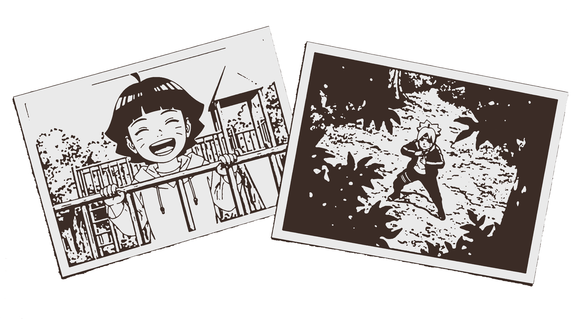
"I know you," he replied, ignoring her question. "I’ve been watching everything. The market runs. The route to the Academy. The nights your husband doesn't come home." He took a slow step forward, his hands raised in a mock gesture of peace. "It’s amazing how easy it is to walk in the shadow of the great Seventh Hokage. His light is so bright, it blinds everyone to the darkness right at his feet."
"I think..." Hinata’s voice wavered, and she cleared her throat, trying to sound steady. "I think you should leave. Please, I need to get home to my family."
"You’re trembling," he observed dryly. "I wouldn't advise running. Not unless you want to see vexactly how fragile vyour little bubble of happiness really is."
"Please let me pass," she whispered, looking for a way around him.
"You aren't listening," he said simply. "This isn't a request."
He reached into a pouch and withdrew a small stack of photographs, tossing them onto the ground between them.
Hinata glanced down, keeping him in her periphery. Her blood turned to ice.
The first photo was of Himawari laughing at the academy playground. A red crosshair was inked precisely over her forehead.
The second was of Boruto training, unaware he was being watched from a high vantage point.
The third was a document. It was an old, sealed Hyuuga scroll, something that should have been buried deep in the clan's most secure vaults. It contained detailed anatomical diagrams of the Byakugan's nerve clusters—information that, in the wrong hands, could be used to create a poison specifically designed to blind every Hyuuga in existence.
"Where... where did you get these?" Her voice shook, not with fear for herself, but with a primal terror for her children and her clan.
"Post-war alliances are fragile things, Lady Hinata," the man said smoothly. "There are factions in Kumo, and elsewhere, who believe Konoha holds too much power. Naruto Uzumaki is too strong. But everyone has a weakness."
"Please," she breathed, her knuckles white on the basket handle. "If you touch my children..."
"I have no interest in harming children," he lied easily. "Not if I get what I want. The scroll is insurance. The photos are motivation."
"What do you want? Money? I can get you money..."
He stepped closer, towering over her. The oppressive aura he radiated seemed to double in intensity. "I want to break the Hokage's pedestal. I want the world to see that the perfect hero's home is rotten."
His eyes swept over her with slow, deliberate lechery. They lingered on the frantic pulse fluttering in her throat, as if imagining his rough thumb pressing down to choke off her cries. He traced the heavy rise and fall of her chest beneath her hoodie, his gaze stripping away the fabric to visualize the weight of her breasts filling his hands.
His eyes dropped to the curve of her waist, picturing how his large hands would span it completely to haul her body flush against his, before devouring the wide flare of her hips, anticipating the sound of flesh slapping against flesh.
Finally, he stared at the thick, soft shape of her thighs, fantasizing about the resistance they would offer before he forced them open to claim what was between them. It wasn't just cruelty she saw there now; it was a heavy, possessive hunger that made her skin crawl.
To the rest of Konoha, she was the picture of grace—the gentle, dignified wife of the Seventh Hokage, always composed and proper. She was a figure of soft-spoken nobility that the village looked up to. That public image of propriety only fueled his excitement. He was going to dismantle that perfect reputation, piece by piece.
He wanted to turn the dignified woman into his personal whore in a rundown inn, keeping the secret of her defilement like a trophy. The thrill lay in making the most respected woman in the village submit to his basest desires while the rest of the world remained oblivious.
"I want you."
Hinata stared at him, her brow furrowing. The words hung in the air, but their true meaning didn't penetrate the wall of her innocence. She assumed he meant abduction—a political bargaining chip to use against the village. "I... I don't understand," she stammered, clutching the basket tighter. "What do you mean?"
The man let out a dark, dry chuckle, shaking his head at her naivety. "Stop playing dumb. I’m not talking about dragging you off to a cell to wait for a ransom."
He leaned in, his voice dropping to a coarse, filthy rumble that seemed to vibrate against her skin. "I'm talking about your body, Lady Hinata. I want to peel you out of those clothes, spread those leg’s of yours, and use you until I’m satisfied. I want to be deep inside the Hokage's wife, hearing you beg while I take what belongs to him. Do you understand now?"
The crude, violent imagery hit her like a physical slap. Hinata stumbled back, her face draining of all color as a wave of pure nausea rolled over her. She felt instantly dirty, as if his words alone had coated her skin in slime.
"You’re sick," she choked out, her voice trembling with a mix of horror and rising panic. "I won't do that. Never. I’ll tell Naruto right now."
The man laughed, a harsh, grating sound. "Go ahead. Tell him. By the time he mobilizes his guards, that scroll will be broadcast to every rogue ninja and enemy nation. The Hyuuga will be hunted. And your daughter? Accidents happen so easily to academy students."
The threat was absolute. He wasn't asking for a tryst; he was demanding her soul as leverage.
"The Dragonfly Inn, room 4 on the outskirts, tomorrow night at ten," he commanded. "Come alone. If you aren't alone, or if you're late, the scroll goes public."
Hinata stood rooted to the spot, her mind reeling as she tried to process the impossible choice he had laid at her feet. The weight of the threat pinned her in place, leaving her exposed.
Taking advantage of her shock, he moved with terrifying speed, closing the distance between them instantly.
Hinata gasped, her hands flying up to shove hard against his chest—a desperate, instinctive attempt to create space. "Don't—!"
It was like pushing against a stone wall. He didn't even flinch. Instead, he leaned down, burying his face in the crook of her neck. Hinata froze, her resistance crumbling into paralysis as the heat of his breath washed over her skin. He inhaled deeply, taking in her scent of vanilla and soap, before his hand tangled roughly into her dark hair. He yanked her hair back, exposing her throat and forcing her to look up at him.
"You smell like a good wife," he sneered against her ear, his voice vibrating through her body. "Let's see if you can be a good whore."
He released his grip on her hair, letting her stumble back onto her heels, and stepped away, melting effortlessly into the deepening shadows of the alley, leaving Hinata alone with the damning photographs scattered around her feet.
Hinata slid down against the rough brick wall, her legs refusing to hold her up any longer. She stared at the empty space where he had been standing, her mind racing to catch up with reality.
He was watching us, she thought, a cold shiver running down her spine. He knows when I go to the market. He knows when Naruto isn't home. He knows where Himawari plays.
She looked down at the photos scattered on the ground. The red ink on her daughter's face. The sealed Hyuuga scroll.
If I tell Naruto... he would try to find him immediately. He would do anything to protect us.
But the man’s voice echoed in her head: Accidents happen so easily.
What if the man is watching right now? What if he acts before Naruto can stop him?
She closed her eyes, clutching her trembling hands together.
I can't gamble with their safety. I can't risk Himawari getting hurt.
She gathered the photos with shaking fingers, her breath hitching in her chest.
If I don't go tomorrow... he will do exactly what he said.

***

Hinata didn't remember walking the rest of the way home. She moved like a ghost, her body performing the necessary motions while her mind remained frozen in that dark alleyway. She could still feel the phantom pressure of his hand tangling in her hair, the heat of his breath against her neck, and the vibration of his voice calling her a "good wife." She felt dirty, a sensation that seemed to seep through her skin and settle deep in her marrow.
She gathered the photos with trembling fingers, shoving them deep into her pocket as if they were burning coals. The image of the red crosshair on Himawari’s forehead and the stalker’s shot of Boruto training were branded into her vision.
When she opened the front door, the warm, savory scent of the house hit her like a physical blow. It was the smell of safety, a sharp, painful contrast to the cold terror gripping her heart.
"Mom! You're back!" Himawari came bounding into the hallway, a bright, chaotic whirlwind of energy.
Hinata’s breath hitched. For a split second, she didn't see her daughter’s smiling face; she saw the red ink.
"Mom?" Himawari slowed down, tilting her head. "Are you okay? You look pale."
Hinata forced a smile onto her face. It felt brittle, like cracked porcelain. "I'm fine, sweetie. Just... a little tired from the walk. The market was busy." She dropped to her knees and pulled Himawari into a hug, squeezing her tighter than usual, desperately trying to replace the memory of the man's scent with the smell of sunshine and shampoo.
"You're squishing me," Himawari giggled, wriggling free.
"Sorry," Hinata whispered, standing up.
"Welcome back, Mom." Boruto strolled out of the living room, a handheld game console loosely gripped in one hand. He looked so much like his father—the same spiky hair, the same confident posture. "Dad not with you?"
"No," she said, forcing a casual tone as she walked past him. "I haven't heard from him, so he's probably stuck at the office again."
"Figures," Boruto muttered with a shrug, though there was no real bite to it. "I'm starving. Is dinner soon?"
Hinata looked at her son—strong, capable, but still a child in the eyes of the monster who had hunted him from the shadows. She suppressed a shudder. "Yes. Go wash up. It will be ready soon."
She moved into the kitchen and started dinner. The familiar routine helped ground her a little, but her hands still felt unsteady. She focused entirely on the simple tasks—chopping vegetables, checking the rice, setting the table—trying to keep her mind from drifting back to the alleyway and the photos burning a hole in her pocket. It was a distraction, but a poor one.
Naruto didn't come home that night.
It wasn't unusual; the Hokage’s office often claimed him for days at a time. But tonight, the empty chair at the head of the table felt like a gaping wound.
"This pork is amazing, Mom," Boruto mumbled around a mouthful of rice, reaching for the serving bowl to pile more onto his plate. "I was starving. Konohamaru-sensei worked us to death today."
"Did you have a good session?" Hinata asked, her voice sounding thin to her own ears. She picked at her rice, moving the grains around to look like she was eating.
"It was intense," Boruto said, gesturing with his chopsticks. "We were out at the training grounds near the river, practicing stealth and detection. We had to hold a position for two hours without being spotted."
Hinata’s stomach twisted violently. The river. That was the background of the second photo. The man had been there, watching her son from the tree-line, invisible and unnoticed while Boruto trained.
"Did you... did you sense anyone else nearby?" she asked, the question slipping out before she could stop it.
Boruto looked at her, confused. "Huh? No, just the team. Sensei says my sensory skills are getting sharper, though. I bet I could spot a fly buzzing from fifty yards away now. Nothing gets past me."
Hinata felt a cold sweat break out on her palms. He was there, Boruto, she thought, the secret burning in her throat. He was right above you, taking photos, and you didn't feel a thing.
"That's... that's good," she managed to say, forcing a smile that didn't reach her eyes. "But never get too overconfident, okay?"
"I'm not overconfident, I'm just good," he scoffed, taking a gulp of water. "Anyway, Shikadai said we might start mission sims next week."
"I saw Inojin today!" Himawari chirped up, cutting through Boruto’s boasting. She swung her legs under her chair, kicking the table leg rhythmically. "We didn't do ninja stuff. We drew flowers."
"Flowers are easy," Boruto teased, stealing a piece of egg from his sister's plate. "Try dodging shuriken."
"Hey! Mom, tell him to stop!" Himawari pouted, guarding her plate. "And drawing is hard too! You have to get the colors exactly right or it looks messy. Inojin helped me mix the yellow for the sunflowers. He said mine was the prettiest."
Hinata looked at her daughter’s hopeful face. The red crosshair from the photograph flashed in her mind's eye, superimposed over Himawari’s bright blue eyes.
"That sounds wonderful, sweetie," Hinata said softly. "I'm glad you had fun."
"I did! Can we hang it up on the fridge?" Himawari asked, her eyes wide. "Right in the middle?"
"Of course we can."
"You're gonna run out of space on that fridge soon," Boruto mumbled, though he was smiling at his sister. "Maybe we should plaster your room with them instead."
"No! The kitchen is better. That way everyone sees it when they get hungry."
They bickered gently, a warm, familiar sound that usually filled Hinata with joy. But tonight, it sounded fragile. They were discussing drawings and training drills, completely unaware that a predator had breached their walls.
As Boruto launched into a complaint about Sarada’s throwing accuracy, Hinata’s gaze drifted past him to the dark kitchen window. The glass reflected the warm, yellow light of the room, but beyond it was only blackness.
Is he out there now? she wondered, her grip on her chopsticks tightening until her knuckles turned white. Is he watching us eat? Is he laughing at how safe they think they are?
She felt a sudden, irrational urge to close the curtains, to lock every door, to gather them in her arms and never let go. But she couldn't. She had to act normal. She had to keep the mask on.
Later, after the children were asleep, she lay in the large, cold bed, staring at the empty pillow beside her. The isolation was suffocating. The house was quiet, but it didn't feel safe anymore. It felt like a cage where she was just waiting for the lock to turn.
She curled into a ball, clutching the duvet tight, but sleep didn't come. Every time she closed her eyes, the darkness seemed to shift, reforming into the image of his hungry, lecherous stare. The memory of his raw, unfiltered lust—the absolute certainty in his voice when he claimed her as his prize—played on a loop in her mind, a sickening reminder of the fate waiting for her .
Morning arrived not with the warmth of the sun, but as a harsh, gray intrusion through the curtains. Hinata hadn't slept, not really. She had spent the hours drifting in a shallow, terrified doze, jolting awake at every creak of the house settling.
She rose before the alarm, her body heavy and aching with exhaustion. In the bathroom mirror, the reflection that stared back was gaunt. Dark shadows of fatigue sat under her eyes, and her skin looked like paper. She splashed ice-cold water on her face repeatedly, trying to shock some color back into her cheeks and scrub away the feeling of grime, but the pallor remained. She practiced a smile in the mirror, but it looked brittle. She would just have to hope they didn't look too closely.
By the time the children stumbled downstairs, the table was set.
"Morning, Mom," Boruto mumbled, rubbing sleep from his eyes. He slumped into his chair, his hair a chaotic mess. "Is there coffee?"
"You're too young for coffee," Hinata said automatically, placing a plate of grilled fish and rice in front of him. Her voice was steady, but her hands trembled slightly as she poured tea.
"Everyone drinks it," he grumbled, picking up his chopsticks. He squinted at her. "Whoa, Mom. You okay? Your eyes are kinda red."
Hinata flinched, turning away to wipe the counter. "I just... I stayed up a little late reading a scroll. Eat your breakfast before it gets cold."
Himawari came down next, dragging her favorite stuffed panda. She climbed into her chair, looking bright-eyed despite the early hour. "I had a dream about giant sunflowers!" she announced. "They were taller than the Hokage Rock!"
"That sounds lovely," Hinata said, forcing a smile as she plated Himawari's food.
She watched them eat, a lump forming in her throat that made it impossible to swallow her own tea. The sunlight streaming into the kitchen felt wrong, too bright and too cheerful for the darkness festering inside her. Every bite they took, every laugh they shared, felt like sand slipping through her fingers.
"Alright, I'm out," Boruto announced, shoving the last of his rice into his mouth and standing up. He grabbed his bag. "Got early practice. See ya tonight, Mom!"
"Wait," Hinata called out, louder than she intended.
Boruto stopped in the doorway, looking back. "What?"
She walked over to him, fighting the urge to grab his arm and forbid him from leaving the house. Instead, she reached out and straightened his collar, her fingers lingering against the fabric. "Just... be safe. Watch your surroundings."
"Mom, seriously?" He rolled his eyes, but he grinned. "I'm a ninja. I'm always safe. Later!"
He vanished out the door. Himawari finished soon after, giving Hinata a quick, sticky hug before running off to meet her friends.
The house fell silent. The dishes sat in the sink, the sunlight pooled on the floor, and Hinata was alone again. The hours that followed were an agonizing blur. She moved through the empty rooms like a prisoner pacing her cell, every tick of the clock sounding like a hammer strike against her nerves. The day didn't pass; it was endured, second by suffocating second.
Eventually, the silence was broken by the sound of the front door opening. Boruto and Himawari tumbled inside, filling the house with the noise of kicked-off sandals and chatter about their day. The evening blurred into a haze of dinner and homework, Hinata watching them from a distance as the sky outside turned from orange to bruised purple, and finally to black.
She glanced at the clock on the wall. The hands were aligning mercilessly.
It was almost ten.
She stood up, her legs feeling heavy and numb. "I'm going to visit Kurenai for a bit," she announced, her voice sounding strange to her own ears. "I might be late."
Boruto was already back on his game console and barely looked up, giving a distracted wave. Himawari hugged her legs, telling her to have fun.
The innocence of their goodbyes nearly broke her.
She walked out of the house, leaving the warmth of her family behind, and stepped into the cool night air. Her feet carried her away from the safety of the village center, toward the outskirts where the lights were dimmer and the shadows stretched long and deep.
Toward the Dragonfly Inn.

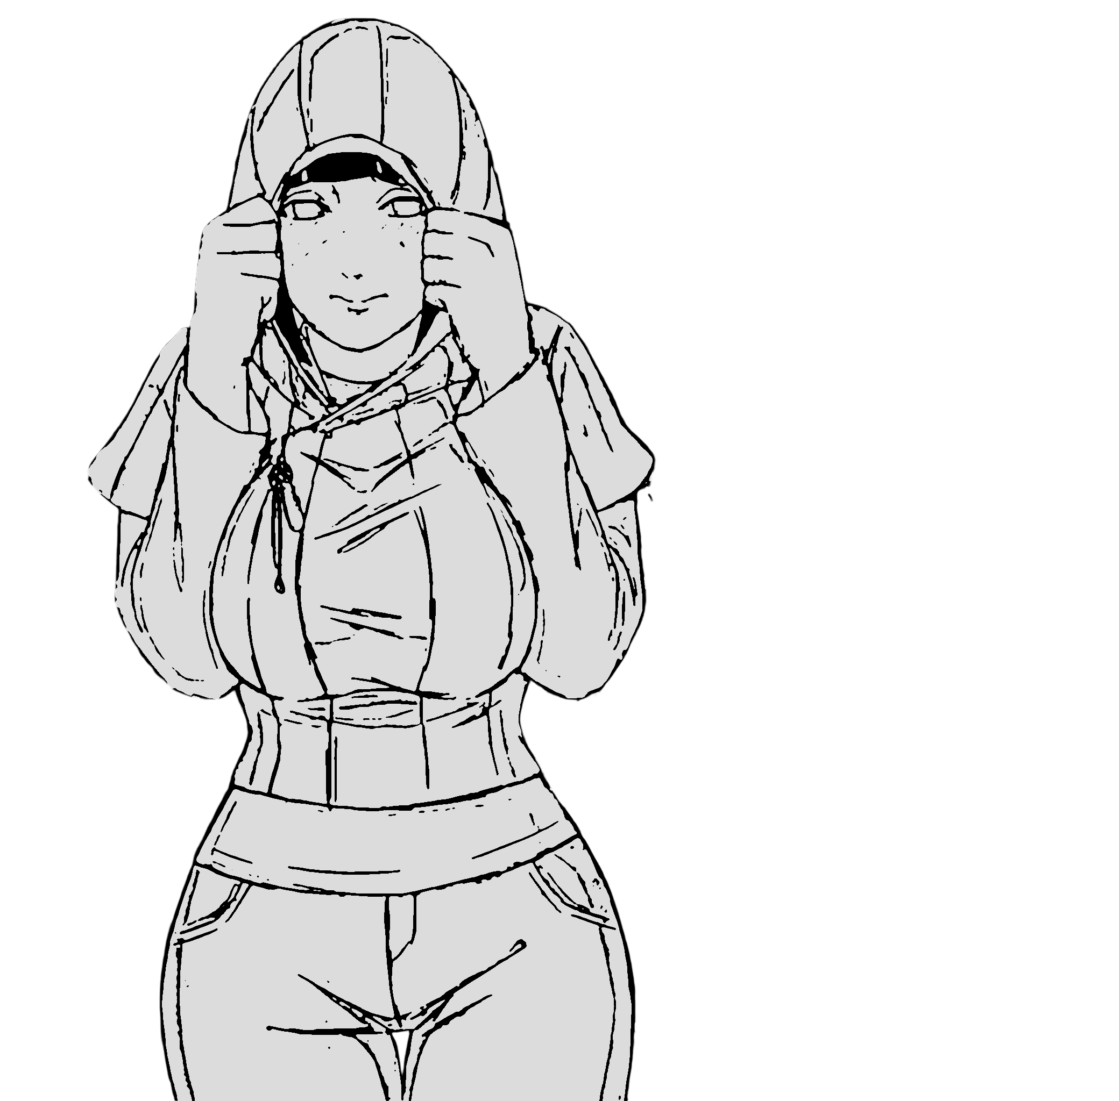

The Dragonfly Inn sat on the edge of the entertainment district, far away from the quiet streets where Hinata lived. It was a messy part of town filled with glowing neon signs and narrow, dark alleys. The air smelled of stale alcohol, smoke, and cheap food. Loud music thumped from the bars, mixing with the voices of people looking for trouble or a good time. The inn itself was a narrow, two-story building with peeling paint and a buzzing sign. It wasn't the kind of place a woman like Hinata Hyuuga ever visited. It was a place built for secrets and cheap affairs.
Hinata pulled her hood lower, bowing her head as she walked, but she couldn't block out the sights around her. The district was shameless. As she hurried past a darkened alley, she caught a glimpse of movement in the shadows—a woman pinned against the brick wall, her legs wrapped tight around a man's waist as they moved together with a frantic, animalistic rhythm.
A few steps later, she flinched as a door burst open, revealing a smoke-filled room where a group of men were cheering on a woman stripping on a table, her body slick with oil. Across the street, through a window with the curtains left carelessly open, she saw a naked couple engaged in a rough, violent coupling, the woman’s hands pressed flat against the glass as she shook with every thrust. It was a chaotic, dirty world where nothing was hidden, and the raw display of lust made her face burn with shame.
"Hey, you!" A rough voice cut through the noise. A man leaning against the entrance of a bar pushed himself off the wall, stumbling into her path. He was swaying, his face flushed with drink, and his eyes raked over her form with hungry entitlement. "You look clean. Too clean for this dump." He grinned, revealing yellowed teeth, and reached out a hand to grab at her arm. "How much for a quick toss? I've got ryo. Come on, let me show you a good time."
Hinata recoiled as if burned, sidestepping him with a burst of speed she usually suppressed. She didn't answer, keeping her head bowed low, but his lewd laughter chased her down the street. "Playing hard to get, huh? I like that!" The encounter left her shaking, a stark, humiliating reminder that in this place, she wasn't the Hokage's wife; she was just potential prey.
She walked quickly, but she couldn't escape the scattered glances. A shopkeeper pausing to wipe a table, a pair of off-duty ninja sharing a drink on a patio—heads turned as she passed. They didn't shout, but she felt the sharp prick of recognition in their stares. There was a sense of misplaced familiarity in their eyes, a silent question forming on their lips as they tried to place the elegant woman walking through the red-light district. She felt exposed, terrified that at any moment, the whisper would start: Isn't that the Hokage's wife?
She stepped inside the inn, escaping the prying eyes of the street. The lobby was empty and smelled of stale smoke and old wood. There was no one at the front desk, just a bell that she didn't dare ring. She knew where she had to go.
The wooden stairs creaked under her sandals, the sound echoing loudly in the silence. Room 4 was at the end of a dimly lit hallway on the second floor. The door was plain, battered, and indistinguishable from the others, but to Hinata, it looked like the gates to a hell she would never leave.
She stood in front of it, her heart hammering against her ribs. Her hand shook as she reached out, her knuckles hovering inches from the wood.
This is it, she thought, a tear sliding down her cheek to vanish into her scarf. Once I knock, I can never take it back.
She knocked. Three times.
The door opened instantly.

***

The man was standing right there, his massive frame filling the doorway.
He didn't say a word. Before Hinata could speak or hesitate, he reached out, gripping her arm with iron strength. He yanked her inside, the force of it nearly pulling her off her feet, and kicked the door shut behind her.
The sound of the lock clicking into place was like a gunshot in the small room. It was the sound of her escape route vanishing.
Hinata stumbled, catching her balance against a rickety wooden table. Her breath came in shallow, panicked gasps as she spun around to face him. The room was small and sparse, illuminated only by the neon light filtering through the thin, grime-streaked curtains. It smelled of mildew and stale lust. There was a single bed with a thin mattress pushed against the wall, a wooden chair, and the oppressive presence of the man towering over her.
He leaned back against the door, crossing his massive arms over his chest to block the exit. He looked even bigger in the confined space, his dark gear standing out against the peeling wallpaper.
"You're earlier than expected " he noted, his voice perfectly level. "Punctuality. I appreciate that."
"I..." Hinata’s voice failed her. She swallowed hard, trying to steady her breathing, but her heart was pounding so hard it hurt. "I’m here. Just as you said."
"Good. Obedience is quite becoming on the Hokage's wife" he replied smoothly, pushing off the door and taking a slow step toward her. The floorboards groaned under his weight.
He stopped just out of arm's reach, his eyes raking over her form. "Are you ready, Lady Hinata?" he asked, his voice low and utterly steady. Hinata couldn't move. She couldn't speak. She just looked at him, the question hanging in the air like a final, inescapable verdict.
He moved then, slowly, deliberately, raising his large hands. They didn't settle softly; instead, his rough palms clamped against her cheeks, gripping her face firmly and surprisingly roughly. Hinata gasped in shock, the unexpected pain in his grip making her flinch. He held her head still, his gaze openly admiring the delicate beauty of her features—the pale, porcelain-like smoothness of her skin, and the wide, fearful Byakugan eyes. He lingered on the full, soft curve of her lips, watching the vulnerable tremor that crossed them, tasting the shame and terror he saw there. He held the admiration for a beat, then, without warning, he shifted his grip and delivered a quick, sharp, open-handed slap to her cheek.
Hinata’s head snapped sideways. A hot, stinging pain erupted on her skin, but she made no sound, biting back a whimper.
Before she could turn back, his hands were already at her waist, hooking roughly under the hem of her light purple hoodie.
Hinata grabbed at his wrists, her fingers digging frantically into his skin, but he ignored her resistance entirely. He hauled the garment upward in one violent, jerking motion. The t-shirt she wore underneath bunched up in his crushing grip and was dragged up right along with it.
There was a frantic, muffled struggle as her head was briefly trapped in the tangle of cotton, but his strength was overwhelming. In a single, rough movement, he pulled both layers up and over her head, discarding them into the corner.
The action left her completely bared to the damp air and his hungry gaze. Her pale skin stood out starkly against the gloom of the room, the dim light from the window tracing the soft, heavy curve of her breasts and the frantic, shallow rise and fall of her ribs as she struggled for air. There was nothing left to hide the flush of shame burning across her skin or the violent hammering of her heart.
Hinata stumbled backward, her legs hitting the edge of the bed. She collapsed onto the thin, stained mattress, the springs groaning loudly under the sudden impact. She lay there, chest heaving, her hair messy and static-charged, her upper body completely bared to the dim light.
She scrambled backward, trying to curl her knees up to her chest, but he was already moving. The mattress dipped as he climbed over her, his massive frame blotting out the window.
He reached down, his fingers closing around her wrists like iron shackles. He slammed her arms down against the sheets, pinning them wide apart on either side of her head.
Hinata squeezed her eyes shut, turning her face away, her breathing coming in sharp, terrified gasps.
"Too high and mighty to look at me?" he sneered, tightening his grip on her wrists. "Open them."
Hinata forced her eyes open, her vision swimming with tears she refused to shed. She looked up at him, her chest heaving, waiting for the next insult or the next blow.
But the taunting stopped.
He stared down at her for a heartbeat longer, his expression shifting from mockery to a cold, blank efficiency. The game was over. He had broken her posture, stripped her defenses, and pinned her down. Now, there was only the act itself.
He shifted his weight, keeping his left hand pinned hard against her wrists, holding both of them effortlessly above her head. His right hand moved down to his waist.
The sound of heavy metal clinking against leather shattered the silence of the room.
Hinata flinched violently at the noise, a fresh wave of panic surging through her limbs. She bucked her hips, a desperate, useless attempt to dislodge his weight, but he didn't even acknowledge the struggle. He was immovable, like stone.
He undid the buckle with slow, deliberate movements. There was no rush, no frantic lust—just the methodical preparation of a man claiming what he believed he had bought.
The belt slid free of the loops with a sharp hiss. He dropped it to the floor, the metal buckle clattering loudly against the wood.
Hinata stopped struggling, her body going rigid with terror. The reality of what was about to happen crashed down on her, heavier than the man himself.
He reached for the button of his trousers, his eyes never leaving her face, watching the light die in her eyes as she realized there were no more words to be said.
He didn't bother to remove his trousers completely, just shoving them down enough to free himself.
He reached down, his hands finding the waistband of her shorts. There was no hesitation, no request for her to lift her hips. He simply yanked the denim down, dragging them over her legs and tossing them onto the floor with the rest of her clothes.
He used his heavy knee to wedge her legs apart, forcing them wide until he could settle his weight between her thighs, keeping them open.
Hinata didn't kick. She didn't scream. She simply let her head fall back against the bare, stained mattress.
As his weight settled between her thighs, blocking the cool air, she stopped looking at him. She fixed her eyes on the ceiling directly above the bed.
There was a water stain there—a yellowing, jagged ring on the peeling plaster that looked like an old bruise.
He gripped her hips, his fingers digging bruisingly into her skin to anchor himself.
Then he thrust forward.
The pain was sharp and immediate, a tearing intrusion that made her whole body jerk against the mattress. His cock was huge, hot, and brutally thick, driving straight into her tight pussy. She felt the sudden stretch and burn as he buried himself deep inside her, forcing a ragged, silent gasp from her chest. She bit down hard on her bottom lip, tasting the copper tang of blood, but she didn't make a sound.
She forced her eyes to stay wide and dry, locking her focus entirely on the ceiling. She traced the outline of the yellow stain. She counted the tiny cracks spiderwebbing out from the center of the plaster.
One. Two. Three.
The bedsprings shrieked in a rhythmic, violent cadence that filled the small room. He didn't hold back. The rhythm wasn't steady; it was punishing. He moved with a violent, possessive aggression, his heavy breaths huffing against her neck as he drove into her harder and faster, shaking the entire frame of the bed.
Hinata felt her body sliding against the sheet with every impact, the friction burning, but she refused to make a sound. She kept her eyes locked on the yellow stain. Her wrists were still pinned tight above her head, her fingers curling into helpless fists as the blood circulation cut off under his crushing grip.
Her silence seemed to irritate him.
He suddenly shifted his weight, grinding his hips down harder to keep her in place. His free hand—abandoned its grip on the mattress.
It landed heavily on her side, his palm rough and hot against her skin. He didn't caress her; he dragged his hand upward with a slow, claiming possessiveness. The calloused fingers scraped over the fragile curve of her ribs, sliding through the sheen of cold sweat that coated her torso. He continued up, his heavy palm pressing flat and hard over the swell of her breast, treating her body like terrain he had conquered, before his fingers slid past her jaw and tangled roughly into the dark roots of her hair.
He yanked her head back against the mattress, breaking her stare at the ceiling and forcing her neck to arch vulnerably.
He immediately lowered his face, his mouth rough and hot against the vulnerable curve of her throat. His tongue flicked out, tracing and wetting the fragile skin of her neck, eliciting a silent shudder. Still maintaining his brutal rhythm, he shifted his weight, burying his face in her chest. His lips closed forcefully around one swollen nipple, drawing a sharp cry from her throat that was instantly swallowed by the ongoing action.
His mouth worked furiously, an aggressive, wet demand. He pulled and tugged at the sensitive peak, drawing it deep into his mouth. His rough jaw moved rhythmically against the soft, swollen curve of her breast, applying strong suction and pressure. The heavy, pulling sensation was intense, and he used his hand to cup and squeeze the soft weight of her breast, controlling the position of the sensitive peak. His simultaneous attack—his mouth on her breast and his cock driving deep—created a brutal physical reality that overwhelmed her senses.
He suddenly released her wrists. Before the blood could return to her numbed fingers, he grabbed her hip and shoulder, hauling her body around with a rough, careless heave.
Hinata gasped as the world spun. She didn't have a chance to resist before her face was slammed into the thin, stained mattress. She tried to scramble forward, a desperate, instinctive attempt to crawl away, but he was too fast.
He collapsed his weight onto her back, pinning her flat, crushing the air from her lungs. He didn't give her a moment to adjust. He grabbed a fistful of her dark hair, yanking her head back sharply. Her neck cracked painfully at the angle, forcing her to gasp for air, before he shoved her face back down into the pillow, smothering her cry.
He resumed his rhythm, harder now, the angle deeper and more punishing.
When she tried to brace herself, digging her fingers into the sheets, he reached down and swung his open palm hard against the soft flesh of her right buttock. The impact was heavy and stinging, the sharp crack of skin against skin echoing loudly in the small room.
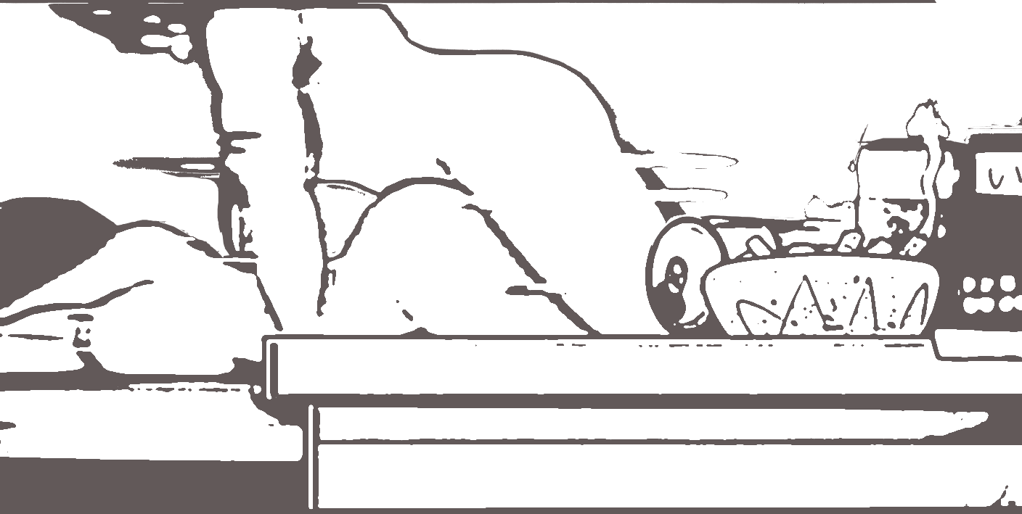
The shock of it forced a sharp, broken whimper from her throat before she could bite it back.
He continued his assault, his hands roaming her body, finding new points of humiliation. He seized her small waist, his hands spanning it completely, and lifted her hips slightly off the mattress. He then slammed her back down onto the sheets, using the impact to drive his dick even deeper inside her. The violent, bone-jarring impact forced a choked cry from her lips, but he immediately drowned it out by pressing his heavy body down harder, emphasizing the sheer difference in their size and strength, his satisfaction drawn from her absolute, non-resistant misery.

The agony was relentless. It was a dark eternity, a punishment she accepted, believing every thrust was a nail driven into the coffin of the scroll, buying another hour of life for her children.
Then, with a final, guttural roar of triumph and relief, the relentless pressure ceased. The man slumped heavily onto her back for a moment, his breath shuddering out in exhausted relief.
After a beat, he pulled out, the wet, sickening sound a final, humiliating punctuation mark. He rolled off her and landed on the bed with a groan, causing the springs to creak.
He then forced her to roll onto her back, prying her eyes open. He climbed over her, straddling her hips, trapping her under his weight. He grabbed the back of her head, his fingers tangling tightly in her hair, and slammed her mouth down onto his cock. The sheer size of his shaft immediately stretched the small capacity of her mouth to its limit, pressing hard against the hinges of her jaw. He held her head fast, making it impossible for her to pull away or struggle, using her mouth as a final point of control.
He forced himself into her mouth, silencing her gagging protest with the sheer invasion of flesh. He didn't care about her comfort; he used her throat with the same violent efficiency he had used the rest of her body, his hips snapping forward in short, sharp bursts.
He anchored her head firmly with his large hand, preventing any movement, and started his final, rapid rhythm. Hinata's body convulsed on the mattress, her arms flailing uselessly against his massive thighs as he drove his semen deep into her throat, silencing her gagging protest entirely with the crushing force of his invasion.
Hinata choked on a sound of pure, unadulterated horror, her body convulsing in a silent, desperate rejection of the violation. She was helpless, trapped, and forced to endure the final, sickening act of his pleasure.
He pulled back abruptly, releasing her jaw. Hinata immediately rolled to her side, coughing and retching, her body convulsing as she tried to spit out the thick, white semen coating her tongue and throat.
The coughing turned into a wrenching, violent heave that originated deep in her diaphragm. Her stomach coiled in a spasm of pure revulsion, rejecting the entire experience. Her body doubled over, shaking, as a torrent of bile and stomach acids, mixed with the sickeningly warm, slick fluid, erupted from her mouth. It splattered onto the thin, stained sheet beneath her face. She kept retching, ragged and broken, dry heaving long after her stomach was completely empty. The sound of her desperate, violated body was the only noise in the oppressive silence.

***
The faint blue glow of the console screen was the only light in the living room. It was 12:30 AM, and Boruto was slumped on the sofa, headphones barely covering one ear. He wasn't even playing a game; he was in the middle of a complex combo against a final boss in Shinobi Gaiden XI, his thumbs flicking furiously across the buttons of his handheld console. The house was quiet, the only sound the faint, tinny combat music leaking from his headphones.
Boruto knew better than to be awake. His mom would kill him if she found him out here, but the boredom, and maybe a slight, restless anxiety over the fact that she was later than usual, kept him rooted.
He tried to run through the possible reasons for her tardiness, but none of them quite fit. She was probably stuck at Aunt Kurenai's, and they were talking about that new baby Shikamaru's sister-in-law had, or maybe even planning a girls' trip to the hot springs. The conversation could have run super late because Aunt Kurenai makes those fancy Hyūga rice crackers, and Mom can't say no. Or maybe she ran into Ino at the flower shop near the Hyūga compound and got trapped listening to her complain about Sai's latest painting project being too messy. Yeah, that had to be it. She was just stuck in an endless, boring adult conversation, and had to walk the long way home because all the street lamps were out, making it take forever.
He shifted, frowning, and then a ridiculous thought popped up, making his cheeks feel hot. Or maybe she just got asked out. Boruto frowned harder, running the scenario through his head It was stupid, but everyone in Konoha, even the old Jōnin, always mentioned how beautiful his mom was, and how one particular elderly council member kept calling her "generously proportioned.". He imagined some clueless, smooth-talking guy—maybe even a civilian who didn't know who she was—seeing her on the street and trying his luck. Boruto pictured his mom, blush heavy and stuttering, trying to politely refuse the guy, but the guy just wouldn't leave, making her late. It was a dumb reason, but the thought of some stranger trying to flirt with his mom was enough to make his thumbs clench in annoyance on the console buttons. Mom would never, obviously, but still. Get lost, weirdo.
Then, the sound of the front door latch turning shattered the quiet.
Boruto froze instantly. The boss music still leaked from his headphones, but his thumbs were rigid. Panic flared in his chest. He threw the console onto the sofa cushion beside him, scrambling to rip the headphones off.
He dove for the floor, rolling under the coffee table, barely fitting his lanky frame into the dark space. His heart was hammering a frantic rhythm against the polished wood of the floor. He knew the drill: if he was caught up past midnight, Hinata's disappointed silence would be far worse than any shouting, and the console would be locked away for weeks. Losing his save file on the final boss was a fate worse than death itself. He squeezed his eyes shut, trying to regulate his frantic breathing. He could hear the faint, muffled sound of her footsteps in the entryway.
Why is she so late? The thought screamed in his mind, eclipsing the immediate terror of being grounded. Kurenai-sensei's house wasn't that far, and Hinata was always home by eleven, even if she had gone shopping. He tried to force his mind back to the immediate danger—stay still, stay quiet—but the anxious curiosity was a physical itch. He pictured her in the hallway, maybe leaning against the wall, tired from talking about boring adult things. Please, Mom, just walk to your room. Don't look in here. I can explain the time, I just can’t lose the console. He listened intently, willing the muffled footsteps to travel straight up the stairs, past the point of no return. The suspense was almost worse than the idea of being caught.
The muffled footsteps continued past the living room doorway and started ascending the stairs.
Boruto let out a long, silent breath that felt like a balloon deflating in his chest. Yes! Safe! He stayed tucked under the table, every muscle tense, waiting for the distinct sound of the bedroom door closing upstairs. He listened to the slow, measured thump... thump... thump of her feet on the wooden steps, each one seeming to take an agonizing age. Finally, there was the soft click of the bedroom door latch closing .
A wave of dizzying relief washed over him, momentarily blinding him to everything else. He was safe. The console was safe. He could sneak back up to his room now, and Hinata would never know he had been up. He started to wiggle his way out from under the table.
As he moved, a sudden, intrusive scent hit him. It was thick, faintly metallic, and profoundly specific—a pungent, slightly sweet, musky smell. Boruto recognized it instantly. It was the scent of semen. It was stronger than anything he'd ever smelled on his own sheets; heavy and cloying in the air where his mother had just passed. The thought of it being attached to Hinata—to his mom—made the blood rush from his head. No. No way. That's insane. He frantically dismissed the idea. It had to be a mistake, maybe some chemical residue from a strong cleaner used at Kurenai's house, or something clinging to her shoes from outside.
Maybe he was just going crazy. He hadn't slept properly in days due to the late-night gaming, He quickly decided the smell was a phantom, a symptom of his own sleep deprivation, and nothing more.
He quickly retrieved his console and crept to the stairs, ignoring the strange, lingering scent in the air. His mission was complete: avoid the grounding and save his game. He ascended the stairs, careful to avoid the creaky third step, and slipped into his own bedroom. Throwing himself onto his bed, he felt the heavy weight of exhaustion finally claim him. He was asleep before his head fully settled on the pillow, the mysterious odor and his mother's strange return already sinking into the murky depths of his subconscious mind.

***

