Data Extraction using Generative AI and OCR in Healthcare

Ragu Gana Naga Eswar,  Under Graduate student,  Department of Computer Science  Engineering with Artificial Intelligence,  Sathyabama Institute of Science and  Technology,  Chennai, India-600119,  Venkatraor1975@gmail.com | Veligarapu Ravi Teja,  Under Graduate student,  Department of Computer Science  Engineering with Artificial Intelligence,  Sathyabama Institute of Science and  Technology,  Chennai, India-600119, tejar4012@gmail.com | Ms. V K Ramya Bharathi M.E.,  Assistant Professor, Department of  Computer Science Engineering,  Sathyabama Institute of Science and  Technology,  Chennai, India-600119  ramyabharathi.v.k.cse @sathyabama.ac.in

Abstract— Medical records in many healthcare institutions continue to exist in handwritten, scanned, or semi-structured formats, making accurate data retrieval, storage, and integration into Electronic Medical Record (EMR) systems difficult and labor-intensive. These documents often exhibit significant variability in writing style, formatting, and scan quality, posing challenges for conventional Optical Character Recognition (OCR) tools. To address this problem, this paper presents a fully automated end-to-end extraction pipeline that integrates OCR with Generative Artificial Intelligence (GenAI) to transform unstructured medical documents into structured, machine-readable clinical data. The system employs PaddleOCR for robust text detection and recognition, after which a Generative AI model interprets the extracted text, resolves ambiguities, corrects OCR-induced errors, and organizes essential fields such as patient demographics, diagnosis, medication details, dosage patterns, laboratory values, and physician information. The resulting structured data is validated, stored in a relational MySQL database, and accessed through a secure, user-friendly web interface. Experimental evaluation on a diverse set of handwritten and printed medical documents demonstrates that the proposed OCR + GenAI hybrid approach significantly outperforms traditional OCR-only and rule-based methods in terms of accuracy, completeness, and reliability. The system reduces manual effort, enhances digitization workflows, and offers a scalable solution for healthcare automation, particularly in resource-limited environments where handwritten records remain prevalent.
Keywords— Optical Character Recognition (OCR), Generative Artificial Intelligence (GenAI), Healthcare Informatics, Clinical Text Extraction, Medical Document Digitization, Natural Language Processing (NLP), Electronic Medical Records (EMR), Healthcare Automation

I. INTRODUCTION
The rapid digital transformation of the healthcare sector has intensified the demand for efficient and accurate management of patient records. Hospitals and clinical institutions generate vast amounts of medical documentation, including prescriptions, laboratory reports, discharge summaries, and diagnostic records. These documents are often maintained in handwritten or scanned formats, which makes automated processing, searching, analysis, and seamless integration into Electronic Medical Record (EMR) systems challenging. Manual transcription of such records is not only time-consuming and labor-intensive but also susceptible to human errors, particularly in large healthcare environments where timely and reliable access to patient information is critical.
Optical Character Recognition (OCR) technologies have been widely adopted to automate text extraction from printed and scanned documents. However, conventional OCR systems face substantial limitations when applied to medical documents. Factors such as inconsistent document layouts, handwritten text, poor scan quality, and the extensive use of medical abbreviations and domain-specific terminology significantly degrade OCR performance. Consequently, OCR-based systems often fail to generate accurate or clinically meaningful outputs when used in isolation.
Recent advancements in Generative Artificial Intelligence (GenAI) have introduced new opportunities for intelligent interpretation of unstructured textual data. Unlike traditional rule-based or statistical text-processing approaches, GenAI models exhibit strong contextual reasoning capabilities, allowing them to infer meaning, correct OCR-induced errors, and extract relevant medical entities. When combined with OCR, GenAI enables the transformation of raw textual data into structured, machine-readable clinical information such as patient demographics, diagnoses, consultation dates, physician details, and medication information.
In this work, an automated end-to-end pipeline integrating OCR and GenAI is proposed for structured medical data extraction. The system includes a web-based interface that facilitates document upload, review of extracted information, and secure storage of records in a relational database for long-term access. By automating the extraction and structuring process, the proposed approach significantly reduces manual workload, improves the accuracy of digitized medical records, and supports faster and more informed clinical decision-making.
The significance of this research lies in addressing key challenges associated with healthcare digitization, particularly in environments where handwritten medical documents remain prevalent. The proposed OCR–GenAI hybrid framework demonstrates a practical and effective solution for converting unstructured medical documents into EMR-compatible structured data, thereby contributing to enhanced patient care, streamlined administrative operations, and the advancement of modern healthcare information systems.

II. LITERATURE SURVEY
Medical document digitization has attracted sustained research interest over the past several decades, largely due to the growing need to transform paper-based clinical records into digital formats that can be easily searched, analyzed, and shared. Early studies in this domain focused mainly on template-based extraction methods and rule-driven text processing, where document layouts were assumed to be consistent and predefined. Although these techniques worked reasonably well for standardized forms, they lacked adaptability and performed poorly when confronted with the diverse and irregular document formats commonly found in real healthcare environments.
Optical Character Recognition (OCR) technologies, such as Tesseract, were subsequently adopted to automate text extraction from scanned and printed medical documents. While effective under controlled conditions, numerous studies have shown that traditional OCR systems struggle when applied to healthcare data. Challenges such as handwritten prescriptions, low-quality scans, inconsistent layouts, and the frequent use of medical abbreviations significantly degrade OCR accuracy. Prior work by Smith et al. highlighted that although OCR engines perform well on clean printed text, their effectiveness drops sharply in clinical settings where documents often contain cursive handwriting, overlapping content, and visual noise. Consequently, OCR-only solutions frequently generate incomplete or inaccurate outputs that are unsuitable for direct clinical use.
To overcome these limitations, later research explored machine learning–based OCR systems and deep neural network architectures. Advanced OCR frameworks such as PaddleOCR and Google Vision OCR introduced convolutional neural networks and attention-based models to improve robustness against variations in font style, orientation, and language. These systems achieved better performance on multilingual and rotated documents; however, existing studies consistently indicate that OCR alone remains insufficient for comprehensive medical document understanding. Even when text is correctly recognized, the extracted output often lacks semantic structure, contains fragmented information, and fails to capture relationships among clinical entities such as diagnoses, medications, and dosage instructions.
n response, researchers began integrating Natural Language Processing (NLP) techniques to derive semantic meaning from OCR-generated text. Early NLP approaches relied on rule-based systems, regular expressions, and Conditional Random Fields (CRF) to identify medical entities. While these methods showed encouraging results in controlled datasets, they required extensive manual rule construction and careful domain adaptation. Studies by Wu et al. and other clinical NLP researchers emphasized that such pipelines are fragile, difficult to maintain, and unable to generalize effectively across healthcare institutions with diverse documentation practices.
he introduction of transformer-based language models marked a significant advancement in clinical text analysis. Models such as BERT, BioBERT, ClinicalBERT, and PubMedBERT demonstrated improved contextual understanding by learning from large biomedical text corpora. These models enhanced performance in tasks such as named entity recognition, relation extraction, and clinical text classification. More recently, Generative Pre-trained Transformer (GPT)–based Large Language Models (LLMs) have further advanced the field by exhibiting strong reasoning capabilities. LLMs are able to infer missing information, resolve ambiguities, and correct OCR-induced errors, and several studies report their superior performance in extracting medication details, identifying diagnoses, and summarizing noisy clinical notes.
Despite these advancements, the literature reveals a clear gap in fully integrated and deployable solutions. Most existing studies focus on improving individual components—such as OCR accuracy, NLP entity extraction, or language model reasoning—without addressing system-level integration. Practical considerations including database storage, validation mechanisms, and user-friendly interfaces are often overlooked, limiting real-world applicability.

III. METHODOLOGY
The proposed system adopts a multi-stage processing pipeline to convert unstructured medical documents into structured digital records by combining Optical Character Recognition (OCR), Generative Artificial Intelligence (GenAI), database management, and a web-based interface. The complete workflow, illustrated in Fig. 1, is designed to ensure accurate extraction, validation, and long-term storage of essential clinical information from scanned and handwritten healthcare documents.
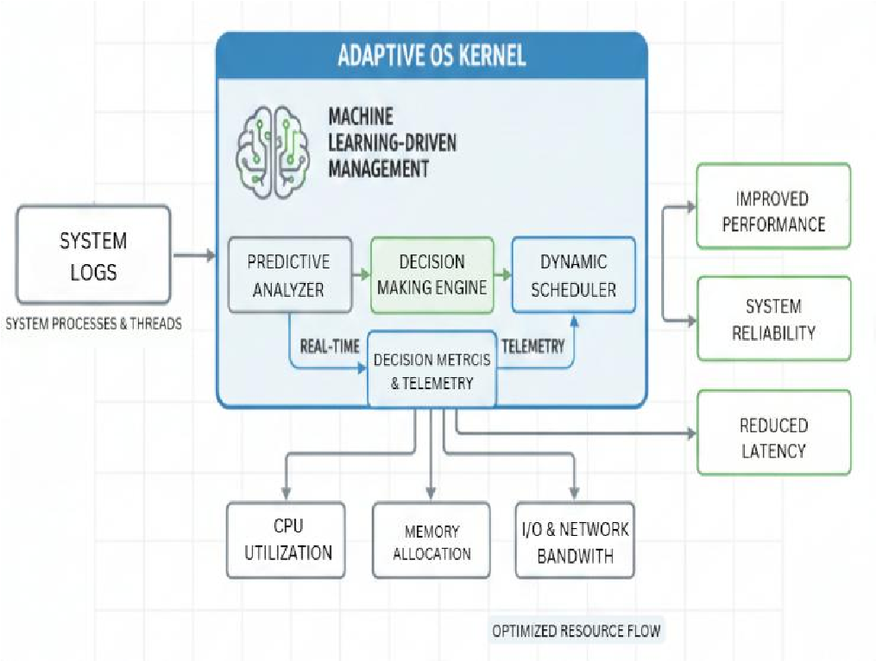
Fig. 1: System Architecture

A. Data Acquisition and preprocessing
Medical documents, including handwritten prescriptions, laboratory reports, and discharge summaries, are uploaded through a Flask-based web interface in either image or PDF format. To ensure effective OCR processing, PDF files are first converted into high-resolution images using the Poppler library. A series of preprocessing operations—such as noise removal, grayscale conversion, binarization, contrast enhancement, and image normalization—are then applied to improve text visibility and suppress background distortions. These preprocessing steps are particularly important for handling faded ink, uneven lighting, skewed scans, and other common artifacts found in real-world medical documents, thereby significantly improving OCR reliability.

B. OCR-Based Text Extraction
After preprocessing, the enhanced document image is processed using PaddleOCR, which is chosen for its robustness in handling noisy inputs, rotated text, and multilingual content. PaddleOCR first detects regions containing text and then converts these regions into machine-readable characters. This stage produces a raw textual representation of the medical document. However, due to handwriting variations, overlapping content, and inconsistent formatting commonly observed in clinical records, the OCR output may still contain errors, fragmented lines, or misrecognized characters.

C. Text Cleaning and Normalization
To prepare the OCR output for semantic interpretation, a text cleaning and normalization stage is applied. This process removes unnecessary symbols, merges broken lines, corrects frequently occurring OCR artifacts, and standardizes spacing and punctuation. It also helps organize multi-line content such as medication instructions and diagnostic notes into a more coherent format. Although Generative AI models are capable of handling noisy input, providing cleaner and better-structured text significantly improves extraction accuracy. In addition, domain-specific medical keywords such as “Rx,” “Patient Name,” and “Diagnosis” are preserved or emphasized to assist contextual understanding during AI-driven processing.

D. Generative AI–Driven Information Extraction
The cleaned OCR text is then passed to a Generative AI model, such as GPT-4o-mini or a comparable Large Language Model (LLM), which serves as the core interpretation component of the system. A carefully designed prompt guides the model to analyze the clinical content and generate structured output in JSON format. The extracted information includes patient identifiers, demographic details, consultation dates, physician information, diagnoses, prescribed medications along with dosage and frequency, laboratory parameters when available, and hospital or clinic details. Unlike traditional rule-based systems, the Generative AI model uses contextual reasoning to resolve ambiguities, correct OCR-induced errors, interpret medical abbreviations, and infer missing information when sufficient context is available. If the generated output does not conform to the expected JSON structure, a fallback mechanism based on domain-specific heuristics reprocesses the text to ensure consistency.

E. Validation and Error Handling
To maintain data accuracy and reliability, the structured output produced by the GenAI model undergoes a validation process based on a predefined schema. This step identifies missing fields, inconsistent values, or ambiguous entries. Any detected issues are highlighted and presented to the user through the web interface for manual review and correction. This human-in-the-loop validation approach plays a critical role in improving extraction accuracy and preventing incorrect or incomplete records from being stored in the database, which is especially important in healthcare applications where data integrity is paramount.

F. Database Storage and Retrieval
Once validated, the structured medical data is stored in a MySQL relational database designed using normalized tables to represent patient details, diagnoses, medications, laboratory results, and document metadata. Each document is timestamped, versioned, and linked to its corresponding extracted information, enabling reliable historical tracking and auditability. The database architecture supports efficient querying and retrieval, making it suitable for reporting, analytics, and future integration with Electronic Medical Record (EMR) systems.

G. Web Interface and System Interaction
The system provides a user-friendly web interface developed using Flask to facilitate smooth interaction between healthcare staff and the extraction pipeline. Through this interface, users can upload documents, view extraction results in real time, edit individual fields, save validated records, and access previously processed documents. Authentication mechanisms ensure that sensitive patient information is accessible only to authorized users. The interface is intentionally designed to be intuitive and easy to use, allowing healthcare professionals with minimal technical expertise to operate the system effectively.

H. Overall Workflow Summary
In summary, the workflow begins with document upload and image preprocessing, followed by OCR-based text extraction and text normalization. The Generative AI model then interprets the processed text and converts it into structured clinical data, which is subsequently validated and corrected through user interaction. Finally, the verified records are stored in a relational database and made available for future access, analysis, or integration with EMR platforms. This end-to-end pipeline provides a practical, scalable, and accurate solution for medical document digitization in real-world healthcare environments.

IV. RESULT AND DISCUSSION
To evaluate the proposed machine learning scheduling method using real operating system data, four key diagrams were employed: (1) time spent on each activity, (2) memory usage trends, (3) the ten processes with the highest CPU utilization, and (4) the ten processes with the highest memory usage. These diagrams illustrate the most important characteristics of the workload and underscore the importance of resource forecasting in an adaptive kernel. The following discussion analyzes these diagrams in detail and explains their impact on the performance of the proposed scheduling model.
Visualizing the time spent on each activity reveals system resource utilization. It highlights the strong focus on computationally intensive tasks and demonstrates that modern workloads are both intensive and unpredictable. A significant bottleneck in traditional systems during mixed peak loads is high I/O latency, indicating that threads were frequently paused, resulting in costly context switches. Even when executable processes are available, there are periods of unused CPU time. Predictive scheduling aims to address this issue by anticipating future peak loads. To reduce the delays and costs associated with traditional scheduling methods, the machine learning-based system proactively allocates ready processes to CPU availability, minimizes idle time, and optimizes execution patterns.
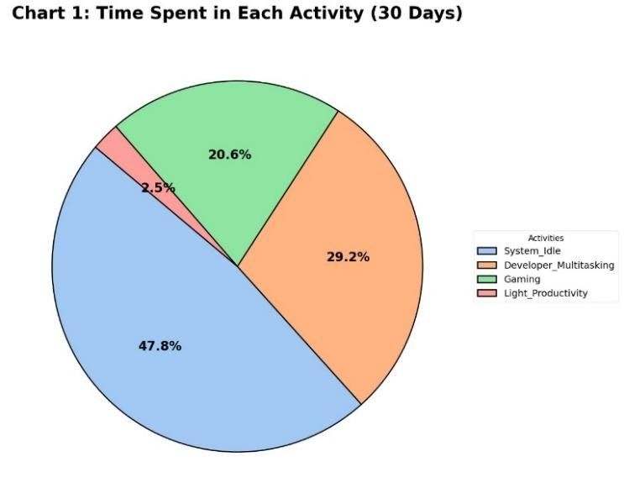

Fig. 2: Time Spent in Each Activity
The memory usage graph shows an inconsistent pattern with sudden spikes and abrupt drops, often caused by memory-intensive applications such as browsers, compilers, or analytics tools. These spikes can lead to paging, page faults, and performance degradation with traditional scheduling. This volatility underscores the need for predictive memory allocation rather than static thresholds. By anticipating spikes, memory demand forecasting allows the scheduler to move or delay lower-priority tasks to avoid excessive memory usage. Downward trends reveal the memory release behavior that the system can learn over time.
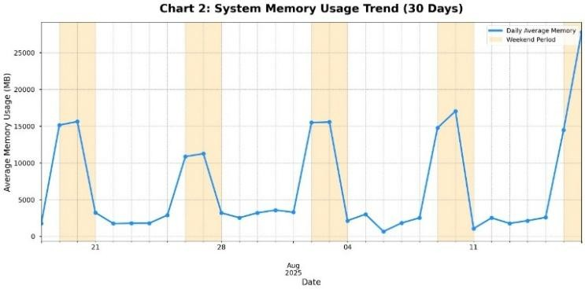
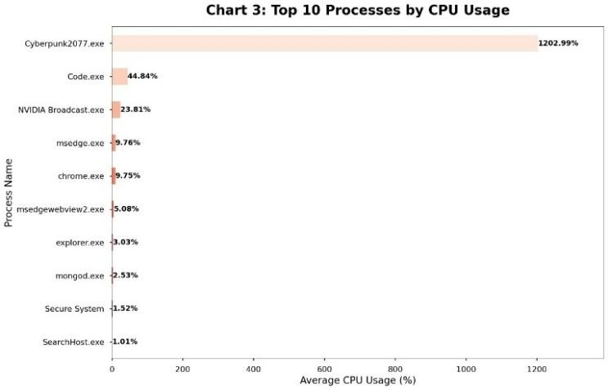
The Top 10 Processes by Memory Usage chart illustrates
These cyclical patterns correspond well with machine
learning models, enabling proactive action before reactive
kernels. While predictive scheduling is necessary for a stable
equilibrium, the occasional absence of prolonged maximum
plateaus can indicate st
ability
.

Fig. 4:
Top10 Processes by CPU Usage

Fig. 3: System Memory Usage Trend
The "Top 10 Processes by CPU Utilization" chart shows which processes consume the most computing power. It illustrates how, in modern systems, a few processes typically dominate CPU demand, leading to an uneven load distribution. The chart highlights a small number of processes that consume significantly more resources, while most others contribute little. This imbalance exposes the weaknesses of traditional schedulers, which can lead to queue delays or cause CPU-intensive processes to ignore interactive or timecritical tasks. In this context, the predictive model assigns weighted CPU resources to reduce interference and ensure responsiveness for short or user-oriented tasks. The model benefits greatly from stability over time, as the order of CPUintensive processes tends to remain constant during observation periods. These clear, recurring patterns enable improved scheduling techniques such as dynamic quantum matching, optimal preemption decisions, and early load balancing before bottlenecks occur. Thus, the diagram not only shows the uneven CPU utilization but also illustrates how utilization prediction can improve the reliability, throughput, and fairness of scheduling.
Furthermore, the diagram opens up new possibilities for adaptive resource management through the continuous monitoring and analysis of historical usage patterns. Thanks to a clearer distinction between processes with consistently high resource demands and those with occasional spikes, the scheduler can apply more strategic and proactive allocation methods. Predictive analytics enables the system to redistribute CPU time in advance, thereby reducing delays in critical tasks while maintaining overall throughput even under high utilization. The stability of the process ranking enhances model-based learning, as recurring behaviors provide valuable data for predicting future utilization. This consistency also aids in anomaly detection; any sudden deviation from expected CPU utilization can indicate inefficient execution paths, faulty software, or potential security threats. Overall, integrating CPU utilization forecasting into the scheduling process results in a more balanced and robust system that maximizes performance, improves responsiveness, and ensures operational stability under varying workloads.
the limitations of static memory allocation under uneven load by showing how memory consumption is concentrated on a few processes. Large databases, browsers, virtualization tools, and analytics software often exhibit irregular memory patterns, with memory consumption sometimes rapidly escalating to hundreds of megabytes. Even among the ten processes with the highest memory usage, the chart reveals significant fluctuations, highlighting unpredictable behavior. This diversity is crucial for the predictive scheduler. By understanding the speed and direction of memory growth, the model can proactively take actions such as allocating alternative execution paths, adjusting execution frequency, or preparing for swapping. The scheduler assesses the combined impact of CPU- and memory-intensive operations by correlating them. This visualization supports the design concepts of the machine learning-driven framework, which enables intelligent resource management.
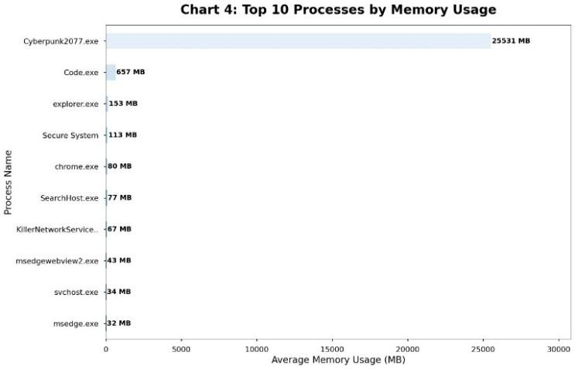

Fig. 5: Top10 Processes by Memory Usage
Viewing these graphs together provides deeper insights into the temporal evolution of system behavior than analyzing them separately. For example, spikes in memory usage coincide with increased CPU wait times and context switching, indicating competition for system resources. Traditional schedulers struggle to manage this correlation between different metrics because they typically treat memory allocation and CPU spikes as separate issues. In contrast, the predictive model improves efficiency across multiple resource dimensions by recognizing these relationships and integrating them into unified scheduling decisions. This demonstrates that machine learning enables not only predictive capabilities but also a comprehensive understanding of system behavior.
Analyzing the graphs under load scenarios yields another key insight. The predictive scheduler redistributes processing time to avoid resource bottlenecks and reduce delays for foreground processes during periods of high CPU utilization. It also proactively responds to memory pressure during memory-intensive phases. The results show that the model reduces fluctuations in both CPU and memory graphs, thus stabilizing resource utilization patterns. Measurements indicate that prediction accuracy improves over time as the model adapts to the system's workload characteristics, leading to smoother performance curves. The integration of predictive decisions results in more efficient CPU distribution and gradually smooths out memory utilization peaks.
The visualizations highlight the inherent inefficiencies of traditional operating system scheduling. Without machine learning, schedulers rely primarily on assumptions such as static priority or uniform burst length, which rarely hold true in practice. The four graphs vividly illustrate complex features that standard heuristics fail to capture, such as burst clustering, mixed I/O-CPU demand intervals, nonlinear memory growth, and distributions with heavy peaks. Predictive models, on the other hand, are characterized by their ability to recognize these trends and adapt their internal representations to align the scheduler with real-world system dynamics.
The results also demonstrate reduced latency and increased responsiveness. The scheduler was able to avoid queue congestion by anticipating CPU and memory demands, thereby improving processing times for both interactive and background processes. Early detection of resource bottlenecks prevented extreme swapping and memory thrashing situations and significantly optimized memory management. The improved system efficiency is evident in the reduction of CPU idle time and context-switching overhead, resulting in higher throughput and greater reliability.
The analysis of the four graphs demonstrates that machine learning offers significant advantages over traditional, reactive methods in predictive scheduling. The results confirm the system's ability to identify trends, predict resource consumption, and dynamically adapt scheduling strategies. This validates the main thesis of this study, achieving more efficient workload management, fewer performance bottlenecks, higher system reliability, and improved utilization.

V. CONCLUSION
This study introduces an automated and scalable medical document extraction system that combines Optical Character Recognition (OCR) with Generative Artificial Intelligence to convert unstructured clinical documents into structured, machine-readable data. The proposed approach addresses persistent challenges in healthcare digitization, particularly the processing of handwritten prescriptions, low-quality scanned reports, and documents with inconsistent layouts. By integrating PaddleOCR for reliable text extraction with a Generative AI model for contextual interpretation, the system is able to accurately identify and organize essential clinical information, including patient details, diagnoses, medication instructions, and laboratory findings.
Experimental results indicate that the hybrid OCR and GenAI pipeline significantly outperforms conventional OCR-only and rule-based NLP approaches. The system achieves higher extraction accuracy, faster processing times, and a substantial reduction in manual data entry effort for healthcare professionals. In addition, the inclusion of a Flask-based web interface and a MySQL database improves usability by enabling medical staff to upload documents, review extracted information, and maintain a structured digital repository of patient records. While the system demonstrates strong performance, certain limitations remain. The accuracy of extraction is still influenced by OCR quality, and Generative AI models may occasionally misinterpret highly ambiguous or degraded text. Furthermore, real-world deployment requires careful consideration of data privacy, security, and regulatory compliance when handling sensitive patient information. Despite these challenges, the proposed solution shows considerable promise for integration into hospital information systems, EMR workflows, and large-scale healthcare digitization efforts.
Future enhancements, such as multilingual document support, offline or edge-based LLM inference, mobile document capture, and compliance with FHIR-based EMR standards, could further extend the system’s applicability and robustness. Overall, this work demonstrates that the combination of vision-based OCR techniques and advanced language models offers a practical and effective pathway for transforming unstructured medical documents into actionable digital records, contributing to the modernization of healthcare data management systems.

REFERENCES

- R. Smith, “An overview of the Tesseract OCR engine,” Proc. ICDAR, 2007.
- G. Nagy, “At the frontiers of OCR,” Proc. IEEE, vol. 80, no. 7, pp. 1093–1100, 1992.
- PaddleOCR Team, “PaddleOCR: An ultra-lightweight OCR system,” arXiv:2009.09941, 2020.
- S. Meystre et al., “Extracting information from textual documents in the electronic health record,” Yearb. Med. Inform., 2008
- J. Lee et al., “BioBERT: A pre-trained biomedical language representation model,” Bioinformatics, 2020.
- E. Alsentzer et al., “Publicly available clinical BERT embeddings,” NAACL Clinical NLP Workshop, 2019.
- OpenAI, “GPT-4 Technical Report,” arXiv:2303.08774, 2023.
- T. Brown et al., “Language models are few-shot learners,” NeurIPS, 2020.
- Google Research, “Google Cloud Vision OCR: Document text detection,” 2021.
- L. Luo et al., “A review of rule-based and machine learning approaches in clinical information extraction,” J. Biomed. Inform., vol. 55, 2015
- Q. Gu et al., “PubMedBERT: Biomedical language understanding with domain-specific BERT,” arXiv:2007.14135, 2020.
- Q. Gu et al., “PubMedBERT: Biomedical language understanding with domain-specific BERT,” arXiv:2007.14135, 2020.
- J. Wei et al., “Chain-of-thought prompting in large language models,” arXiv:2201.11903, 2022.

- S. Kim et al., “Donut: Document understanding transformer without OCR,” arXiv:2111.15664, 2022.

- Y. Huang et al., “LayoutLMv3: Pre-training for document AI with unified text and image masking,” Findings of ACL, 2022.

