Scenario-based Elevator Energy Reduction Results
This section presents the quantitative results of the scenario-based elevator energy assessment. All results are normalized to the baseline case (index = 100) to enable intuitive comparison across scenarios.

Figure 1. Annual energy comparison
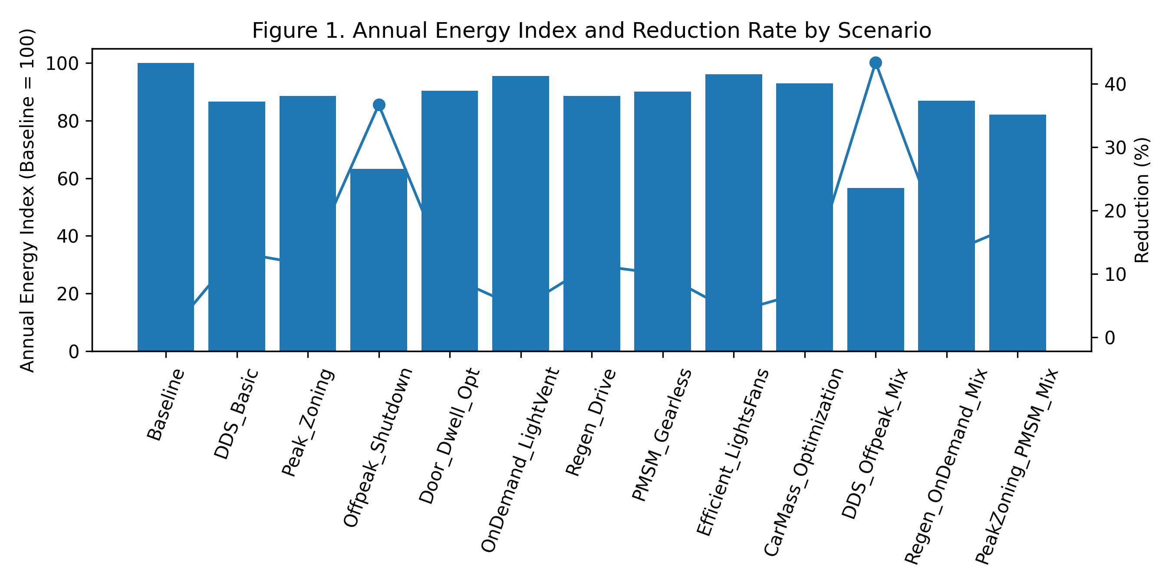
Figure 1 compares annual elevator energy consumption normalized to the baseline (index = 100) together with the corresponding reduction rates. Mixed strategies clearly outperform single-measure scenarios.

Figure 2. Reduction ranking
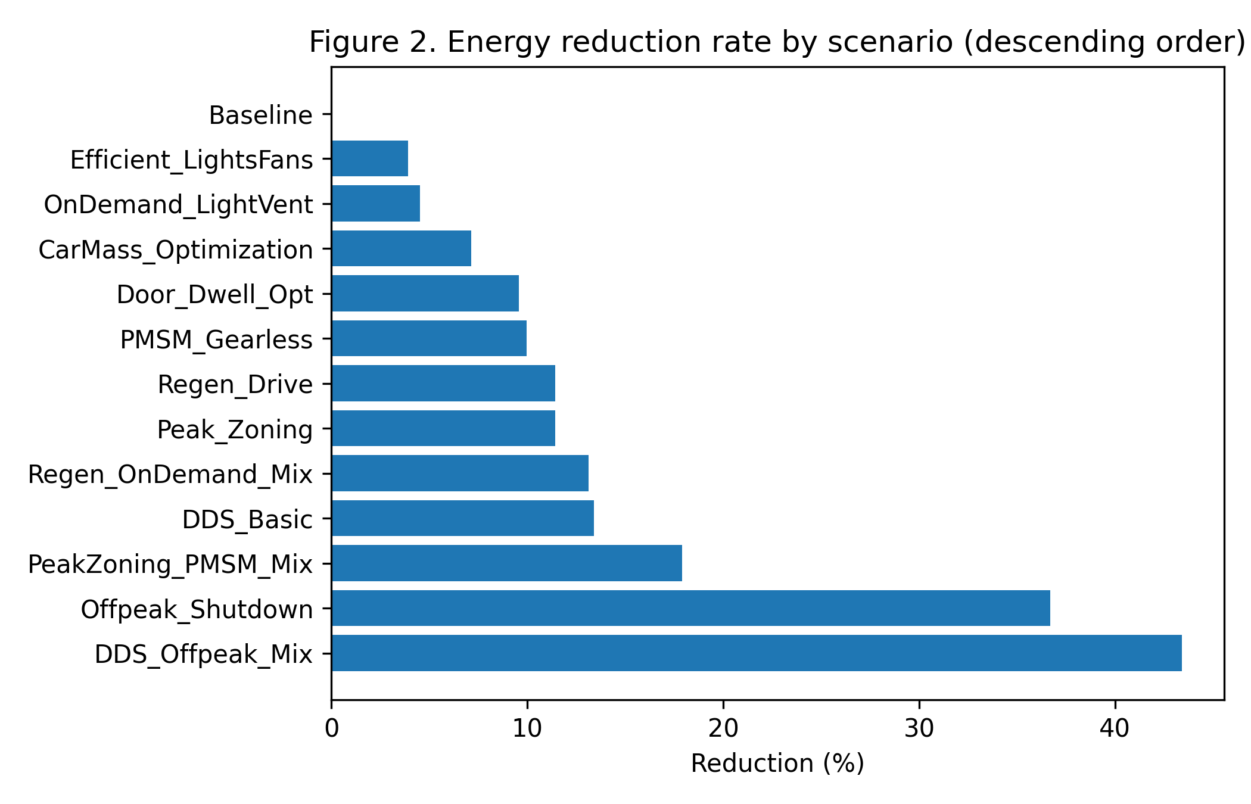
Figure 2 ranks all scenarios by reduction rate, allowing rapid identification of the most effective strategies.

Figure 3. Contribution analysis
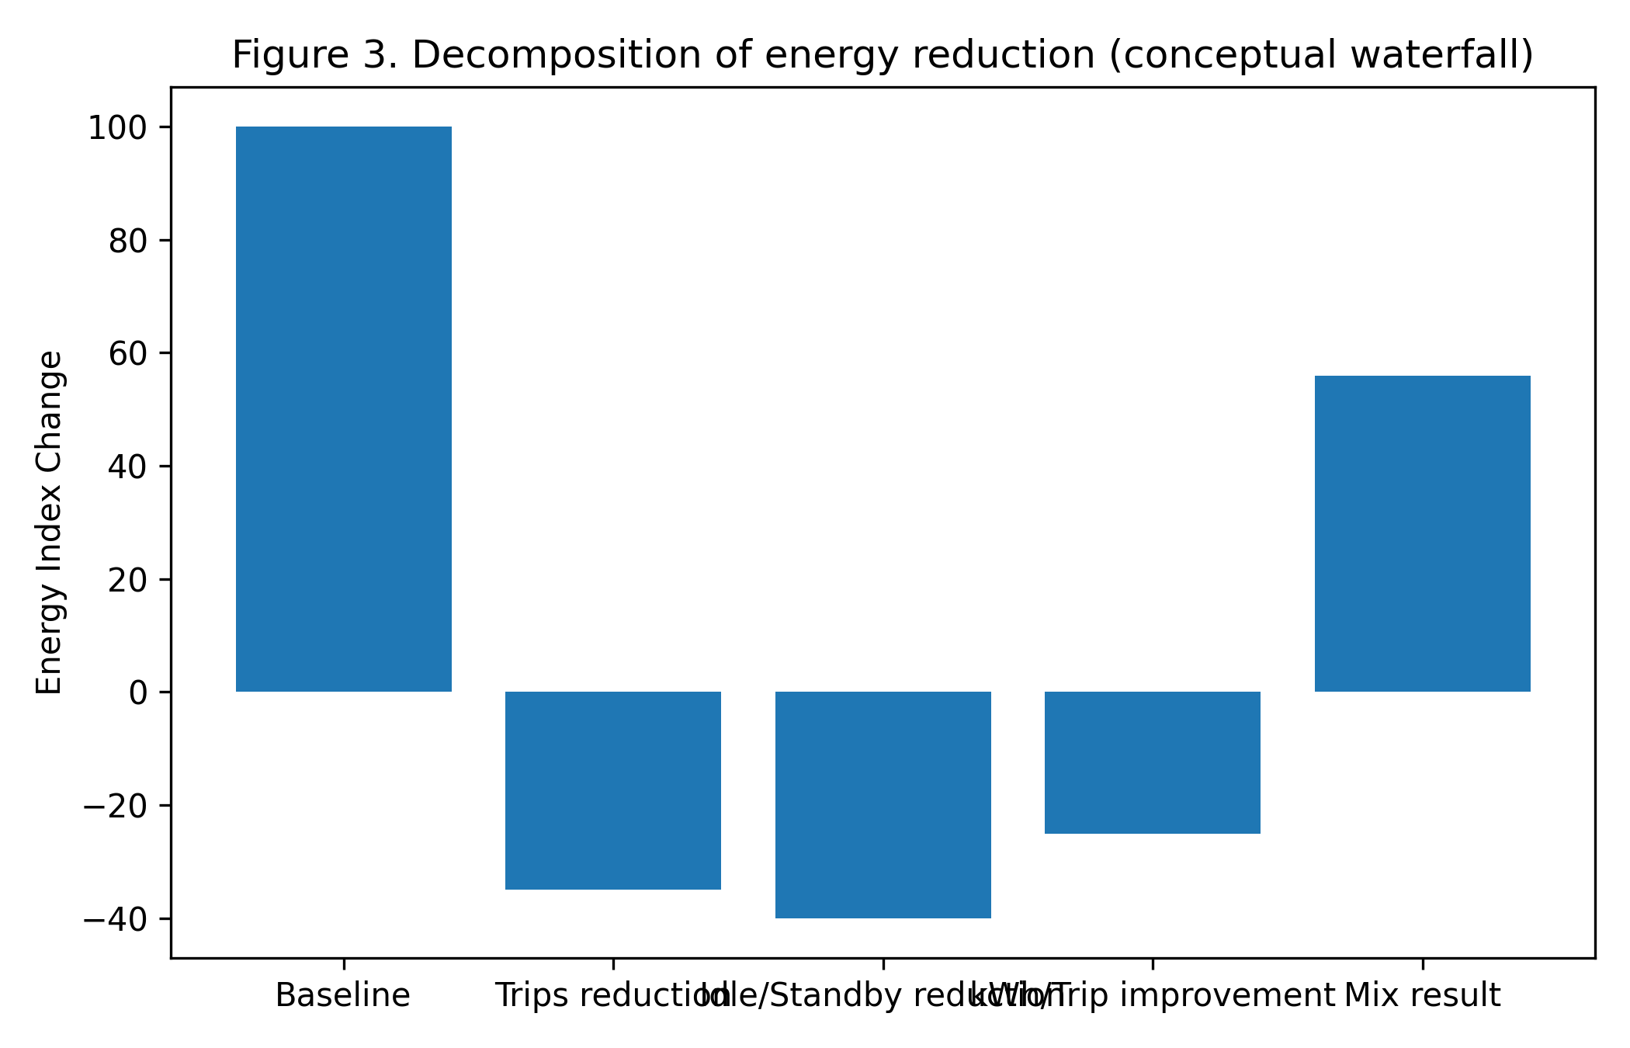
Figure 3 illustrates the contribution of trip reduction, idle/standby reduction, and per-trip efficiency improvement. The mixed scenario aggregates these effects sequentially.

Figure 4. Interaction effect
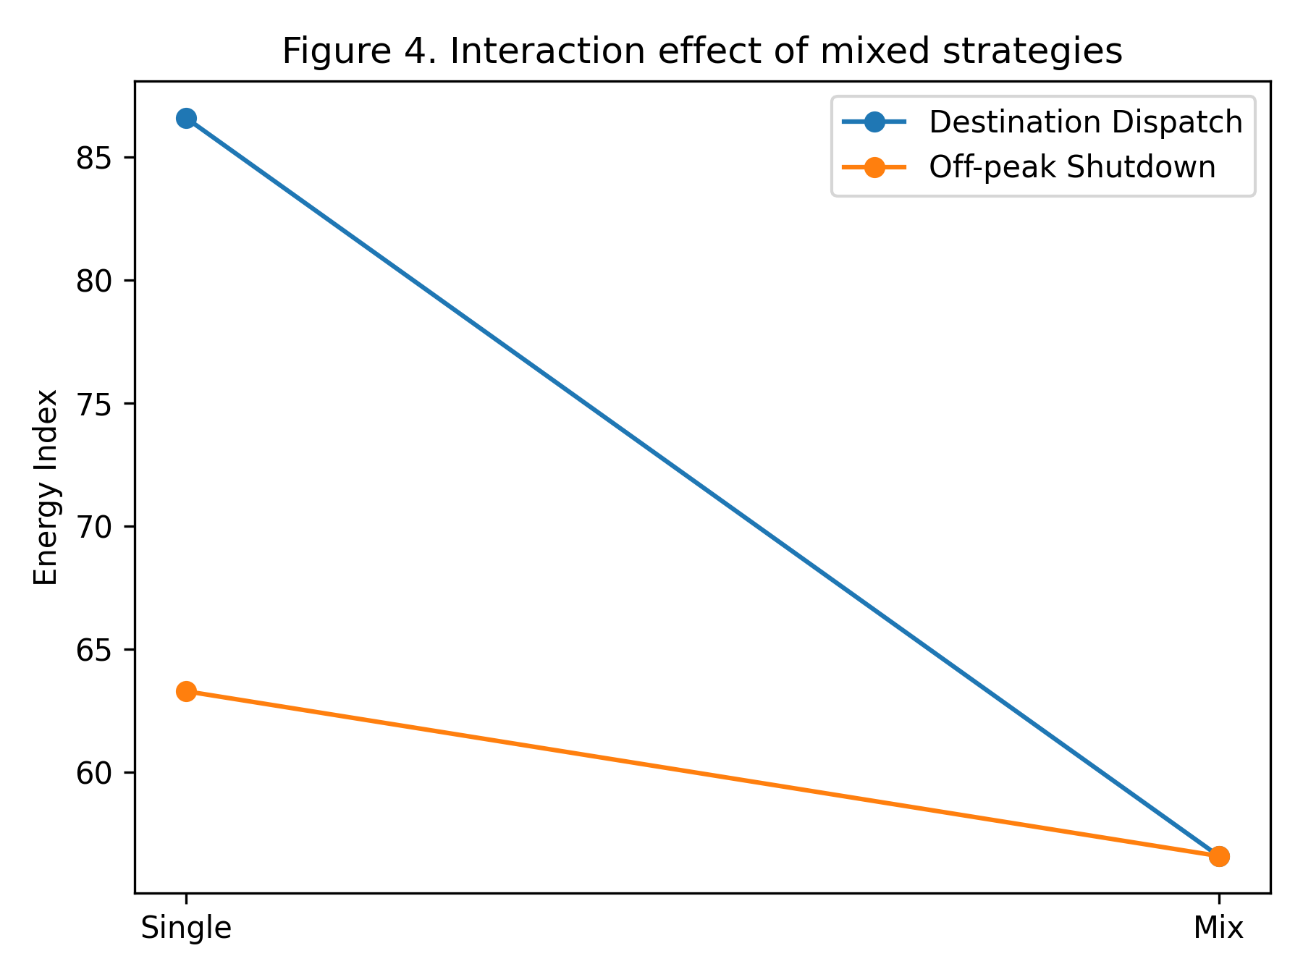
Figure 4 demonstrates that the combined strategy achieves larger savings than the sum of individual effects, indicating a positive interaction between operational measures.

Figure 5. Strategy group comparison
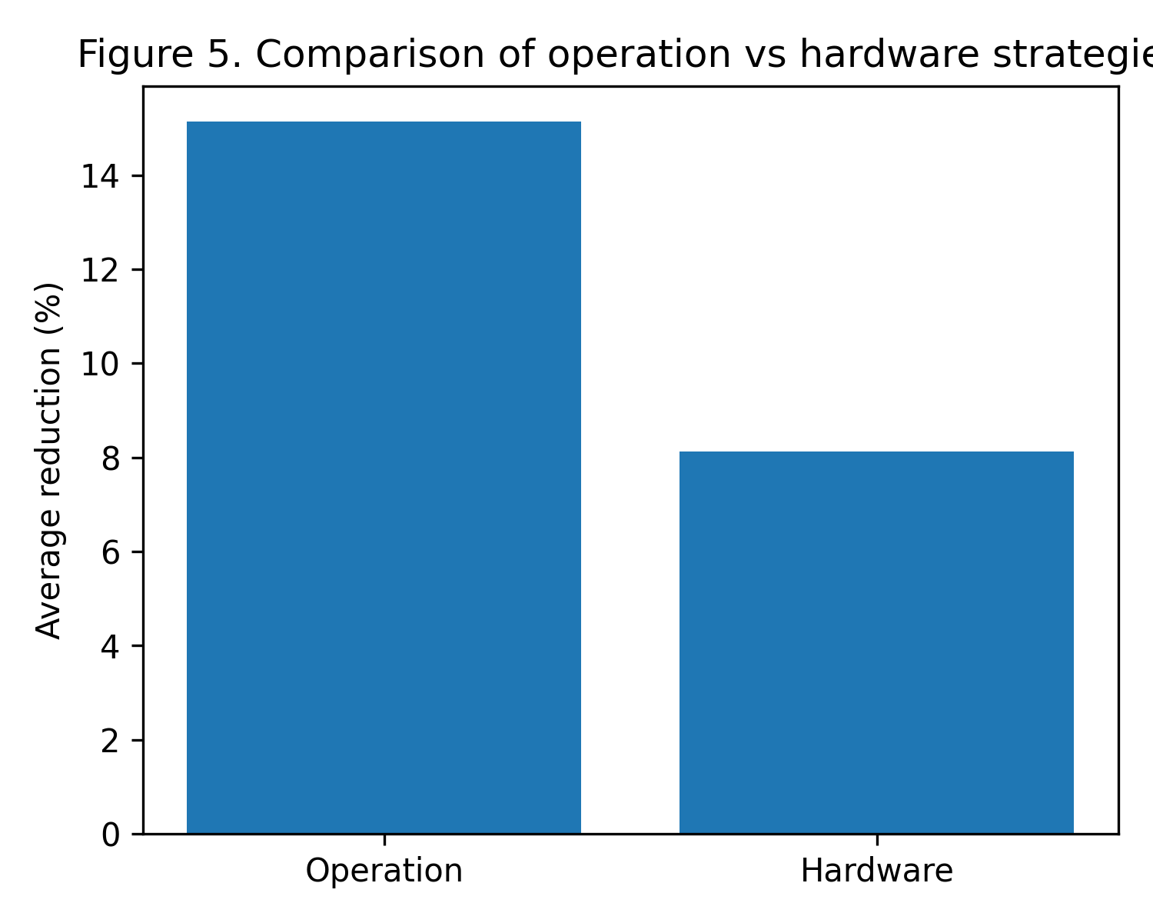
Figure 5 shows that operational strategies provide higher average reduction rates than hardware-based improvements.

Figure 6. Scenario profile
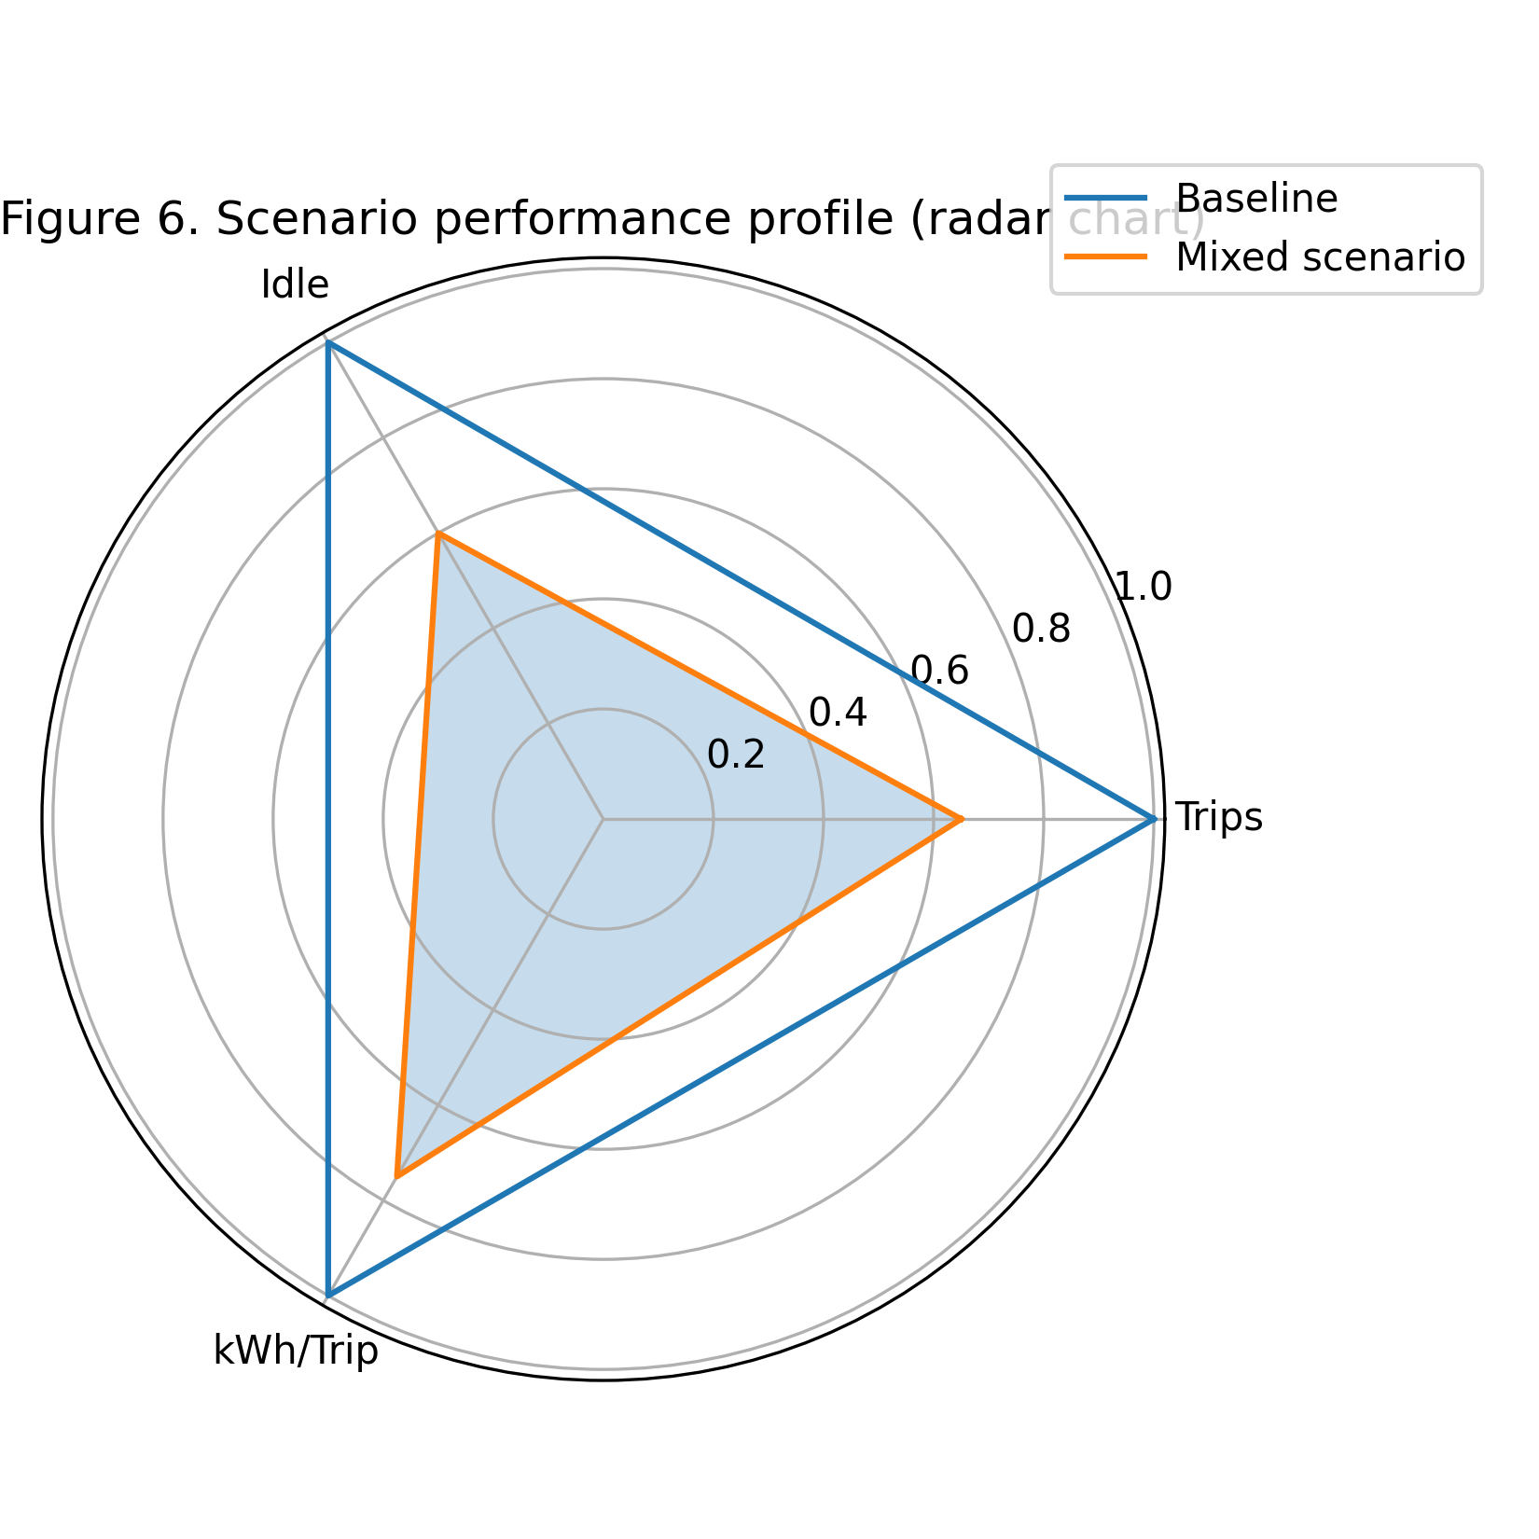
Figure 6 summarizes multi-dimensional performance changes, highlighting the dominant contribution of idle and trip reductions.

Figure 7. Building-scale effect
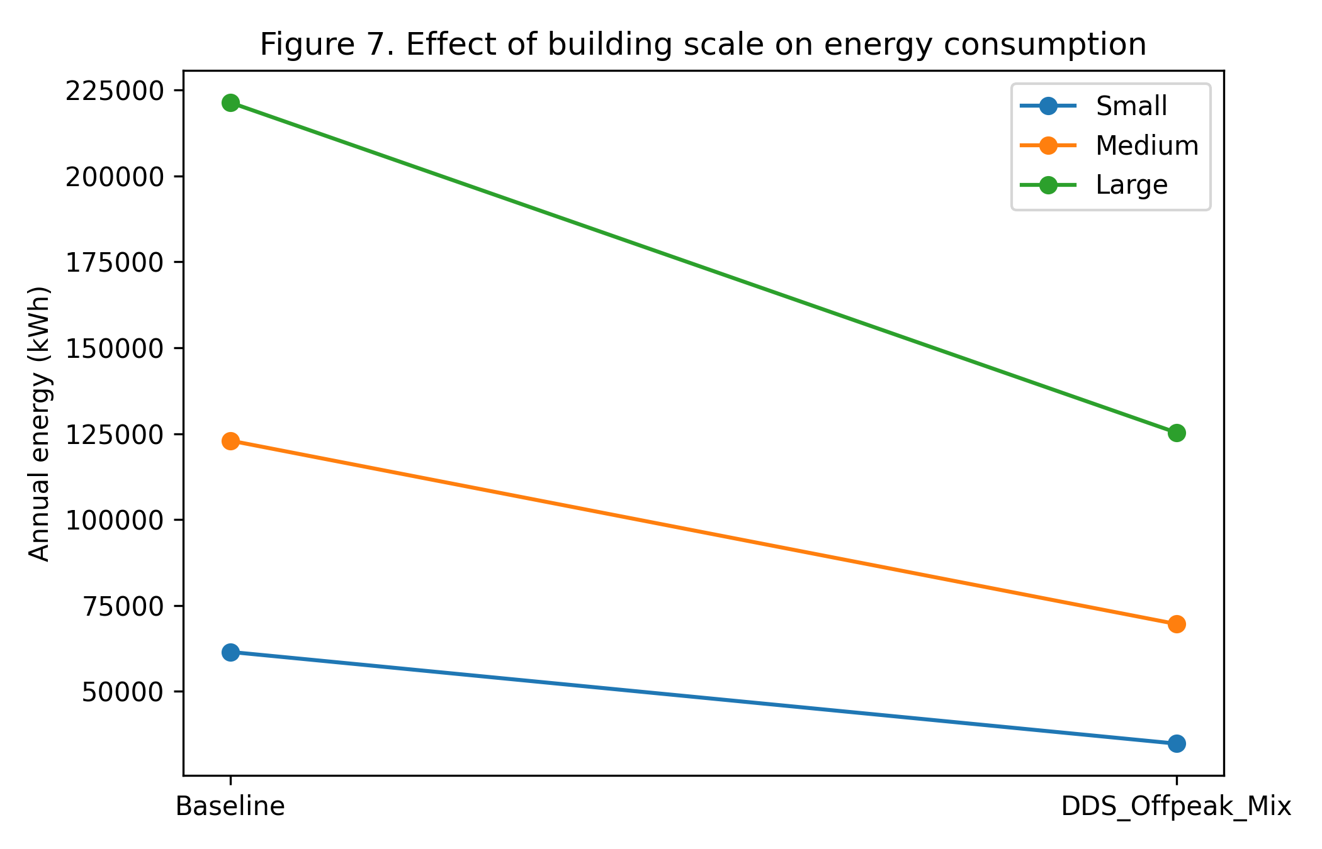
Figure 7 shows that while relative reduction rates remain similar, absolute energy savings increase significantly with building scale.

Figure 10. 건물 규모별 엘리베이터 에너지 소비 비교
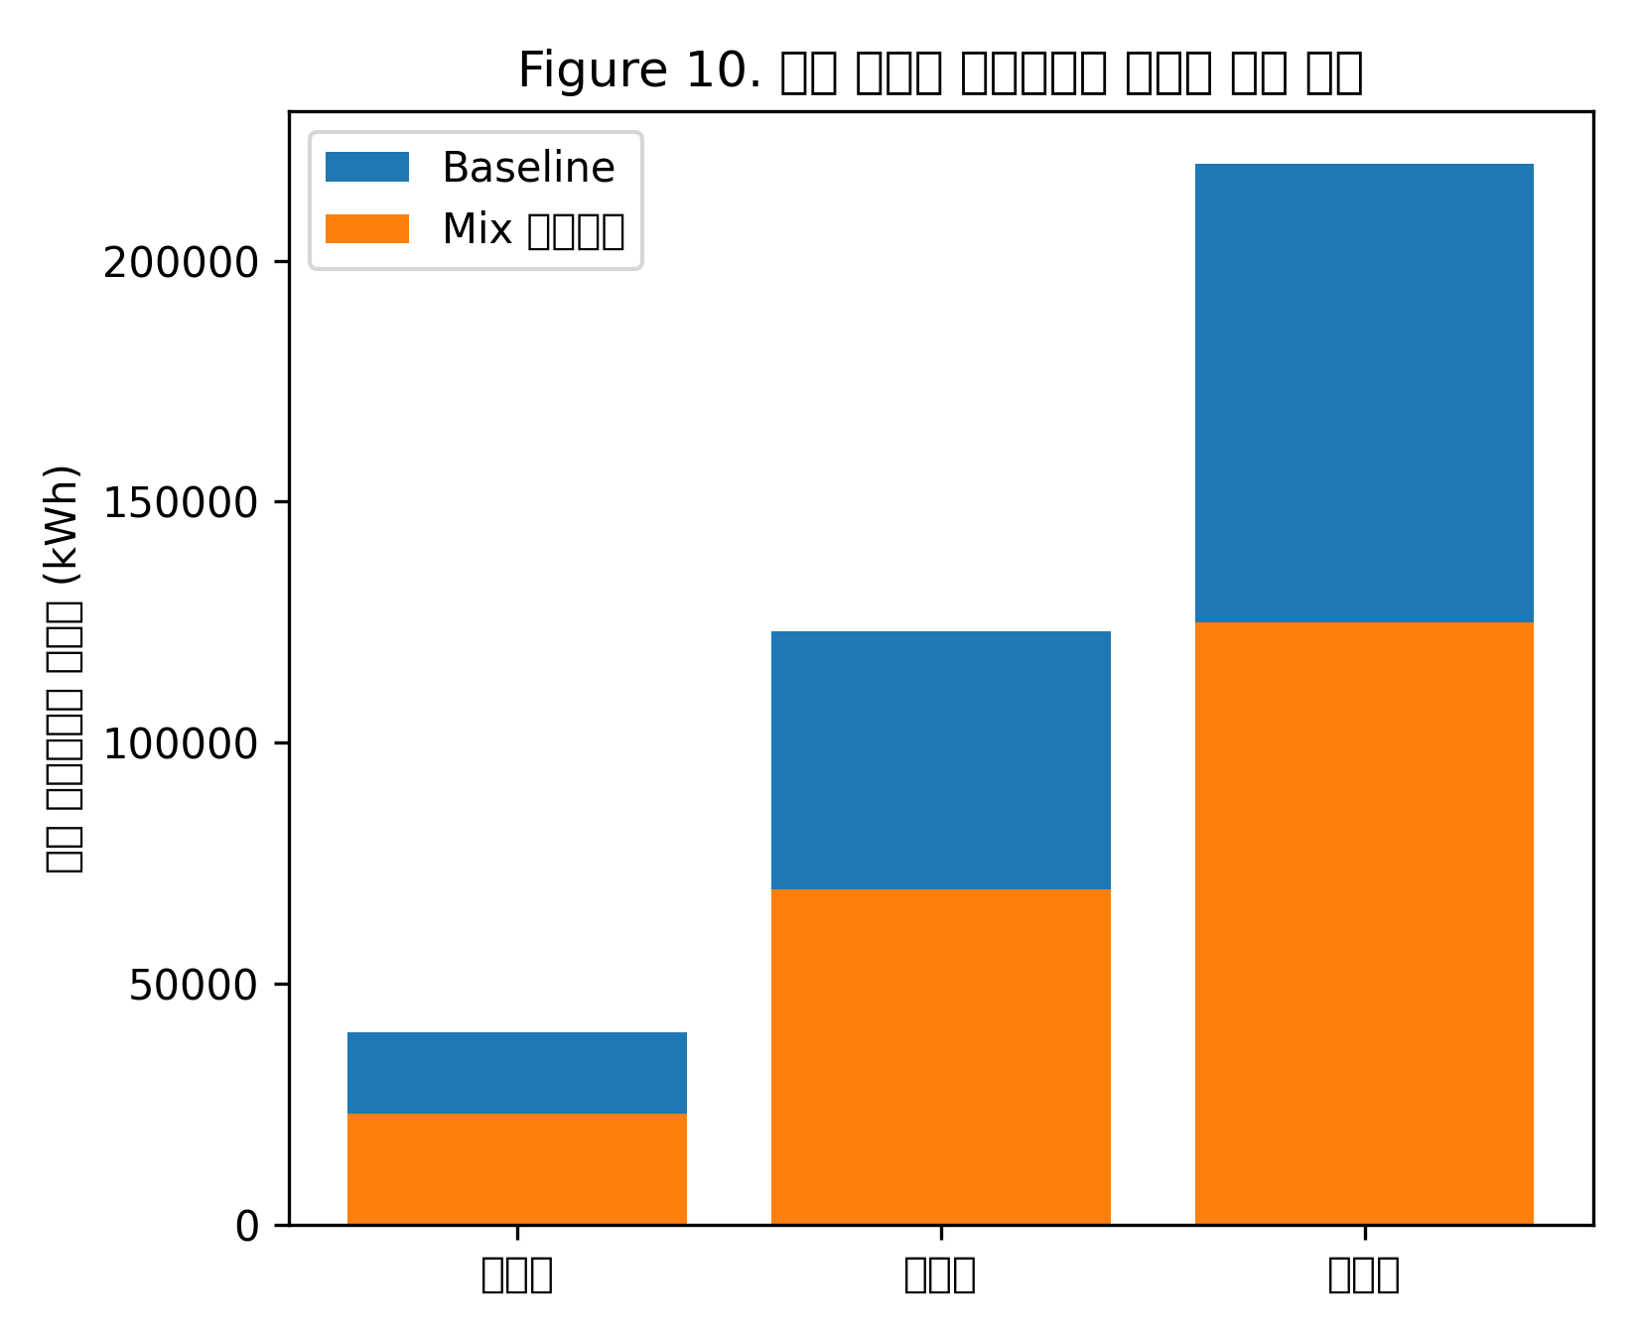
Figure 10은 건물 규모에 따른 엘리베이터 에너지 소비량을 Baseline과 Mix 시나리오로 비교한 결과이다. 건물 규모가 커질수록 절대 절감량이 크게 증가하며, 대형 건물에서 운영 전략 최적화의 효과가 더욱 중요해짐을 보여준다.

Figure 9. 절대 절감량과 상대 절감률 비교
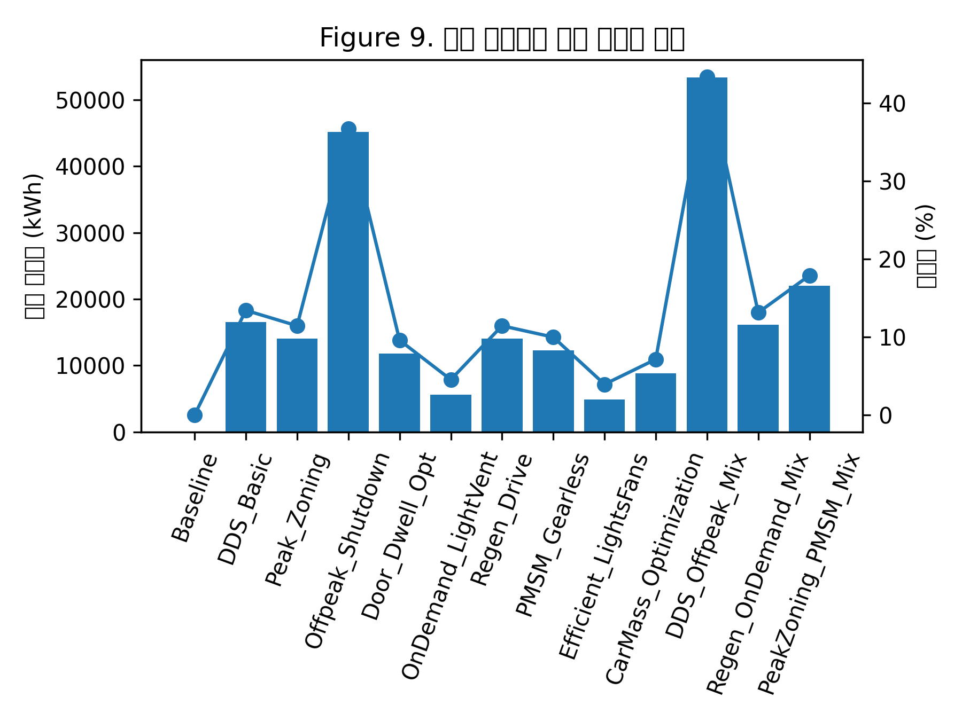
Figure 9는 절대 절감량(kWh)과 상대 절감률(%)을 동시에 비교한 결과이다. 절감률이 유사하더라도 절대 절감량은 시나리오별로 큰 차이를 보이며, 이는 실무적·경제적 관점에서 중요한 판단 기준이 된다.



