“Virtual Replicas: AI Counterparts Transforming Healthcare Horizons”
Artificial Intelligence-driven digital twins are becoming duplicates of human organs, patients and whole healthcare networks replicating real-time biological functions with remarkable accuracy. In healthcare these AI-based models process information, from imaging, wearable devices and genetic profiles to replicate activities, forecast results and evaluate treatments before applying them to a real patient. Beginning as code and data they ultimately preserve lives by transforming unpredictability into insight.
Within cardiology AI replicas reconstruct beating hearts using echocardiograms and stress tests enabling surgeons to practice valve repairs or stent installations on patient models. A complicated scenario could uncover blockages not seen on scans or forecast how blood circulation changes, after surgery reducing operative dangers. Oncology experiences advantages: tumour replicas develop under chemotherapy simulations assisting oncologists in choosing drug regimens that optimize tumour reduction while preserving healthy tissue.
For patients with conditions individualized AI twins monitor diabetes or hypertension continuously. Equipped with glucose measurements, dietary records and activity information the system predicts flare-ups days in advance recommending insulin adjustments or lifestyle changes through apps. This anticipatory feedback loop decreases emergency room visits proving especially beneficial, in India where non-communicable diseases burden healthcare facilities. In pandemics population-scale twins simulate virus transmission across areas enhancing the distribution of ventilators or vaccination efforts.
Surgical planning advances significantly well. Ai replicas model joint replacements considering bone density and walking patterns ensuring prosthetics fit flawlessly, from the start. In neurosurgery brain replicas identify seizure regions using EEG data directing removals that protect speech and memory functions.
India’s healthcare system is poised to benefit. Amid its surge in imaging and genomic projects AI twins might decentralize knowledge—allowing rural radiologists to seek advice from urban counterparts or enabling AIIMS to educate trainees using simulated cases rather, than real patients. Startups are testing twins to track TB development in affected regions linking them with the Ayushman Bharat Digital Mission to ensure smooth data exchange.
Caution moderates excitement. These twins rely entirely on their data: partial profiles from marginalized groups lead to errors possibly distorting care for women, the indigenous communities. Excessive confidence, in simulations may cause complacency overshadowing expertise developed through years at the bedside. Cybersecurity is a concern—compromised twins might reveal genetic information or alter treatment strategies.
Ethical boundaries must take precedence: securing consent for data utilization conducting bias evaluations during model development and maintaining a ‘human-in-the-loop’, for decision-making. Medical education should integrate literacy instructing residents to verify digital forecasts alongside pulse checks and intuitive judgment.
Regulation trails behind innovation. International organizations advocate for standards that ensure twins support rather than replace doctor-patient relationships. In India combining ICMR supervision with NITI Aayog’s strategy could establish the nation as a center, for AI twins providing cost- models to Global South nations.
AI twins herald medicine’s next era: proactive, precise and personalised. By virtualising the body’s complexities, they free healers to focus on what machines cannot—the art of reassurance, the nuance of empathy and the wisdom of ‘first, do no harm’.
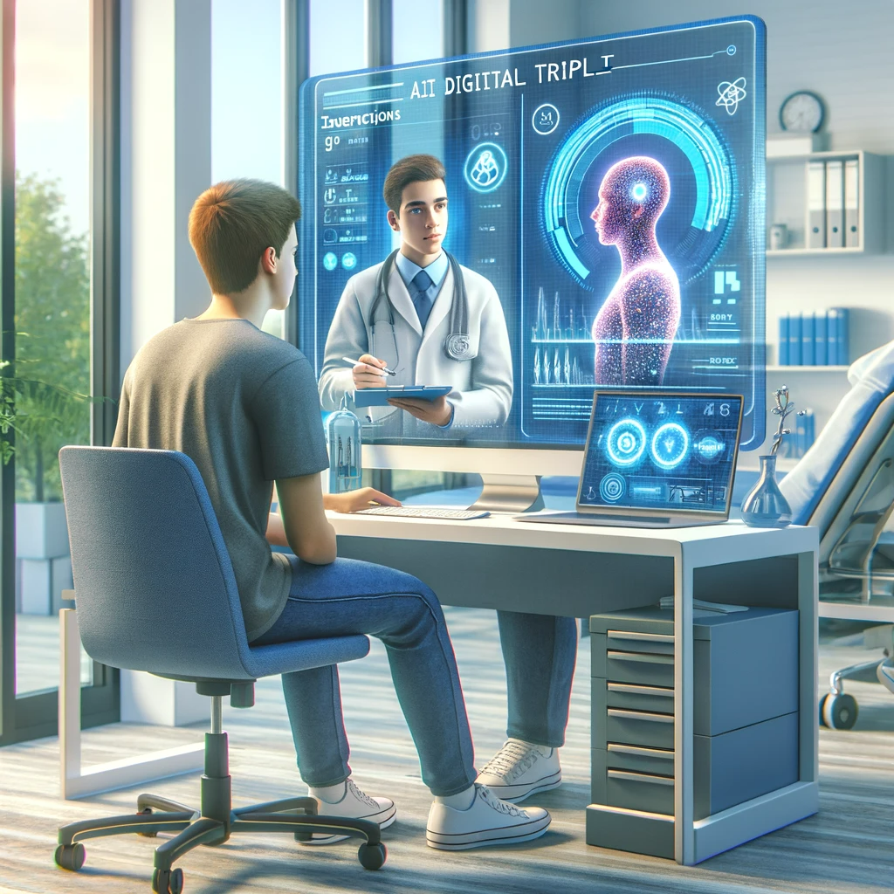
Source: Internet source - koenkas.com

