Chapter 1: INTRODUCTION

  - INTRODUCTION

A building provides its inhabitants with a protective enclosure. Adapting to the local climatic requirements, houses built in each region differ in their material, design, orientation, and form. This function has been played by vernacular architecture at various places for ages by providing a comfortable indoor environment. As Pellegrino, Simonetti and Chie (2015) observes, the more mechanical air-conditioning devices have developed, buildings have become proportionately more dependent on HVAC devices to achieve artificial comfort levels. In conjunction to the previous observation Nayak and Prajapati (2006) classified building stocks broadly into two types based on their indoor thermal condition, viz. conditioned and non-conditioned.

As per the Climate Change 2023 Synthesis Report published by IPCC (2023), an average global temperature rise of 1.09 degreeC has been observed in the decade 2011-2020 over the base period of 1850-1900. This phenomenon has become observed more intensely in the urban areas where the heat effect has concentrated within smaller areas of the city creating the Urban Warming effect as coined by IPCC. The report also observes that – “In urban settings, climate change has caused adverse impacts on human health, livelihoods and key infrastructure (high confidence). Hot extremes including heatwaves have intensified in cities (high confidence), where they have also worsened air pollution events (medium confidence) and limited functioning of key infrastructure (high confidence).” (IPCC, Climate Change 2023 Synthesis Report, 2023, Pp-50).

The map given in Fig. 1 is part of the – IPCC Sixth Assessment Report - Regional Fact Sheet – Urban Areas (2018) and shows that several urban centers around the globe are undergoing an annual rise in their average temperature. Among these urban centers the city of Kolkata is experiencing this phenomenon of “urban warming” at the highest level. The average temperature of the city has increased by 2.6 degree Celsius over the past sixty-eight years (1950-2018). Of which, the urban area is responsible for an approximate 86% and the surrounding hinterland accounts for the rest 14% of heat contribution (Fig. 1.1).

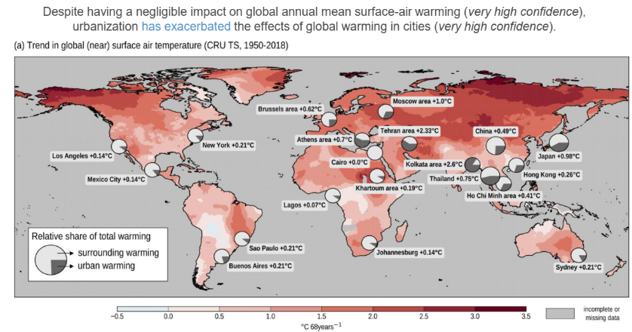

Fig. 1.1: Trend in Global Surface Temperature 1950-2018
Source: IPCC Intergovernmental Panel on Climate Change - Sixth Assessment Report - Regional Fact Sheet – Urban Areas

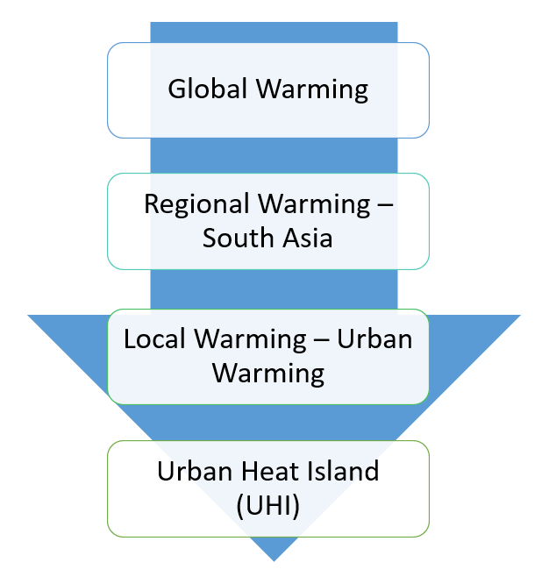

Fig. 1.2:Spatial Scaling of Thermal Change Phenomenon
Source: Author

The phenomenon of global warming, as is seen from Fig. 1.2, scales down spatially into smaller scales and takes various forms of problems. However, the problem never abates in any of these spatial levels.Studies reveal that at any level, the problem of warming is directly influenced by the built environment of settlements (IPCC, Climate Change 2023 Synthesis Report, 2023, Pp-50).

The urban heat island phenomenon, which serves as a trap for atmospheric pollutants, deteriorates the quality of life and has a socio-economic impact in the urbanized areas (Rajagopalan, P. et.al., 2014; Santamouris, M. et.al., 2001; Santamouris, M. et.al. 1998; Taha, H., 2004).In urban areas, too much reliance on mechanical HVAC systems may harm the environment in two ways: first, CFC gases release into the air, depleting the ozone layer, and second, buildings that are poorly designed and heated up can lose their internal heat into their external environment, contributing to the growth of urban heat islands (Mitra, S, 2018).

A primary objective of the Smart City Mission launched in 2015 by the Ministry of Urban Development, Government of India is to promote sustainable development and green building. Sustainable Environment is the eighth of the ten Core Infrastructure Elements discussed in Article 2.4 of the Smart City Mission document (Mohan, M. et.al., 2022).The document also includes "Energy Efficient and Green Building" as one of its twenty-one Smart Solutions proposed under Article 2.5.As a result, architects and planners alike have a responsibility to take all feasible steps toward a sustainable built environment.

As per the IPCC Intergovernmental Panel on Climate Change - Sixth Assessment Report - Regional Fact Sheet – Urban Areas (Regional Fact Sheet),the three main factors that contribute to amplify the warming of urban areas are:
- Urban geometry
- Human activities
- Construction Materials

The three above thrust areas also corroborate with the indoor thermal condition and thermal performances of a building and thus influence the thermal comfort of a built environment. The land use distribution for the city of Kolkata shows a total of 62% under residential use, which accounts for 73% of the total built up structures (Nath & Acharjee, 2013). It is therefore imperative that to improve the urban heating of a metropolis of the scale and urban nature as of Kolkata, a large onus comes on its built environment or more specifically on the residential built environment of the city and hence, the responsibility lies with the decision makers related to this, i.e., the architects, city planners and bureaucrats.

This dissertation therefore aims primarily at improving the thermal comfort condition of the city of Kolkata, the need of which is by far established, by considering the residential buildings of Kolkata as its research domain because of the large share of residential land-use in its built environment.

  - THERMAL COMFORT AND ITS NEED

Abraham Maslow, first in his paper titled “A Theory of Human Motivation” proposed the concept of Hierarchy of (human) Needs (Maslow A. , 1943) and further developed it in his book “Motivation and Personality” (Maslow A. H., 1954). Szokolay in his book (Szokolay, 2014, p. 16) refers to the Hierarchy and highlights that “Thermal Comfort” is one of the basic or fundamental needs to human beings (Fig. 1.3).


Fig. 1.3: Abraham Maslow's Hierarchy of Needs
(Source: https://www.simplypsychology.org/maslow.html)

1.2.1 Conditioning of Building

Buildings provide a protective enclosure for its inhabitants. As each region has its own climate, the houses built therein also varies in their form, material, orientation and design to adapt to the local climatic requirements. For ages, vernacular architecture designed at different places has played this role extremely effectively by providing an insulated indoor environment for its inhabitants. However, since the development of mechanical air-conditioning devices, buildings have relied more and more on HVAC devices to induce an artificial comfort conditions within the built environment (Pellegrino, Simonetti, & Chie, 2015). Buildings under study for their indoor thermal condition are thus divided into two types – conditioned and non-conditioned (Nayak & Prajapati, 2006).

It is envisaged that too much reliance on mechanical HVAC devices in urban areas may harm the environment in two ways – firstly, by the release of ozone layer depleting CFC gases into air, and secondly, by draining the internal heat of the building, especially poorly designed and heated up buildings, into the outdoor environment and thus contributing in the built-up of urban heat islands (Mitra, 2018).

Smart City Mission undertaken by Ministry of Urban Development in 2015 takes up aspects of sustainable development and green building as one of its prime goals. Article 2.4 of the documents talks about ten Core Infrastructure Elements, where Sustainable Environment is the eighth one (Ministry of Urban Development, GoI, 2018). Moreover, “Energy Efficient and Green Building” is included as one of the twenty one Smart Solutions proposed in article 2.5 of the said document. It becomes a responsibility for architects and planners alike to take all steps possible to make the built environment sustainable.

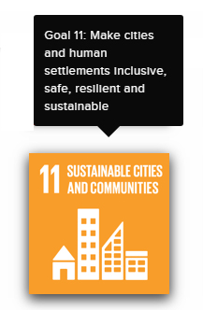
United Nations Development Program (UNDP) took up 17 Sustainable Development Goals in its Rio-de-Janeiro conference of 2012. The target date for achieving these goals was set as the year 2030. Of these, goal number 11 (Fig. 1.4) was to achieve “Sustainable Cities and Communities: Make cities and human settlements inclusive, safe, resilient and sustainable” (UNDP, 2012). Under this goal, UNDP has set forth ten targets that call for an increased awareness on energy usage vis-à-vis thermal performance of built environment (Fig. 1.5).
Fig. 1.4: UNDP Sustainable
Development Goal #11

Fig. 1.5: Targets for UNDP Sustainable Development Goal #11
- By 2030, ensure access for all to adequate, safe and affordable housing and basic services and upgrade slums.
- By 2030, provide access to safe, affordable, accessible and sustainable transport system systems for all, improving road safety, notably by expanding public transport, with special attention to the needs of those in vulnerable situations, women, children, persons with disabilities and older persons.
- By 2030, enhance inclusive and sustainable urbanization and capacity for participatory, integrated and sustainable human settlement planning and management in all countries.
- Strengthen efforts to protect and safeguard the world’s cultural and natural heritage.
- By 2030, significantly reduce the number of deaths and the number of people affected and substantially decrease the direct economic losses relative to global gross domestic product caused by disasters, including water-related disasters, with a focus on protecting the poor and people in vulnerable situations.
- By 2030, reduce the adverse per capita environmental impact of cities, including by paying special attention to air quality and municipal and other waste management.
- By 2030, provide universal access to safe, inclusive and accessible, green and public spaces, in particular for women and children, older persons and persons with disabilities.
- Support positive economic, social and environmental links between urban, peri-urban and rural areas by strengthening national and regional development planning.
- By 2020, substantially increase the number of cities and human settlements adopting and implementing integrated policies and plans towards inclusion, resource efficiency, mitigation and adaptation to climate change, resilience to disasters, and develop and implement, in line with the Sendai Framework for Disaster Risk Reduction 2015-2030, holistic disaster risk management at all levels.
- Support least developed countries, including through financial and technical assistance, in building sustainable and resilient buildings utilizing local materials.

The above discussion clearly points at the requirement for promoting non-conditioned buildings in the city, especially its residential sector as it accounts for majority of the built environment. This would thus take care of the following benefits:
- Occupants in non-conditioned buildings become more adaptive to climatic changes than those in conditioned buildings. The former group may not get into poor condition of health even in extreme conditions, whereas the latter group may vary easily fall prey to slightest changes in their indoor thermal condition (Manu, Shukla, & Rawal, 2014). This is more so because the conditioned building mostly take into account the static model of comfort proposed by comfort standards proposed by ASHRAE 55 or similar codes (Rawal, 2018).
- Buildings occupy more than 40% of the primary energy consumption of the world (Manu, Shukla, & Rawal, 2014). India is no exception to this and conditioning of building accounts for 8% of the total expense on power consumption (Rawal, 2018). The income disparities of Indian population has grown drastically, where the top 1% of the population (in terms of their wealth) has seen a steady increase of over 5% since the turn of the millennium, whereas the bottom 50% in the income table has seen a sharp fall of almost the same 5% during the same tenure (Income Distribution:India, 2019). The constant rise in thermal discomfort of the urban centres affects this lower 50% of the population, who can afford no better than the minimum comfort of basic housing – circumstances that deny the indoor comfort of conditioned houses.
- It would also help achieve the goals of Smart City Mission of Govt of India.

  - INTRODUCTION TO THE CITY OF KOLKATA

Kolkata, erstwhile Calcutta, is a city where major urbanisation and building activities have started with the inception of British occupancy of India (Taylor & Lang, 2016, p. 23). The pre-Independence architecture of Kolkata can be grossly divided into two parts (Bose, 2008, p. 1):
- Buildings belonging to the European quarter of the city
- Buildings belonging to the Non-European (Indian) quarter of the city

Although the initial European buildings have been designed with the architectural tradition of occidental design guidelines, the Indian buildings had a pre-colonial legacy of Hindu and Islamic buildings which they continued to follow. With time, the architectonics of the European designs infused into this Indian tradition to introduce the new Indo-Occidental Colonial style of Calcutta that was its own.

Hence, colonial architecture of the buildings owned by the Indians has distinctly different design principles from those owned by the Europeans. Two factors lie responsible for this, one of which was the design requirements of the buildings based on the difference of lifestyles between Indians and Europeans, and the other one is the old legacy as discussed above(Bose, 2008, p. 3).

The city of Kolkata, since its inception from the three villages of Sutanuti, Kolikata and Gobindapur, has grown drastically and became the second largest city of the British empire (Nair, 1990, p. 12). Although population expansion in Kolkatahas slowed down over the last two decades (1991-2011)(Stevens, 2017) than was ever envisaged since Independence (1947),the building activity of the city is fast flourishing under the tremendous need of housing stock that is still required. The city now thrives with new built developments of commercial, public and residential nature. Recent architectural practice in Kolkata has created a trend of designing public and commercial buildings in glass facade, while the residential condominiums are relying more and more on the RCC frame with indiscriminately placed glazed openings in them.
“In contemporary Kolkata the skyline is broken in some areas by skyscrapers and tall multistory blocks. The cityscape has changed rapidly. The Chowringhee area in central Kolkata, once a row of palatial houses, has been given up to offices, hotels, and shops. In northern and central Kolkata, buildings are still mainly two or three stories high. In southern and south-central Kolkata, multistoried apartment buildings have become more common.”(Sinha & Banerjee-Guha, 2018)

1.3.1 Climate of Kolkata

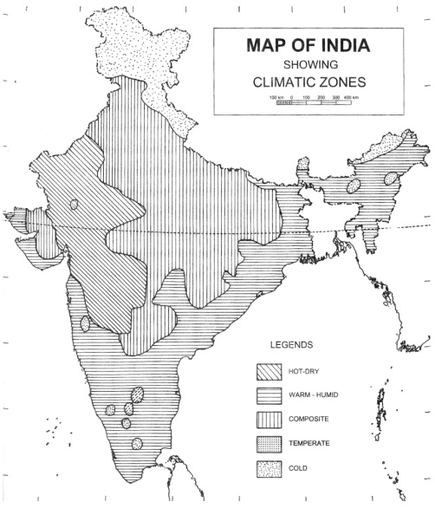
The climatic zoning map of India as proposed in the “Handbook on Energy Conscious Building” (Fig. 1.6) reveals most of the country falling under hot regions having extreme summer conditions. These zones, during the three long months of summer in India, suffer from the extreme heat conditions and it becomes further un-bearable when the condition of high humidity level couples with it. For last few decades, the hot metropolitan urban centres of India are getting warmer, and future predictions by the end of the century portray a very grim future for their residents (Sengupta, 2018).
Fig. 1.6: Climatic Zone Map of India
(Source: (Nayak & Prajapati, 2006)
As per the climate map in Fig. 1.3, Kolkata comes under the warm humid zone. The city and its hinterland not only suffer from very high temperature (above 43 degree C), but is also subjected to high level of relative humidity (within a range of 60 – 85%) (Fig. 1.7 – highlighted cells). The resulting effect of these two factors combined together becomes extremely uncomfortable for the population of the city.

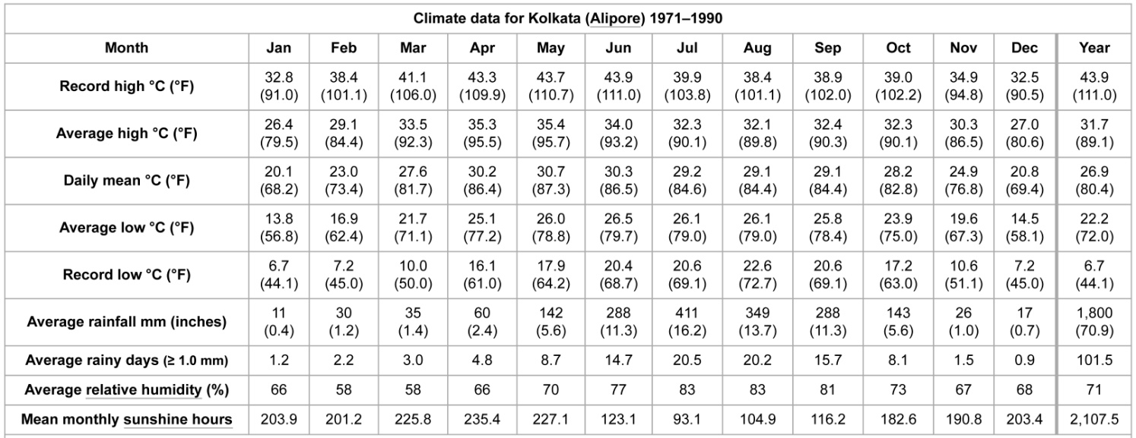
Fig. 1.7: Climate Condition of Kolkata
(Source: https://en.wikipedia.org/wiki/Climate_of_Kolkata#cite_note-NOAA-8)

Although common weather conditions of the city does not remain so extreme as is seen in Fig. 1.7, the average outdoor temperature in the city has always remained high and above 34 degree C throughout the months of April to June during the years 2005-2015 (Fig. 1.8). The level of relative humidity over these years have also fluctuated, with few exceptional values (e.g. 55% in April, 2014), most of the months show RH level above 60% (Fig. 1.9). The average maximum temperature during the period of 2005-2015 is observed to be between 35 and 36 degree C, whereas the average RH level over this period lies between 65 - 70%. The maximum tolerance of temperature for relative humidity level of 65% is given to be below 30 degree C (approx 25 degree C) (Fig. 1.10). If a considerable air movement and a very low clo value is considered in this comfort condition (Chenvidyakarn, 2007), the adjusted Standard Effective Temperature (SET) comfort conditions give us a maximum tolerance of temperature to be 32 degree C approximately for a RH level of 65%, whereas for higher RH level of 70% this tolerance comes to around 31 degree C. The observed average temperature of the city of Kolkata is thus found to be well above both the un-adjusted as well as adjusted values given by the bioclimatic chart.

Fig. 1.8:Average Maximum Outdoor Temperature of Kolkata during 2005-2015
(Data Source: Alipore Station (42807), Regional Meteorological Centre, India Meteorological Department)

Fig. 1.9:Average Maximum Daily Relative Humidity of Kolkata during 2005-2015
(Data Source: Alipore Station (42807), Regional Meteorological Centre, India Meteorological Department)
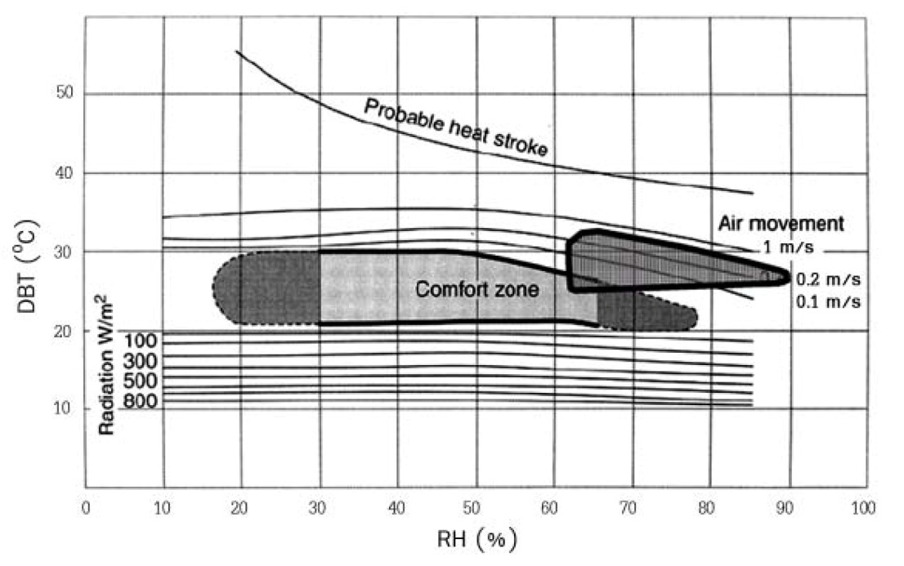
Fig. 1.10:Bioclimatic chart after V. Olgyay modified for SET (Chenvidyakarn, 2007)

1.3.2 Indigenous Buildings of Kolkata

Indigenous buildings, by virtue of being developed over prolonged period of time and thus respecting the local climate to a larger extent, are frequently found to be more climate responsive and thermally comfortable(Nayak & Prajapati, 2006). According to Lehmann, vernacular and indigenous buildings using traditional passive design principles perform better than the modern building stocks because of their “heat avoidance, the appropriate use of local materials, the use of natural cross ventilation and the harnessing of natural energies offered by the location” (Lehmann, 2011).

Kolkata, erstwhile capital of British Indian Empire as Calcutta, has a rich legacy of indigenous buildings that blend the traditional Indian architecture of medieval Bengal along with the European architecture brought in by the colonial British rulers (Taylor & Lang, 2016, p. 70). Before the inception of the trading houses of British East India Company, the city of Kolkata did not exist. In its place was a conglomerate of villages, hamlets and large tracts of marshes and forests (Das Gupta, 1990). Thus the new indigenous architecture that developed with the flourish of urbanization in Kolkata took a new shape and, according to Kamalika Bose on one hand (Bose, 2008) and Joanne Taylor on the other (Taylor & Lang, 2016), was a judicious mix of five architectural prototypes, viz –
- European residential architecture that followed the Palladian design to some extent
- Non-residential architecture of European quarter
- European bungalows that was an anglicized adaptation of Bengal hut
- Houses of rural rich of Bengal
- The design prototype of north Indian haveli, that came to Bengal with its Islamic rulers.

This indigenous architecture that took shape in late 17th and early 18th century Kolkata had some typical components, especially in the houses of the reach traders, landlords and administrative assistants of the British administrators. The design initiated from the sprawling mansions of the landlords of rural Bengal and initial mansions of Kolkata such as the palace of Maharaja Nabakrishna Deb Bahadur spread out in a similar manner over a vast tract of land. However, shortage of area and other socio-economic design needs later changed the design prototype into a more compact typology (Taylor & Lang, 2016, p. 177). The entire plan got divided into two broad parts – (a) Bahir Mahal or the Outer House and (b) Andar Mahal or the Inner House (Fig. 1.11). Both these portions of the house would be typically designed around a courtyard that would be the centre of life for the built spaces around.

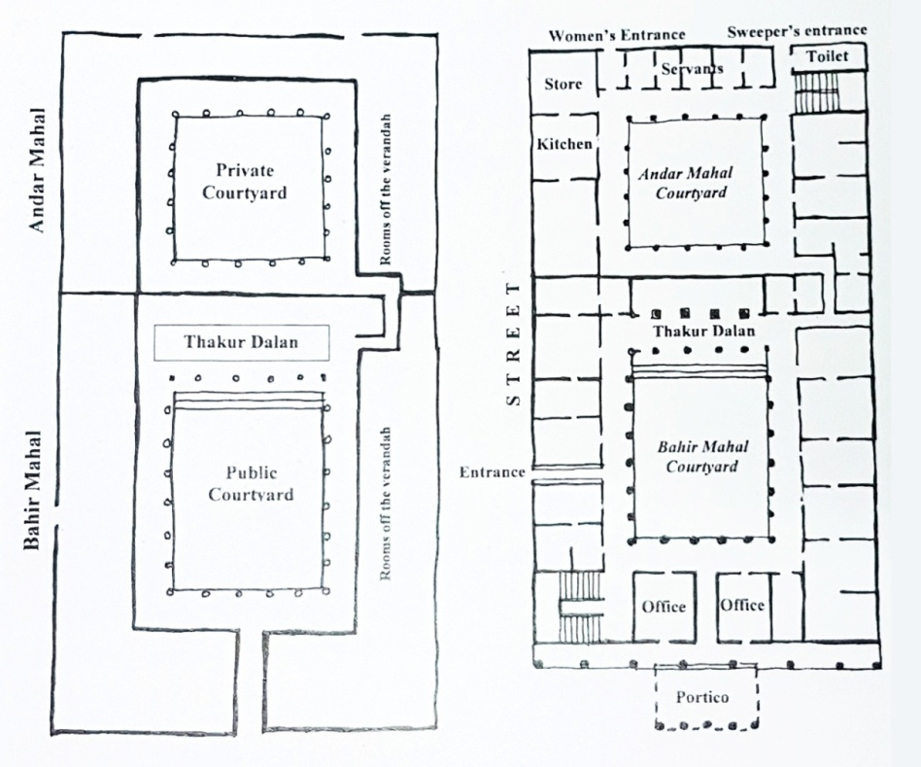
Fig. 1.11: Generic plan and sample generated plan of indigenous house in old Kolkata
(Taylor & Lang, 2016)

The outer court would hold more public ceremonies like Durga Puja, dance and music programs, staging of drama or other cultural program, apart from the regular mundane functions of conducting business of the traders or zamindars. More private functions, requiring active participation of the womenfolk of the house, such as marriage etc would be done in the inner courtyard and so would be the daily chores of life. Apart from serving their social and economic functions, these courtyards also served the climatic function of providing stack effect as well as wind effect to cool the rooms.

However, in the beginning of 20th century, certain events started transforming this design typology. These events had far reaching social, political and economic implications. It started with the partition of Bengal by Lord Curzon in 1905, followed by the shifting of capital of British India from Kolkata to Delhi in 1911. Then came the First and Second World War that hit the city economically. However, even at this time and till 1971 Kolkata was the largest city of India. But its economic degeneration had started with Independence and Partition of India, as is evident from the reducing rate of population growth since 1941-51. This had a profound effect on its architecture since the first decade of 20th century. Buildings became more compact, two courtyards first merged into one courtyard and then slowly vanished from the design altogether (Taylor & Lang, The Great Houses of Calcutta: their Antecedents, Precedents, Splendour and Portents, 2016, pp. 270-272). This has been illustrated in chapter 3 where the ten old buildings surveyed under this research have been briefly described. With the old design approach, their thermal comfort and heat avoidance features have also slowly vanished. It is the premise of many scholarly works on the indigenous architecture of Kolkata and other such cities that the new architecture does not have equal heat avoidance quality like the old indigenous ones.

Thus, this research intends to explore these indigenous houses of Kolkata and assesses their thermal performance against their modern counterpart to seek solution to counter-balance the growing thermal discomfort condition of Kolkata and other similar Indian cities.

It is noteworthy that IPCC (2023) in its report has observed that the phenomenon of global warming has increased particularly from the year 1970 onwards. This research therefore divides its sample study buildings into two parts – pre-1970, designated as Old buildings and post-1970, designated as New buildings.

1.4 RESEARCH GAPS

Thre following research gaps have been identified in the domain and the site city:

- Extensive comparison of thermal performances of old indigenous residential buildings with the new residential buildings of Kolkata on the basis of objective or non-perception indices can be carried out. This would establish whether designing of new residential architecture can learn and incorporate from the design and construction of the old residential buildings. This exploration has rarely been executed for the city of Kolkata.
This leads to the first objective of the research.
- There is a scope to assess and ascertain the contribution of each building component / parameter separately in the overall thermal performance of a residential building. This is to ascertain as to how exactly have modern building techniques or components contributed to worsening urban heat issues compared to the indigenous houses. It involves the correlation of each parameter with the overall thermal performance.
This leads to the second objective of the research.
- The set of parameters can be computed collectively into a composite numerical predictive model. This model would predict the thermal performance of a designed residence before the construction stage – thus providing scope to the architect and the client to make necessary amends in the design stage to reach an agreeable thermal condition in the building.
This leads to the third objective of the research.

1.5 AIM AND OBJECTIVES

1.5.1 Aim

This research aims at solving the urban heating phenomenon of an Indian city by first learning from the thermal comfort qualities of its old indigenous architecture and then incorporating these learning into the current architectural design process for design of the city residences.

1.5.2 Objectives

- To find out whether old indigenous residential buildings of Kolkata show better thermal performance than the new residential buildings of the city by comparing equal number of sample buildings from both old and new building types.

- To ascertain the degree of association between indoor thermal condition of old as well as new building with the physical factors affecting thermal condition.

- To establish a composite predictive mathematical model incorporating the building components to forecast indoor thermal condition of the design of a residential building.

1.6 SCOPE AND LIMITATIONS

The research was framed within the following scopes and limitations:

- The scope of the study includes measured drawings of ten sample old indigenous residential buildings of Kolkata mostly from the northern old neighbourhoods of the city (Fig. 1.12).
- These old residences studied should originally be designed for Indian occupants (and not any European occupant), so that the design takes into consideration the traditional lifestyle.
- The study also includes measured drawings of ten sample new residential buildings of Kolkata, mostly from the northern old neighbourhoods of the city (Fig. 1.12).
- Thermal data (temperature, relative humidity and wind velocity) is also recorded from these twenty sample residential buildings. For each sample building, thermal data for continuous 48 hours and hourly air velocity data would be collected.
- The research is limited to residential buildings of Kolkata, both before and after Independence.
- The study period for old buildings has been limited between 1851 (year on which glass and steel were being used for public building for the first time) and 1947 (the year of independence for India).
- The period of modern residences to be studied would span from 1970 (year of considering global warming as a potential threat and concern) till date.
- The study would also be limited to a sample number of residential buildings within northern Kolkata, and not an exhaustive study of all buildings. Thus, the study does not claim to represent the entire residential stock of the city of Kolkata, and only represents a selected set for the purpose of demonstrative research methodology.
- The study does not include any non-thermal source of heating such as noise or pollution, in its scope.

1.6.1 Delineation of Study Region

For the purpose of delineating and limiting study regions for the research, three zones have been designated within the city of Kolkata (Fig. 1.12)–

- Northern or Old Traditional City – the area between Mahatma Gandhi Road and Dumdum Road in present day city. The eastern boundary is delineated by Jessore Roadvand then CIT Road up to Sealdah.

- Central or European Quarter of the city – the area between Mahatma Gandhi Road on north and Acharya Jagadish Chandra Bose Road on south. The eastern boundary of this area is Acharya Prafulla Chandra Roy Road.

- Southern or the Newer City – northern boundary of this area is AJC Bose Road, APC Roy Road and Sealdah Station, whereas southern boundary is the South Suburban Railway track running south of the Ballygunge area and Rabindra Sarovar lake.
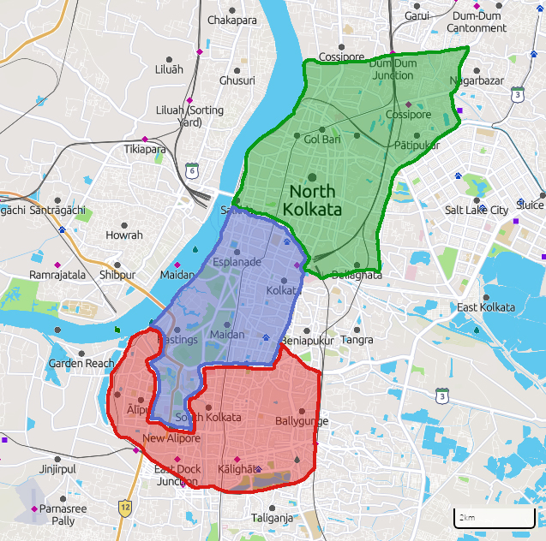
Fig. 1.12: Map of Kolkata showing delineation of research zones

1.7 RESEARCH METHODOLOGY

1.7.1 Step 1 – Choice of Research Techniques
Goal of the research is to find whether old indigenous residential buildings of Kolkata provide more indoor thermal comfort than new residential buildings. Further, if it is proven that old indigenous buildings actually provide better thermal condition inside then to ascertain the reason behind this phenomenon.

The human dependent psychological and behavioural aspect of thermal comfort has been taken as constant for this research as ceteris paribus. Hence, thermal comfort has been taken as indoor thermal condition that can be machine measured in terms of temperature and relative humidity. Thus, to exclude the subjectivity of respondent –oriented study, comfort zones in terms of adaptive comfort temperature (ACT) has been chosen (Szokolay, 2014). The ACT has been calculated on the average ambient temperature as described in standards (ANSI, 2013)(Nayak & Prajapati, 2006). Based on this comfort zone, the scales of Percentage Comfort Hour (PCH) and Comfort Factor (CF) (Nayak & Prajapati, 2006) have been used to assess the absolute comfort condition of each building. The time series temporal condition of each house (for DBT as well as Heat Index values) is then drawn and compared with the ambient condition. Parallel to this, the PCH and CF performances of the old and new buildings are also mutually compared, aiming at the final goal of the research to decide which group performs better. Conclusions are then drawn on this comparison.

The collected and calculated indices are then placed on a table along with the parameters. Correlation coefficients have been calculated between each pair of dependent and independent variable separately to ascertain the inter-dependability of the indices and parameters. Finally, the whole data table is put into a regression analysis for developing a linear regression equation to predict the thermal indices as function of the parameters.

Details of this are given under chapter 2.

1.7.2 Step 2 – Choice of Parameters and Indices

Thermal Comfort has two aspects – the physical condition of the building, its interiors and envelope, and the psychological and behavioural condition of the users within.

As this research is limited within the first scope, the indices and parameters have been chosen accordingly. The thermal conditions – both indoor and ambient – have been measured by the primary indices of temperature and relative humidity. Heat Index has been calculated as a composite index of these two indices.
Physical parameters and the nature of the data collected are as follows:
- Building Orientation – primary data
- Air Velocity – primary data
- Shading Device – primary data on depth, width of chhajha and their side overhangs
- Surface Volume Ratio – primary data on dimensions of room and openings
- Thermal Conductivity of Wall – primary data on thickness and materials of wall
- Thermal Conductivity of Slab – primary data on thickness and materials of slab
- Opening v/s Wall Area Ratio – primary data on dimensions of room and openings
Details of this are given under chapter 2.

1.7.3 Step 3 – Ascertaining Data Collection Time

Kolkata falls in the Warm and Humid climatic region, and theaim of the research is to probe into ther thermal condition of residences during heated months of summer. Hence, the summer season of April, May and June has been chosen for the study. The study has been done in two time phases of summer of 2016 and that of 2017.
Details of this are given under chapter 4.

1.7.4 Step 4 – Physical Survey of Houses and Measured Drawing

All the survey houses, as per permission of the owner / occupant, have been measured and their physical data as detailed under the parameters in section1.6.2 have been collected. Similarly, as permitted, these buildings have been photographed in detail.
Details of this are given under chapter 3.

1.7.5 Step 5 – Collection of Thermal Data

Thermal data have been collected with temperature and relative humidity data loggers in the manner specified in standards (ANSI, 2013). The details of the same have been discussed in chapter 4.

1.7.6 Step 6 – Collection of Time Series Data on Ambient Condition

The ambient data of the city of Kolkata has been collected as secondary data in two parts, viz –
- Time series daily data on Maximum Temperature, Minimum Temperature and Relative Humidity for ten calendar years including and before the conduction of the research (2013-2023).
- Hourly data on Temperature and Relative Humidity from 15 April till 15 June in 2021 and 2022.
Details of this are given under chapter 4.

1.7.7 Step 7 – Calculation of Composite Indices for Data Analysis

The research calculates three composite (or calculated) indices, viz, Heat Index, Adaptive Comfort Temperature, Percentage Comfort Hour and Comfort Factor.
Details of these calculations are in chapter 2.

1.7.8 Step 8 – Comparison between Building Interior and Ambient Condition

The indoor thermal condition of each building has been compared with the ambient condition on both whole time series as well as singular composite index.
Details of these are given in chapter 5.

1.7.9 Step 9 – Comparison between Old and New Buildings

The primary and composite indices for each building have been used to compare the old buildings with the new buildings by grouping them in two separate groups. In this, both inter-group and intra-group comparisons have been done to draw inferences.
Details of these are given in chapter 5.

1.7.10 Step 10 – Inference on Relative Performance of Buildings

Inferences are drawn step by step at each level of comparison of the building’s thermal conditions. Details of these are given in chapter 5.

1.7.11 Step 11 – Calculation of Dependability of Parameters and Indices

Finally, each building has been represented by the central tendency of their whole sample time series data of temperature and heat index values. These indices are then placed alongside their physical parameter data on a table. Each index is then correlated with the parameters one by one, and the correlation coefficients calculated.
Discussions of this is in chapter 5.

1.7.12 Step 12 – Design of Regression Equation for Composite Index of Temperature

The table mentioned in section 1.6.11 is then put through a linear regression analysis and the linear equation has been formed to represent the overall / composite association of the indices with all the independent parameters.
Detail of this is in chapter 5.

1.7.13 Step 13 – Conclusion

Finally, a conclusion has been drawn on basis of the analysis of the collected and computed data in chapter 6. In this, research questions have been briefly revisited in order to ascertain as to what extent they have been answered in the research. Utility of the method and the results in the field of architecture and the allied fields of city planning and city administration have also been mentioned. Future scope of work leading out of the research is also hinted at in this chapter.

The research methodology flow chart diagram is given in Fig. 1.13.
Study on Thermal Comfort Indices and Factors from
- Codes
- Standards
- Earlier work done in the domain
Study of Relevant statistical analysis tool(s)
Study of Earlier Work done and Identification of Research Gaps
Study of History of Urbanism and Architecture of Kolkata
Study of Current Affairs & Policies on Sustainable Development
Study of Secondary Data on Climatic Condition of Kolkata
Fig. 1.13: Methodology Flow Chart of the Dissertation

