CHAPTER 9

The Energy Hemorrhage: Plugging the Leaks
To build an “empowered lifestyle,” first look at why you feel heavy every Tuesday afternoon. It’s a state of lethargy—but not because you aren’t sleeping enough. It’s because you are suffering from a daily energy hemorrhage. How far can your car get you with a punctured gas tank that is leaking fuel? Your structure is currently leaking “emotional fuel” through four main punctures:

- Reactive Emotional Eruptions: The one who lives in the past. Those moments where you “lose it” and the anger pours out. The people pleaser: Or even worse, you hold in emotions daily to avoid problems. The worrier: This is not about judgment. You didn’t get the tools to understand these mental process’ or emotions. We will explore emotions and feelings. Then, we’ll look at how to change habits and patterns into new, healthy perspectives. A perspective is a very powerful tool—changing one’s thoughts serve as a domino effect. It holds significant weight. It can disrupt habits, fears, and illusions by shifting our path, even if just by one degree.

- Unnecessary Anxiety & Stress: The mental loop of “what ifs” that grinds your gears 24/7. Work deadlines, school pressures, kids, endless chores, and mindless worries can pile up. These worries often appear without reason. And worst of all, the abundant flow of propaganda that overwhelms our senses. As a child, you faced threats of punishment for misbehavior. You missed out on a caring explanation of the consequences instead. This is only the beginning of the social and religious fear-based bombardment tactics. As adults, we face constant fear-based propaganda from the media. Then, there are friends and family who buy into this too. They serve to remind us that we should live in fear every day.

- Social & Environmental Leeches: People and places that don’t just annoy you. But withdraw energy from your personal account. Relatives, family, and friends that always seem to need a helping hand or an ear to listen. They repeat the same old conversation over- and-over again. Regardless of the many solutions you provide. Our kind nature does not go unnoticed. Leeches of the world have a radar, and they see us a mile away. Your time is valuable, and it is up to you to create boundaries. If you want to help others, ask yourself: What do I need from them? Are they a mirror of wounds I need to heal? How was I affected by being unseen, rejected, or abandoned growing up? How did you feel being the caretaker of your siblings? Your parents? Were you bullied at home as a child? Did this create a need to control others?

- Misuse of Sexual Energy: A waste of your creative force by careless or wrong expression. This concept has nothing to do with judgments. The key here is to bring conscious awareness to your personal energy leaks. And decide where you want to go from there. I will continue to elaborate on this matter in the next section.

.
Reflection
Be the Observer. When you first wake up in the morning close your eyes and feel within. Stop for a moment and ask yourself, do I sense anxiety, stress, or fear even when there’s nothing relevant going on? What is my internal world trying to tell me this morning? Before I fall asleep?

Nuclear Energy & The Big Bang: The Fourth Leak
We must talk about the most potent fuel in your vessel: Sexual Energy. George Gurdjieff often spoke of the "mechanicalness" of man. And nowhere is that more evident than in our sexual center. Nature has a very simple agenda: procreation. It has equipped us with a drive so powerful it can literally spark a new life into existence. But here is the catch. Nature doesn't care about your "equilibrium" or your personal development. Once the drive is there to ensure the survival of the race, nature leaves the "manual" blank.

The Nuclear Reactor
Think of this energy like nuclear power. In a controlled setting, it can brighten a whole city—your life, your creativity, your energy. But when it is "leaked" or misused, it becomes a radiation burn or burnout. When I speak of sexual misuse, I am not talking about morality, sin, or religious "rights and wrongs." I am talking about The Bleeding of Power.

The Empty Big Bang
An orgasm is, in its own way, a localized "Big Bang." It is a massive discharge of creative frequency. But when we fantasize or view pornography, we’re setting off that Big Bang into "nothingness."
- The Void: When you unleash that much power into a vacuum, you don't get "long-lasting pleasure." Instead, you face emptiness—and you might not even realize it!
- The Scale: Look at the Dashboard (Our Relationship with Emotions). After the "high of desires" the fantasy fades, the needle almost always crashes into Shame (20) and Guilt (30). This is the "Energy Hemorrhage" in its most violent form.

Stopping the Bleed
This isn't about becoming an ascetic or a monk, not even celibate for the sake of whatever. This is about recovering your power.
- Observation: When you feel the urge to "leak" energy through pornography and undirected meaningless masturbation. Is the urge out of a genuine connection. Or is it a mechanical and habitual pattern to reaction. boredom, stress, or loneliness?
- Conservation: When you stop that energy from leaking into a fantasy or a “mindless” escape. You're keeping the "Nuclear Fuel" inside the submarine. Literally, it means more power to you!

When directed properly, that fuel undergoes transformation instead of remaining inactive. It becomes the stamina you use for your virtues. The clarity you use for your Core Being. The vision and clarity to create in the arts. In your career or building your business. And the vitality that keeps you youthful and healthy.

"These drives are necessary for the existence of the human race. Guilt and shame do you no good. You're a captain with a nuclear-powered engine, but no instruction manual. To stop the bleeding is to finally reclaim the very energy that creates worlds."

If you have a partner, are you seeking a true connection, a strong base, or a way to revive your relationship? The Golden Helix supports long-lasting relationships. It unifies and strengthens you as a couple when feelings of connection fade away after sex.
Those of you who are not interested in this method may want to continue to chapter 10. However, the Golden Helix practice serves as a reconnection to the self when used on its own as a meditation.

Transmuting the Wave
If we accept that sexual energy is "Nuclear Fuel." We must learn how to let the reactor heat up without letting it melt down. We are looking for containment, not suppression.

The Secret Ingredient: Golden Helix the Lightness of Being
The following sections are guides, images, mantras, and instructions on how to transmute sexual energy into vitality. A Powerful Practice for Energy Transmutation, Vitality, & Equilibrium

Many seekers approach energy work with a heavy sense of solemnity. We prepare ourselves, focus hard, and treat the spirit's movement like a tough job. But energy—especially the Golden Helix—is a living, dancing force. It does not respond to tension; it responds to flow. In this practice, your greatest ally isn't just your breath—it’s your smile.

“The angels fly because they take themselves lightly.” — G.K. Chesterton

Quick Tips for Success
Dissolving the Confused Ego: The lost ego loves to be serious. It loves to "do it right." Add a bit of play. A calm visualization or a fun thought can help you skip your ego’s judgment.

The Physical Opening: When you laugh or smile, there’s a moment of genuine "lightness." Your nervous system shifts from "Fight or Flight" to "Rest and Digest." This opens the physical channels through which energy travels.

High-Vibration Resonance: Joy is one of the highest measurable emotional frequencies. Start your practice with a light heart. You’re not just moving energy; you’re upgrading it before it reaches your Crown.

Memorability: I don’t want this to be a "serious" practice. Allow the Froggie image to place a smile on your face. Even if it is just a simple Mona Lisa smile.

Focus on Sensation: When you have your eyes closed. The Helix image doesn't have to be perfect. The feelings of warmth & depth of each center or tingling are more important. Whether you are doing this as a daily meditation or for the sexual transmutation.

Posture: Because you focus on the sexual transmutation, the position will vary. A straight-up posture is best for regular meditation. Either way, be comfortable. Lying on your back or sitting, you will figure it out. Remember, make it fun and workable for you.

Solo or With Partner: This practice works either way. But it will be a greater challenge with a partner.
Interactive Image: I’ve made an image to support your meditation steps. Froggie will be there to help you smile! You’ll find it right after the Golden Helix: step-by-step instructions below.
As you go through the Golden Helix, remember. The goal is to be a smooth channel of grace, not a stiff statue of enlightenment. Whether you focus on the forest's light or giggle at life’s absurdity, you’re doing great.

Pre-Meditation: The Playful Practice - Tips for High-Vibration Flow

1. The "Inner Glimmer." Smile before starting the Golden Helix practice. Picture a tiny,
glowing spark in your brain (the pineal gland). Now, give it a little "Mona Lisa" smile.

The Secret: Turning up the corners of your mouth tells your nerves to relax. It’s tough to feel stiff when you're smiling inside.

- Dress the Energy. Energy doesn’t have to be "golden" every day. While gold is a classic, play with your soul's palette.
Feeling Tired? - Picture the helix as a bright emerald green for healing.
Feeling Stressed? - Visualize a calming sapphire blue rising to your heart.
Feeling Creative? - Imagine the strands as fiery electric orange.
Author’s Note: The energy knows where to go; the color just makes it fun.

- Reality Check: If you’re "trying too hard"—furrowing your brow or holding your breath—stop. Look at the meditating Froggie on a lily pad.
The Practice: Laugh at the silliness. That one chuckle will drop your shoulders and reset your nerves. This allows your energy to flow freely.

- Soundtrack Your Spirit. If it pleases you try different "soundscapes" for your 2–3 cycles. Or you may prefer perfect silence. You can also try:
One session in total silence, just the sound of your breath.
Another with running water or birdsong.
Notice how the Golden Helix changes with each tune.

"Equilibrium is not a serious destination; it’s a joyful homecoming. If you’re not enjoying it, you might be holding your breath. Exhale, smile, and let the helix work for you."

The Golden Helix
A Practice for Energy Transmutation, Vitality, & Equilibrium
Step-by-Step Guide

Author's Note: See the Golden Helix Image first. This practice is for solo or partnered sessions.

The goal is NON-Release. It’s designed to redirect and circulate energy into transmutation. Follow these steps for 1-2 cycles.

Begin here:
**Pre-Phase:** Start by increasing your sexual energy. Then, pause at the peak moment of excitement. Then direct that energy as instructed below:

For simple & quick instructions check out the 4 Point Flow “Mantra” on the next 2 pages.
Phase 1: Redirection
- The Pause: Stop your physical movement at the "non-release" point.
- The Ascent: Picture golden strands of energy flowing from your base to your heart. Then, they rise to your pineal gland, then your crown (top of head).
- The Intake: As energy flows to your crown, take a deep breath. Picture pure energy entering through your head.

Phase 2: Circulation
- The Descent: Visualize those golden strands, now full of energy, flowing back to your heart.
- The Root: Send the energy down to your pelvic area.
- The Expansion: Release the energy into your whole body.

Phase 3: Integration
- Breathing: Take deep breaths at your own pace, feeling the energy settle.
- Repetition: Repeat the cycle 2–3 times.
- Stillness: Sit or lie down in total relaxation. Feel the sensations in your body for a few minutes.

The Scale: Look at the Dashboard (Our Relationship with Emotions). After the "high of desires," the fantasy fades; the needle almost always crashes into Shame (20) and Guilt (30). This is the "Energy Hemorrhage" in its most violent form. For the most part, it is not acknowledged.

The 4-Point Mantra
Visualization. Step-by-Step Instructions
PHASE | ACTION | BREATH & VISUALIZATION
1. Redirection | At "non-release," stop physical movement. | Visualize golden helix strands rising.
2. Ascent | Energy hits the Heart, then the Crown. | Take a Deep Breath in; see the force enter the crown.
3. Circulation | Send the charged gold back to  the Heart. | Exhale or hold as needed, guiding the light down.
4. Release | Reach the pelvic area and let it explode outward. | Take many deep breaths at your leisure.
Repeat the cycle 2–3 times.

Integration & Rest
After your final cycle, sit or lie down in stillness.
- Duration: 2–5 minutes.
- Focus: Quiet awareness of the energy vibrating in your entire body.
- Goal: Pure enjoyment and relaxation.
- Pro-Tip: If your mind wanders, just gently think of Froggie on his lily pad to bring a smile to your face and return to the flow!
- Is there anything else I can help you with today, or are you all set to go find your zen?

The 4-Point Mantra

The Four-Point Flow
Keyword | Action | Internal Focus
RISE | Move the energy up. | Pelvis Heart Crown.
INHALE | Take the deep breath. | Pull the Spirit force into the Pineal.
RETURN | Move the energy down. | Crown Heart Pelvis.
RADIATE | Release and breathe. | Expand the gold into every cell.

How to use the 4 Point Mantra:
- As you hit the "non-release" point, think "Rise."
- As you peak at the crown, think "Inhale."
- As you guide it back down, think "Return."
- As you feel the glow spread, think "Radiate."

The 4-Point Mantra: Visualization
Use these four words to guide your focus during the practice:
- RISE: Move the energy from Pelvis – Heart - Crown.
- INHALE: Pull the Spirit force into the Pineal/Crown.
- RETURN: Guide the energy back down Crown - Heart - Pelvis.
- RADIATE: Release the energy outward to fill your entire body

Daily Affirmations for the Energetic Path
You can use these as you sit in "quiet awareness" at the end of your practice:
- "I am a clear conduit for the infinite flow of Spirit."
- "My energy is gold, my heart is open, and my mind is at peace."
- "I release the need to be perfect and embrace the joy of being present."
- "I carry the glow of the Helix into every room I enter today."

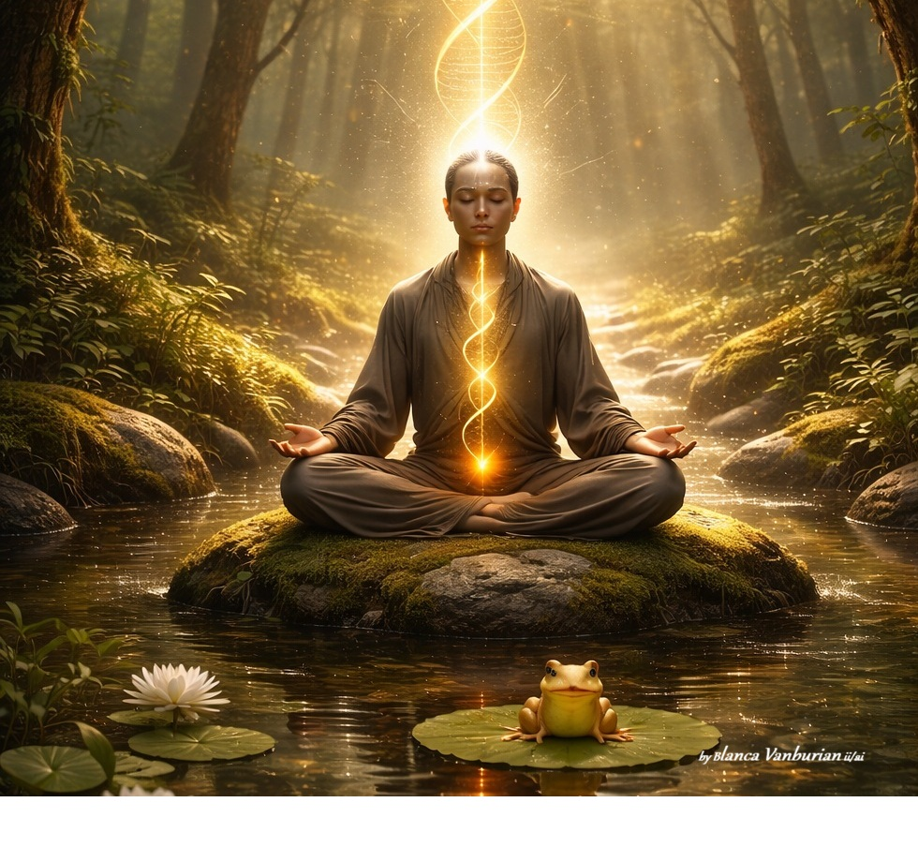

The Golden Helix Blessing
May the light within you rise with the strength of the sun. May the breath within you flow with the ease of the tide. May your heart be a bridge between the Earth and the Stars, And may your spirit always find a reason to smile— Even at a tiny banana on a lily pad.
Go forth with a light head, a full heart, and a glowing soul.

Final Author’s Note to the Reader
"The Golden Helix isn't just a technique you do on a cushion; it is a way of walking through the world. Every time you take a deep, conscious breath, you are inviting the gold back in. You are the alchemist. You are the magic."

The New Experience of "Fullness"
"When you stop the sexual energy leak, you aren't losing a few minutes of pleasure. You are gaining power. You are choosing to keep the light inside the submarine, Illuminating your path, your health, your youthfulness, your beauty, and joy. Above all, you are reconnecting to your spirit. Here the pure ego is also restored. The spirit and pure ego come hand in hand.

Unfortunately, there is a widespread misconception of the ego. Trying to rid oneself of the pure ego is like trying to get rid of our own spirit or infinite intelligence. The ego is part of our identity here on earth. You can’t survive without it. Unfortunately, the pseudo-ego, lost, and confused ego has taken over. As we have seen in previous chapters.

Instead of that post-orgasm "Empty Hemorrhage" where you feel siphoned and tired. You remain with a feeling of Profound Fullness. You aren't "recovering" from a release; you are "overflowing" with vitality.

The Two Secret Commonalities
These four drains have two key similarities that keep the "vampire" alive:
- Commonality #1: They are "Mechanical" Reactions. None of these are choices; they are reflexes. You aren't "choosing" to be anxious; your machine is reacting to a sensory input. Because it is mechanical, it bypasses your "Origin" (your True Self, your i.i.) and goes straight to the old, dusty rules of your lost ego.

- Commonality #2: They Need Your "Identification." For these to drain you, you have to believe they are you. You say, "I am angry" or "I am stressed." Instead of "I am (the one noticing, observing a lower-frequency impression of anger)." The moment you identify with the drain. By saying or thinking “I am angry," you immediately give it the "keys" to enter and take over your submarine. You take the driver's seat with one single step, conscious awareness. Whatever is happening is not who I AM! That brief space of reflection gives you the power to change the reaction into a healthy choice.

Reflection
"Look at those four leaks. You’ve been calling them 'life' or 'my personality,' or ‘this is who I am!' I’m telling you they are structural defects in how you process the world. You aren't a stressed-out person; you are a person whose energy is being siphoned off by a mechanical habit. When you can stop the identification, you don't just save energy. You stop the pain before it even starts as you remodel and regenerate your submarine."

SI Integrity: Personal Spiritual Integrity
In the submarine, a leak isn't a nuisance; it’s a threat to the entire mission. Next, you will learn how to identify three categories of Personal Spiritual Integrity. To understand where your PSI may be dropping. Other chapters go into depth with the understanding and clearing of these leaks. At the end of the chapter, you will find the Visual Mapping Chart of the 3 Categories below. For convenience, it is used in conjunction with the Sovereign Vessel 7-Day Check-in worksheet.

Category A
The Hull Leaks (Physical/Biological) - These leaks occur in the "Lower Engine" or the physical body.

The "Identification” Leak (The Stress Spike): This is when you "become" your problem. You aren't experiencing traffic; you are the anger. Anger is low frequency. It consumes your Si 12 or nuclear fuel for a 5-cent problem. Once you take a moment to observe what you are doing, you can step back. This is your opportunity to look at yourself in a different light. Anger is speaking to you, letting you know a shadow is lurking within you.

The Fix: Use the "3-Second-Deep Breath" Breathe in 3, hold 3, out 3. To disconnect from the emotion. As you face those painful shadows. Acknowledge them. Meet the pain face to face and let it know you are no longer afraid to look. These are the demons in your closet. Ask, why does this situation make me so angry? Go deep into your childhood if necessary.

The "Sensory Overload" Leak (The Digital Vampire): Mindless scrolling through discordant frequencies (doomscrolling). You are taking in "sludge" that your internal factory cannot digest. At this point, you are hypnotized and do not realize that you can control your existence. This becomes a pattern or a habitual force that takes many hours out of your day.

The Fix: Scheduled "Submerge Time" (Digital Detox): Give yourself some time to
Step away from the device. Many times, you do this unaware of lingering feelings within. Become aware of feelings like boredom, sadness, hurt, or pain. When identified, take the time to address the shadows inside. Acknowledge them by feeling them. Work through it until you feel light again.

Why is this important? Because once you rid yourself of emotional shadows, your mind becomes light and clear. Clarity brings peace. It gives you space to create and shape your true desires and purpose.

Category B
The Ballast Leaks (Emotional/Relational) - These leaks occur in the "Middle Engine" and affect your stability.

The "People-Pleasing" (Pothole): Keeping everyone else’s ship afloat can sink your own. You are pumping your own oxygen into someone else's cabin. This is such a difficult topic. Because saying “NO” is easier said than done! You have learned to ignore your “Core Being." Everything and everyone else come before you.

The Fix: Establish "Sovereign Boundaries" through strengthening your core area of:
Honor, Integrity, Valor, Purpose, & Equilibrium.
A.M. and P.M. sit in silence. Place your hand on your lower abdomen (red chakra). Breathe into it. Hold for 10 seconds, acknowledging and reinforcing those five core features. Repeat 3 times.

The “Shame & Guilt” (Denial Leak):
I refuse to talk about that; nothing happened! “Shutting down conversations due to feelings of victimhood and shame without awareness.” Moving on to your busy day or your next task without delay.

The “Strong and Proud” (Denial Leak):
Completely closing yourself. Refusing to talk about hurtful situations with pride and anger. Here, the pain and trauma are so intense it’s necessary not to face it.

The Fix: The very first step is to admit the pain. But this happens when you have suffered enough and are ready to move out of that state! Next, the will to do this is at least 50% of the healing. Acceptance, self-forgiveness, and forgiving others are essential to the journey ahead.

The “Fearful”: (Self-Unknowing Leak):
This is the great forgetting of your i.i. Spirit! Fear comes from the fear of death through self-denial. You suffer when you deny your true nature and forget that you are a permanent drop in the sea of eternity. Which is your place of origin. “You are the manifest spark of light that never ceases to be within the infinite.”

The “Vengeful One” (Competitive & Controlling):
Stems from a need for recognition and validation. It may result from the pain of rejection and abuse. It is usually driven by the need to be perfect. This is common for those who have experienced maltreatment. They externalize their trauma by adopting aggressive behaviors like the behaviors they lived.

The Fix: Admit the painful emotions that seem to control you. Take control yourself. Observe where they sit in your body. Consider how people developed this way. Accept that the people in your life did not learn how to handle their emotions. Like most of us, they weren’t given a manual. Practice acceptance and forgiveness. Above all, forgive yourself!

The "Unprocessed Grief" (Hemorrhage):
Holding onto what you lost without processing the experience. This sits in the hull as heavy, stagnant water until you work it from the inside out. Remember, you cannot avoid losses in your life. For example: Death of a loved one, Friendships, Careers & Jobs, Belongings, Reputation, & Health. You need to acknowledge as a natural feeling of pain and processed.

The Fix: Grief must pass through guilt, fear, and anger to find acceptance. This process is important because it helps to release emotional tension and the pain of loss. Many internal healing processes, including this one, need periods of silence.

Category C:
The Navigation Leaks (Mental/Spiritual) - The Upper Leak: is in the Upper Engine. This mental and spiritual leak clouds your judgment and sense of direction. Past, Present, & Future are not what they seem.

The "Future-Projection" Leak Anxiety: You're gearing up for a future that hasn’t arrived yet. You are wasting fuel on "What Ifs." But how can you avoid living with anxiety? Anxiety has drowned cultures, societies, and homes. The media, propaganda, and people around you propagate fearful narratives globally. For centuries, these narratives have been a constant in our lives. Is it a wonder that you live with anxiety, and do not even know it?

The Past: You may live with pain, regrets, or sorrow from past experiences. How do you rewrite your past? You must change your perspective. It is possible and doable. A genuine will and dedication are needed to rewrite past experiences.
a) The will to see the painful experience as an opportunity for growth
b) The acknowledgment and reflection need to be deep and honest. “There are always two sides to a story.” What was your participation, and what did you learn?
c) A sincere effort to sit and contemplate as the Victim or perpetrator.
d) Acceptance that you and that moment could not be anything other than what they were.
e) Forgiveness for everyone, especially yourself.
f) Don’t expect that experience to ever go away. Do expect to embrace the memory of it with gratitude and kindness.

The Present: Is experiencing each moment with full awareness. When you live in the present, you gain clarity and inspiration for your future. This makes it easier to grow and find balance. The present is the best time to create and act.
The Future: If you want to shape your future, you need to pay attention to your thoughts and hidden feelings. Worrying about the future or holding onto pain from the past can keep you stuck in a cycle of self-pity.

The Fix: Try to return to your 'Place of Origin' by living in the present. And by the true feeling of presence. Not just wanting to be present. Feel that you are the spirit, your true self, and that your power comes from this place. Whenever you notice your mind drifting to the past or future, bring your focus back to your core self for a few minutes. Become the observer. Remember, you are the observer! Soon, this will become a regular habit.

The "Comparison" Corrosion: Looking through the periscope at other vessels and feeling "less than." Just as much as looking (judgment) for those that are lesser than you, while feeling “more worthy” than them. Either situation creates “disharmony” in your self-worth. Idolizing someone brings you to a lower frequency. If I believe someone is better than me. I also believe someone is less than me.

The Fix: Focus on your own "Core being as the Infinite Pattern”. Being judgmental takes you to the lower the lower frequencies.

The "Rules vs. Laws" Friction: Trying to live by man-made regulations that contradict Universal Laws. This is the friction of the "Demiurge" system as it tries to steer your ship. We all need to abide by rules and regulations to live in harmony with one another. However, there are plenty of social stigmas and organizations that dictate rules and regulations that don’t resonate with you. If not, you will find yourself in a cross-current that will take you to a deserted island surrounded by sharks and piranhas with feelings of despair, solitude, and helplessness. Where you are no longer in control of your vessel.

The Fix: Reconnect with your true self and your deeper source. Start by focusing inward.
Keep your attention on your inner self. It is important to reflect on your core being. Ask yourself how you can honor who you are, act with integrity, and live your purpose with courage and balance. Finding your unique purpose will inspire and support you.

The Captain’s Readiness Audit
Mapping Your Leaks

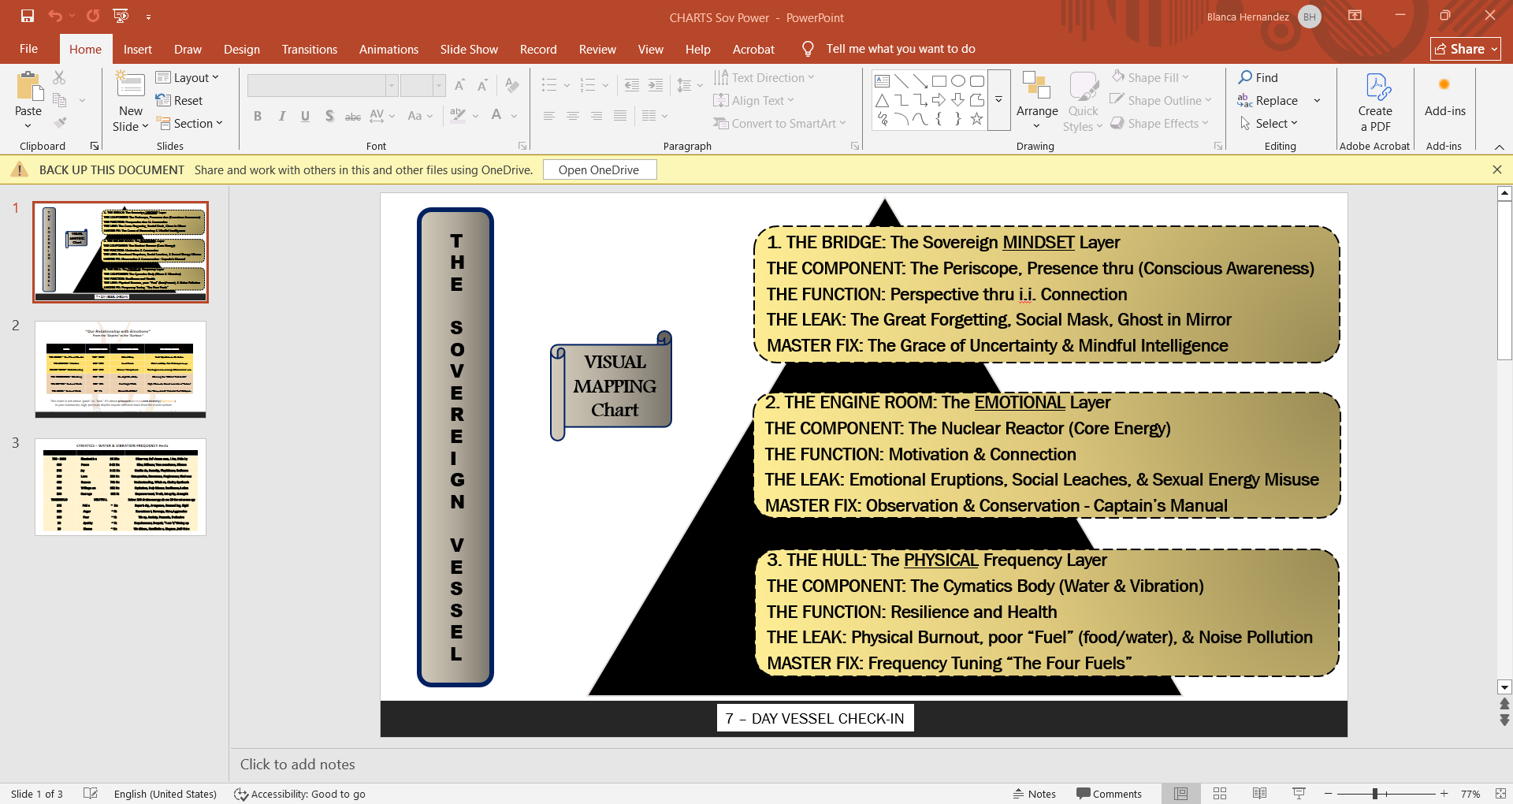

Diagnostics Quiz

Before we move into the Mastery section, we must find out where your hull is thinnest. Be honest. There is no "shame" (20) here; there is only Observation—and as we know, Observation is the first step to Elevation.

Instructions: Rate how often you experience the following "Alarm Lights" on a scale of 1 (Never) to 5 (Constantly).

Section 1: THE BRIDGE (Mental)
- My mind is constantly running "What If" scenarios about the future. [ ]
- I feel like a "fraud" when I compare my vessel to others on the horizon. [ ]
- I feel trapped by "Rules" and "Shoulds" that don't align with my inner truth. [ ]
Mental Sub-Total: /15

Section 2: THE ENGINE ROOM (Emotional)
- I say "Yes" to requests when my internal periscope is screaming "No." [ ]
- I feel "heavy" with the weight of past regrets or things I cannot change. [ ]
- I feel responsible for the "weather" (moods) of the people around me. [ ]
Emotional Sub-Total: /15

Section 3: THE HULL (Physical)
- I feel physically exhausted even after sleeping 8 hours. [ ]
- I react to minor inconveniences (traffic, spills) with intense bodily tension. [ ]
- I spend more than 60 minutes a day on "discordant" digital input (news/scrolling).
Physical Sub-Total: /15

Scoring Your Ship’s Integrity
Total Score: /45

09–18: The Sovereign Voyager
Your hull is tight, and your engines are refined. You are already living primarily in the "Power Zone" (200+). Use this book to polish your virtues and reach the Peace (600) frequency.

19–32: The Leaky Vessel
You have significant "Energy Hemorrhages." You are likely oscillating between Courage and Fear. You have the tools; now you must apply the "welding" techniques in the next chapters to stop the drain.

33–45: The Emergency Dry-Dock
You are currently "treading water." Your vessel is heavy, and your nuclear fuel (Si 12) is being used just to stay afloat. Stop everything. The next section, "The Four Pillars," is your emergency repair manual.

The Captain’s Analysis: Understanding Your Score

09–18: The Sovereign Voyager
The State: Flow & Frequency. If you scored in this range, you have already begun the "Great Remembering." You likely have a natural or practiced ability to remain the Observer. When a wave hits your hull, you don't call it a disaster; you call it "weather."
- The Energy Profile: You are vibrating consistently at 200 (Courage) or higher. Your "Nuclear Fuel" (Si 12) is being used for creativity and expansion rather than just survival.

- The Warning: The danger for a Sovereign Voyager is spiritual pride or stagnation. Even the cleanest hull can collect barnacles.

- Your Mission: Focus on Part IV: The Mastery. Learn to refine your frequency until "Peace" (600) isn't just a place you visit, but the atmosphere you breathe.

19–32: The Leaky Vessel
The State: The Oscillating Engine. This is where the majority of high-achievers and empaths live. You have moments of "Sovereignty" where you feel connected to the One Source, but then a "Vampire" (a stressor, a critic, a deadline) appears, and you immediately lose your pressure. You are essentially taking two steps forward and one step back.

- The Energy Profile: You are likely bouncing between 125 (Desire/Anxiety) and 250 (Neutrality). This "oscillation" is more exhausting than staying low, because your engine is constantly revving and braking.

- The Diagnosis: Your "Digestion Gap" is too wide. You are taking in impressions but "swallowing them whole" without processing them through your Core-Self.
- Your Mission: You must master Chapter 9’s "Welding" techniques. Stop trying to sail further and focus on plugging the holes first. You don't need more fuel; you need a tighter ship.

33–45: The Emergency Dry-Dock
The State: The Hemorrhage. If you are here, I want you to take a deep breath. You are likely feeling a sense of "Heavy Tuesday" every single day. Your vessel is sitting low in the water, and the "rules and regulations" of the world are currently screaming louder than your Internal Dashboard.

- The Energy Profile: You are operating in the Contractive Zone (20–100): Shame, Guilt, and Fear. At these frequencies, the "Submarine" is under too much pressure to function. Your body may be showing signs of "Cymatics Chaos"—inflammation, brain fog, or chronic fatigue.

- The Diagnosis: You have "Identified" so deeply with your roles, your mistakes, and your storms that you have forgotten the Captain entirely. You are currently acting as the water, not the vessel.

- Your Mission: Your priority is Conservation. Stop the "Nuclear Leak." In the following chapters, we are going to pull your ship out of the water entirely for a total "Systems Reboot." You aren't broken; you are just overwhelmed.

CHAPTER 10

Mapping Your Depths: The Geography of Power

Mapping Your Internal World
Up until now, we’ve talked about "high" and "low" frequencies in a general sense. I will refer to lower frequencies as our shadows or shadow work to be done. But to truly navigate, we need a map. Dr. David Hawkins developed a Scale of Emotions that assigns numerical values to our emotional states. (Hawkins, 2004) I have modified it according to a broader view: The scale of Your Relationship with Energy.

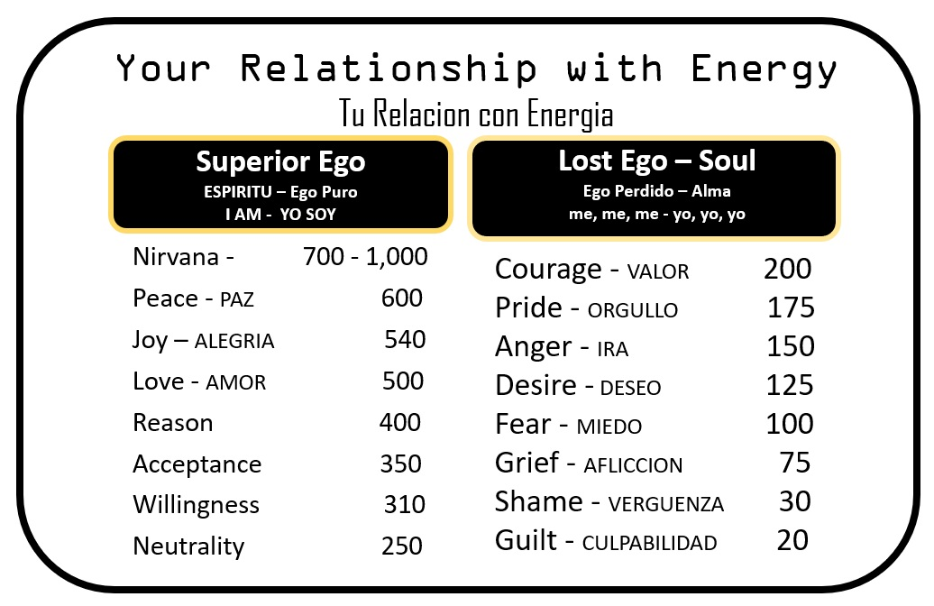

Think of this as the Dashboard of your Submarine. When you look at the gauge, it tells you exactly how much "fuel" you are burning or creating.

The Geography of Your Relationship with Energy
We begin at the bottom of the scale. These are the shadow energies that drain us. We could live to 100 years old and never address our inner shadows:
- Shame (20): An emotion attached with feelings of despair, misery, & humiliation. A belief or perspective of being despised. (due to dysfunctional parents or environment, traumatic experiences like rape, war, etc.) (Shame-Related States of Mind in Psychotherapy, 2012, pp. 335-340)

- Guilt (30): A hurtful experience brings one to believe that you must blame the other or yourself. Perspective that I must live with this because I caused it to happen (self-punishment) or feeling the need to hate and take revenge on all women because one hurt me. Living with the perspective that Life is Evil. (The Scale of Emotions, 2025)

- Apathy & Despair (50): A situation where your perspective is now that you are Condemned and your life is Hopeless. (Scale of emotions, 2023)

- Grief (75): Grief of something or someone you lost. The perspective and attached emotions are personal regret and unworthiness. Left with the feeling that life is tragic. The misperception that things last forever, and somehow, we are responsible or not good enough because I lost something or someone. Understanding the Universal law of change brings acceptance through our mourning. (Hawkins, 2020)

- Fear (100): The belief that we will be punished causes a (constant undetectable) form of Anxiety in the body. “Life is ultimately frightening.” (Becerra et al., 2020)

- Desire (125): The misperception that until I get “__” I will be happy. Always craving something you don’t have. Otherwise, I will be unhappy & unfulfilled. This is a total denial of your need to find your self-worth& inner truth. (The Scale of Emotions, 2025)

- Anger & Hate (150): The perception that life is hostile and God is a vengeful God. (Doll, 2024)

- Pride-Pseudo (175): Pride is a complex and dual-edged emotion. At its healthiest, pride can reflect a rightful acknowledgment of one’s achievements, self-respect, and a sense of worth. That supports healthy boundaries and self-efficacy. However, in this context, this is a problematic form of pride, often called hubris or egoic pride. It involves an exaggerated sense of self-importance, superiority, or separateness from others. Pseudo-pride is more common than healthy pride. This form of pride inhibits the potential of personal growth. (University, n.d.)

- Courage (200): Your attitude towards life begins to shift. Life is affirming, and it is feasible that I got this! Life is permissible; it allows you to be you.

- Trust & Neutrality (250): Higher Emotions begin here. Feelings of satisfaction through achievements in life. A perspective of an enabling force that supports you.

- Willingness (310): A positive and optimistic perspective of life, leading to a sense of hope and inspiration.

- Acceptance (350): Living in harmony with life’s ups and downs and above all loss. Life is abundant and merciful. A forgiving perspective. A desire to forgive yourself and others who hurt you through acceptance.

- Reason (400): Few people reach this level. A perspective that understands life: everything has a meaning and a purpose for existing. You can only be wise by knowing your true nature within the life force in connection with everything.

- Love (500): Ultimate respect for life. The perspective that life is not frightening or tragic, it is simply what it is. The belief that the universal force or web of life is one of creation and expansion through love.

- Joy (540): Life now becomes serene & peaceful. Accompanied by the feeling that “I AM” complete within the ALL.

- Peace (600): A blissful sense of being feelings of all-encompassing beauty and greatness. Life is perfect as it is. “I AM-Being”.

- Enlightenment (700-1000): Unexplainable, everything is!!! There are absolutely no judgments. You are the unconditional Love manifested as the “SELF.” This level of frequency is unattainable for humanity.

Shame (20) through Pride (175): These are the most contractive forces. At these levels, you aren't just losing energy; you are barely holding on to life. They are the "vampires" we talked about. Unfortunately, these are the most common states. Guilt and shame, although felt within you for years, are not recognized as significant problems. Although when you catch yourself acting out of shame & guilt in your daily life, it is felt deeply & silently. Slightly noticeable through your gut feeling, but denial steps in quickly. You continue living as if it can’t be changed. The feelings of apathy, helplessness, & hopelessness become normal. Like another extension of your body. Deep down inside, you know it’s there, yet you pretend it is not.

The Mid-Range: As you climb, you hit anger, pride, and courage. Courage (200) is the "tipping point" where you stop being a victim of the lower frequencies and start taking responsibility. Here you start to shift your mindset. Try making different choices and taking a deep dive into research. You are determined to live a different life, and you begin to see some of the patterns and habits that no longer suit you. Overall, you feel a new sense of hope.

The Power Zones: Once we hit Love (500) and Peace (600), you aren't just surviving; you are vibrating at a frequency in sync with the "Original Universal Pattern" we discussed in Chapter 4. Only a handful of people reach this frequency. At this point, your growth in inner truth can set you apart from others in your environment. You may outgrow friends, careers, and jobs. It’s like a snake shedding off old skin. The transformation can be slow or quicker for others. Many find their way of serving; others may choose a harmoniously peaceful journey, detaching from their previous life. The important thing is to settle within yourself, find balance & joy. This may occur at an early or later stage in life.

Note: Throughout your growth span, frequencies continue to fluctuate on the scale. At a certain point, you reach a steady plateau within the higher frequencies. Yet, nothing is set or stable, quite yet. Some of us have lived with deeply hidden wounds; now and then, they flourish, pulling you back temporarily into mini states of confusion. Until you work out those hidden shadows. Leftover remains of guilt, shame, or anger, still trying to keep you down. Remember, life is a process, many steps forward and a step backward. It is what it is! It is all okay!

Why are these lower emotions so common all around the globe? How did humanity end up with such dark emotions ruling most of our lives? Why do only a handful of people reach the power zones? Have you asked yourself, what do we all have in common? Have you ever wondered why this world seems so cruel? Why does the law of “Survival of the Fittest” exist? Why do people say, “God is a punishing God”? Why does God allow so much suffering and injustice? Where is the loving God, if there is one?

Gnosis is Direct Data
Knowledge is information gathered from the world around us, while Gnosis is direct, unfiltered experience from the Source. Gnosis offers a straightforward encounter with Truth, not relying on intermediaries, interpretations, or external validation.

Earlier, you learned about the fundamental concept of Duality (Yin & Yang) and the origin, described as a powerful force that predates Earth and the demiurge. Consider the biblical phrase "I’m a jealous God." Does this suggest the existence of more than one God?

Let’s propose that God the Father (Yang), representing the originating force, is the #1 God. Mother Earth, the demiurge (Yin), is the #2 God. This matches the law of duality, with two Gods: Light/Yang/Father and Dark/Yin/Mother Earth. The demiurge is the creator of the physical world, distinct from the original divine.

To deepen this exploration, let’s consider global suffering and lower energies. My ongoing questioning of God's dual aspects begins with observing these contrasting realities.

#1- Benevolent Divine God: Existed eons before the earth, stars, & planets. The place of origin, Spirit, unique divine spark, Eternal, Infinite. The I AM, the immovable observer, Infinite Intelligence, free will to choose, abundant, bountiful, and loving. Love is the web of life.

#2- Incoherent, Heartless God of the Demiurge: The Demiurge or Matrix refers to the “System of Social Programming.” This system promotes the belief that humans are born as sinners, imposing guilt and shame from childhood, instilling fear and the need for punishment. God is seen as judgmental, vengeful, and jealous. The system makes society accept pain and suffering as humanity’s purpose. For example, Jesus on the cross suggests everyone has a cross to bear. God asks Abraham to kill his only son, Isaac. In this world, injustice, unnecessary wars, death, and children kidnapped and killed are rampant. There is persistent pedophilia, rape, homicide, sex trafficking, poverty, homelessness, and natural disasters killing thousands regularly. Where is the love? I am compelled to doubt and question these many contradictions. The lower frequencies outweigh the higher. Let’s move on.

Many years ago, without knowing why, I felt compelled to divide the scale of emotions into two parts. Originally, it was simply an up-and-down scale. Today, I recognize this came through gnosis (spiritual intuition). The scale now clearly marks the line between two opposing energies: #1, the Yang God, the place of origin; and #2, the Ying God of the Earth.

Am I simply being judgmental? Why does this matter? How does this affect you in your daily life?

You were taught to believe in a single, judgmental God, regardless of your religion. Now, examine the scale again. Which emotions—shame, guilt, apathy, contempt, anger, fear, hate—align with the lower frequencies?
You’ll see that the left side of the scale fits the benevolent god and the right side fits the god of the demiurge, the frequency #20 of Shame through #200 Courage.

It’s All a Matter of Perspective
You have a choice: Will you identify with lower or higher frequencies? Free will means you decide which path to follow.

Reflection
How many life experiences will it take before you let go of the concept of inherent sinfulness that exhausts you?

The Math of Energy
The "Two Commonalities" from the previous chapter come into play here. When you identify with a low frequency (saying "I am shameful"), you lock yourself into that 20Hz frequency. The fact is, most of us don’t say the words, “I am ashamed”; you live it in silence as a deep, irreplaceable feeling inside. Worst of all, you can’t admit it to yourself. It took me many years to accept that I was navigating the deep waters of shame, guilt, and pride in many areas of my life. The first acquired sense of instilled shame occurred at the age of 20 years old. It happened as a date rape. But I remember well, it was not limited or isolated to the traumatic experience. The trauma attached to my identity, and the detaching from my spirit that took over my mind in that precise moment when it was happening. That became my greatest devastation, a hurdle of self-sabotage for so many years thereafter.

Well, as a pleaser, I inherited my dad’s sense of righteousness; that was one issue. The second was that favoritism was a determining factor in a dysfunctional home. Since I was the black sheep, and a truth-seeker with a pack of narcissistic mother, brother, and sister. The mental abuse was extreme, at least towards me it was. I was constantly told by my mother, “Don’t look in the mirror, because you have no hope, you are ugly, and that is it”.

The 7-Day Practice
Lasting Self-Awareness Check-In
Use with Visual Mapping Chart

- Day 1: The Leak Detection. Identify one person or habit that left you feeling drained today. Where did the energy go? EMOTIONAL
- Day 2: Frequency Tuning. Listen to 10 minutes of silence or "brown noise." How did your physical body respond to the lack of "Matrix" noise? PHYSICAL
- Day 3: The Ballast Check. Face a "Shadow" thought (e.g., "I'm not enough"). Instead of fighting it, ask: How can I use this weight to stay steady today? EMOTIONAL
- Day 4: Fuel Analysis. Look at what you "digested" today—not just food, but social media and news. Was it high-octane spirit or "junk" impressions? MINDSET
- Day 5: The Periscope Shift. When a "storm" (conflict) happens today, look through the periscope. What is the "One Source" trying to show you through this duality?
- Day 6: Emotional Intelligence Audit. Label your primary emotion today. Is this your "Original Pattern," or is it a reactive eruption?
- Day 7: Releasing the Wheel. Practice ten minutes of total surrender. What happened when you stopped trying to control the current?

CHAPTER 11

The Four Pillars: Your Sovereign Toolbox
If you want to live a life of high frequency "Power," you cannot leave your internal state to chance. You need a structure. Imagine these four pillars as the four massive steel beams that hold your Submarine together under the pressure of the deep ocean.

1. Virtues: The Gifts of the Origin
Your virtues are not things you "earned"; they are the specific way the Universal Pattern expresses itself through you. Maybe it’s an effortless kindness, a sharp intellect, or the ability to see beauty where others see chaos.
- The Trap: We often hide our virtues because we don't want to seem "arrogant." But hiding your light is a form of "leak."

- The Tool: Radical Acknowledgment. When you use your natural talent, you aren't being "boastful"—you are being a clean straw for the Spirit to blow through.

- Action: Write down three things that come to you so easily they feel like "cheating." Those are your anchors and your virtues. Use these virtues to pull you up from your bootstraps in difficult moments.

2. Shadows: The Unclaimed Territory
As we discussed in Chapter 9, your "mechanical reactions" often come from the dark corners of the hull. Your shadow may show up as triggers, pettiness, obsessive compulsiveness, need to control, arrogance, over-pleaser, selfishness, competitiveness, envy, and more. All these shadows stem from a disconnection from your true natured spirit. Through pain, rejection, fear, and or threatening circumstances, something convinced you, ‘you are lesser than what you are’.

Know this---you are NOT what you do or what you did! You are not what you have or don’t have! You are not what you look like! Remember, one of those universal laws?--- Unconditional Love! You don’t have to earn or win over love, YOU ARE LOVE! No one needs to forgive you. You only need to forgive yourself by remembering who you are!
- The Trap: Suppression. When we push the Shadow down by ignoring and denying things we struggle with, it creates "Pressure" (Anxiety, depression, anger, fear, shame, guilt, etc). The trick is to face those emotions, acknowledge the pain and hurt, and forgive yourself. Always take the time to sit and reflect whenever something unfavorable happens to you.

- Releasing the Pressure Valve: Sitting quietly and concentrating on the painful feelings that arise, asking the questions. How does this feel? Where in my body do I feel it? How can I help my inner child? What have I done to hurt you? How can I repair this pain? What can I do not to hurt you again? Practice feeling the pain till it can hurt no more. Give it a number from 1 to 10. Give it a color. See the hurt, feel the hurt, the color the number for 60 seconds. Then stop, open your eyes, breathe in and out slowly a couple of times. Close your eyes and repeat these steps a few times until the pain gets down to 1, 2, or 3. Repeat this exercise a few times until you feel lighter.

- Making Amends: Once you’ve made amends with yourself through the above exercise, take any necessary actions to further support your healing. Begin by analyzing where your pain originated, bringing closure by forgiving yourself and those who hurt, abandoned, rejected, abused, or ignored you. Only if appropriate, apologize to anyone you may have wronged.

For example, if you allowed others to take advantage of your kindness repeatedly until you finally reacted. First, face your inner shadows by acknowledging that you neglected to respect and protect your inner child. Apologize to yourself for hurting, ignoring, or denying your inner child all those years. This is your first step toward healing. While that shadow “scar” may remain, it will no longer control you. With this understanding, you can take responsibility for your actions and make amends with others if needed. The healing comes from embracing your shadows, not from rejecting or expecting them to go away. On the contrary, thanking the shadow for the lesson that needed to be learned works like magic.

- The Tool: Integration of the Shadow. In general, on a day-to-day basis. For example: Instead of saying "I shouldn't feel jealous," you say, "I see the part of me that feels small right now." By bringing the Shadow to the "Dashboard," it loses its power to steer the ship in secret.

3. Pure Essence: The Immovable Observer
This is your Spirit. While everything else in your life is "Impermanent" (your body, your job, your emotions), your Essence/Spirit is the Immovable point. It is the silent space between your thoughts and the unknown.
- The Trap: Identifying with the "Movie" instead of the "Screen." We think we are our problems. We have learned to think of ourselves as the role, not the actors, in our lives. We are handed a script to fulfill in this movie called Life, and we fail to accept that we are so much more than the script; in fact, we become the script!

- The Tool: The Stillness Practice. This is the part of you that doesn't change, whether you are at a "20" or a "500" on the Scale of Emotions. It is your direct line to the "Infinite Pattern" we explored in Chapter 4. The challenge here is to remember that there is nothing to become. Practice for a few minutes before you fall asleep, and the first thing before you get out of bed.

- In Silence: In your mind, search for 8-10 things you are NOT. For example: I am not my body; I am not my thoughts; I am not my career; I am not what I have, and so on. Then, while breathing deeply, focus on the infinite that existed before the Big Bang. Observe and feel you are that infinite intelligence, that is your place of origin, your real home, you are immovable and untouchable here! This is your creative time & space to a loving connection with your divine light.

4. Core Being: The Captain’s Code:
This is the most "human" part of the toolbox. It is the bridge between your Spirit and the Physical World. Your Core Being is forged through Honor, Integrity, Valor, and Purpose.

- HONOR: Being true to yourself: High Self-Esteem, Self-Respect, Honesty, & Loyalty.

- INTEGRITY: A Sense of being whole & Undivided with yourself, High Values through Self-Awareness & Conscious Living.

- VALOR: Strength of Mind & Spirit that Enables you to Face Difficulties with Courage & Firmness.

- PURPOSE: Reason for Your Existence. Natural (effortless) Talents & Abilities.

- EQUILIBRIUM: A State of Harmony & Joy.

5.The Pillar of Equilibrium: This is "Self-Responsibility." It is the refusal to blame the weather for the direction of your ship.

The Integration: Finding Equilibrium
The Integrity Check. Before you speak, act, or react, ask yourself: "Is this coming from my Core (Integrity), or is this a Mechanical Reaction (The Smaller Ego)?"

For example: When you have these four tools, you no longer fear the "Pain and Suffering" from Chapter 9. Why? Because you’ve learned how to refrain and self-check.
- When pain arises, your Essence observes it.
- Your Shadow reveals why & where it hurts.
- Your Core Being chooses how to respond with Integrity, honor, & valor.
- Your Virtues give you the strength to move through it.

"Equilibrium isn't the absence of waves; it is the presence of a stable center. You are no longer a victim of the sea; you are the master of the vessel."

A Visual for Your Toolbox
Balancing the light of the Virtues with the depth of the Shadows, all centered by the Core—it.
helps to see them as a unified system of consciousness.

The Captain’s Equilibrium Audit - A Practice in Self-Responsibility
Before you move to the next chapter, I want you to sit with your "Submarine." We aren't looking for perfection; we are looking for Honesty. Take a deep breath, connect with your Pure Essence (that quiet space behind your eyes), and answer these four prompts:

1. Honoring Your Virtues
Identify with one "Natural Talent" you’ve been dimming down or ignoring. > Reflection: "This week, how can I use this gift as a service to others or myself without feeling like I have to apologize for being good at it?"
2. Bringing the Shadow to the Dashboard
Think of a "Mechanical Reaction" that happened recently (e.g., you snapped at someone or felt a wave of Guilt/Shame). Work through your shadows as shared earlier.

Reflection
"I am not this reaction, but I am the one observing it. What is this Shadow trying to protect me from? How can I hold space for this part of me instead of pushing it back into the dark?"

3. Anchoring in Pure Essence
Close your eyes for sixty seconds. Try to find the 'You' that doesn’t have a name, a job, or a problem.

Reflection
"Can I feel the 'Immovable' part of me that remains calm even when the dashboard is blinking red? This is your place of origin, we discussed in Chapter 4, as in your infinite intelligence, your personal i.i.

4. The Core Being Commitment
Choose one of the five Core values: Honor, Integrity, Valor, Purpose, or Equilibrium.

Reflection
"Which of these feels the 'thinnest' in my life right now? What is one small, self-responsible action I can take today to strengthen that pillar?"

When in Doubt: When you are confronted with any situation or emotion that places you in any kind of doubt, before taking any action, bring forth the 5 core questions: Depending on the situation, ask yourself, “Am I honoring myself with this decision?” Am I acting with full integrity for myself and others?” “Am I lacking courage and valor in this moment, and why? “Does this decision portray or align with my purpose?” “Am I too far one way or another? What do I need to find my balance?

Closing the Chapter: A Note from the Heart
My friend, having a toolbox is a heavy responsibility. It means you can no longer claim you are "lost at sea." You have the map (Chapter 10), and now you have the tools (Chapter 11).
The pain we talked about in Chapter 9 hasn't necessarily disappeared from the world, but it has lost its power to hemorrhage you. You are becoming "leak-proof." You are learning that while you cannot control the depth of the ocean, you are entirely responsible for the integrity of your ship.

You learn to see both your virtues (natural talents) and your shadows (struggles) as STRENGTHS, not as self-indulging pride or weakness. Meaning — without your struggles, you wouldn’t grow into the expansion you already are, and without virtues, you wouldn’t be able to polish the rough stone into the diamond within you.

You are the Captain! Now let's see where we’re heading.

CHAPTER 12

The Operating System Mechanics: Attitudes of Equilibrium
Equilibrium isn't a destination you reach and then park the submarine; it is a dynamic state of being. It is an active choice you make every time an "impression" hits your senses. To stay in that high-frequency Power Zone you found on the Scale, you adopt four specific attitudes.

Think of these as the Four Valves of the Heart—when they are open, energy flows. When they are clogged with "mechanical reaction," the hemorrhage begins.

1. Self-Awareness: The Internal Spotlight
Before you can change your frequency, you must know what it is. Self-awareness is the act of turning the lights on in the engine room.
- The Practice: It’s the split second between a trigger and a reaction. Instead of reacting, you observe. You notice the "mechanical" urge to be angry or afraid, and by simply noticing it, you create space. Space now puts you in control!

- The Caring Truth: Awareness is the greatest act of self-love. You are finally paying attention to yourself, while healing is taking place inwardly to rise outwardly, smoothly and effortlessly. We take a few steps forward and, at times, a step or two backward. The perfect imperfection of being human!

2. Willingness: Opening the Hatch
On the Scale, Willingness (310) is a massive jump in power. It is the end of "I can’t" and the beginning of "I am open to."
- The Practice: It is the attitude of saying "Yes" to growth, even when it’s uncomfortable. It’s being willing to admit you might be wrong, or willing to try a new way of breathing through the pain.

- The Caring Truth: Willingness is the bridge over the gap of resistance. It doesn't mean you have all the answers; it just means you've stopped fighting the process.

3. Rationalize: The Logic of the Spirit
In personal development, we often think "rationalizing" is a bad thing (making excuses). But here, we use it as a Higher Logic. It is the ability to look at a situation and strip away the lost ego's drama.
- The Practice: When a "Vampire" tries to drain you, you rationalize the truth: "This person isn't attacking my soul; they are simply acting out of their own mechanical pain." You use your intellect to recognize and manage your emotions, and to walk away when necessary.

- The Caring Truth: Using your mind to protect your heart is one of the most powerful things you can do.

4. Acceptance: The Deep Stillness
Acceptance is not "giving up." It is the total acknowledgment of What Is. When you accept that the ocean is currently stormy, you stop wasting energy wishing for sun and start focusing on navigating the waves you are currently facing.
- The Practice: Letting go of the "Shoulds." (e.g., "This shouldn't be happening.") When you accept the present moment, you immediately stop the flow of energy.

- The Caring Truth: Acceptance is where the fighting ends, and the healing begins. It is the frequency at which the "Submarine" finally finds its buoyancy.

The Flow of Equilibrium
Watch how these work in a sequence when a challenge hits:
- Awareness: "I feel my chest tightening; I'm becoming stressed."

- Willingness: "I am willing to see this differently instead of just snapping."

- Rationalize: "This stress is just a mechanical reaction to a deadline. It doesn't define my worth."

- Acceptance: "The deadline is here. I accept the pressure, and I choose to work with peace." Take a moment to process all steps, giving yourself time to reflect on your emotions. Specifically noticing the patterns and habits that you now realize don’t belong to you.

"Equilibrium is the art of being unshakeable, not because the world is still, but because you have mastered the four valves of your own heart."

The Shift: Reflection Exercise
In Chapter 10, we saw that Courage (200) was the tipping point. These four attitudes are what keep you above that line. Without them, you fall back into the "Mechanical" world of Chapter 9.

A Case Study in Equilibrium
Imagine you are sailing through a relatively calm week when, suddenly, you receive an email or a phone call that feels like a direct hit to your hull. Perhaps it's a financial setback, a harsh criticism from a loved one, or a sudden change in plans that ruins months of work.

Without these four attitudes, the Mechanical Reaction takes over. You feel the "Energy Hemorrhage". You drop down the Scale into Anger or Fear. But as a Captain with a Toolbox, you engage the Attitudes of Equilibrium:

a. The Spotlight: (Self-Awareness)
Instead of immediately firing back an angry email or spiraling into "What if?", you pause. You literally feel the heat in your face or the knot in your stomach.

The Thought: "Ah, there it is. My 'Mechanical Machine' is triggered. I am observing a state of high-pressure stress entering the cabin."
The Result: You have separated your Pure Essence from the emotion. You are no longer "Stressed"; you are the one witnessing stress. (Breaking the pattern)

b. The Open Hatch: (Willingness)
Your ego wants to stay angry. It’s "comfortable" to be the victim; it is all you’ve known. This mental state is comparable to an addiction, something hard to let go of. But now you know to choose the attitude of Willingness.

The Thought: "I am willing to let go of the need to be 'right' or 'offended' in this moment. I am willing to see if there is a higher-frequency way to handle this."

The Result: The "Vampire" loses its grip because you aren't fighting it; you are simply choosing a different path. (You automatically feel the pressure valve open, giving you a sense of relief)

c. The Spirit’s Logic: (Rationalize)
Now you use your intellect to dismantle the drama.

The Thought: "Is this a life-threatening event? No. Is this person’s opinion the 'Original DNA' of who I am? No. This is a temporary impression. It is a wave, and the submarine is built for waves." “I can do this!”

The Result: You have stripped the event of its "Power" and returned it to its actual size. Something that doesn’t belong to you. Something that cannot take your power away. Ultimately, it is your time to choose.

d. The Deep Anchor: (Acceptance)
Finally, you stop wishing the email hadn't been sent. You stop the shame, guilt, fear, and anger right in their tracks. You stop arguing with reality. You separate into your i.i. personal dark space, and you begin to watch the eye of the wave.

The Thought: "This is the situation. The 'weather' has changed. I accept this moment exactly as it is, without judgment. From this place of stillness, I will decide my next move." And now you wait long enough for the result. It may not be an inner voice; it may just be total calmness with a different perspective. A perspective where you choose your feelings and emotions. This is the healthier version of you.

The Result: You reach Equilibrium. The hemorrhage stops. You are back at the controls in the place you belong. The Captain of your yellow submarine.

It Takes Practice
Some situations are easier than others. Most of the time, we take a few steps forward and a few backwards. In time, it becomes easier and more rewarding to continue without much thought.

Why This Matters
When you practice these four steps, you aren't just "coping"—you are re-programming your machine. Each time you choose Awareness over Reaction, you strengthen the "Core Being" we talked about in Chapter 11.

The Ultimate Goal
The goal and the easier path are to remember who you are! When you genuinely remember that you are the spark of light coming from the benevolent, unconditional god, your place of origin, the infinite intelligence…. That becomes the one-degree shift in perception that changes your life drastically, like a submarine changing its course by only one degree, which can lead it down a vastly different trajectory. Until then, I leave you with handy & practical tools.

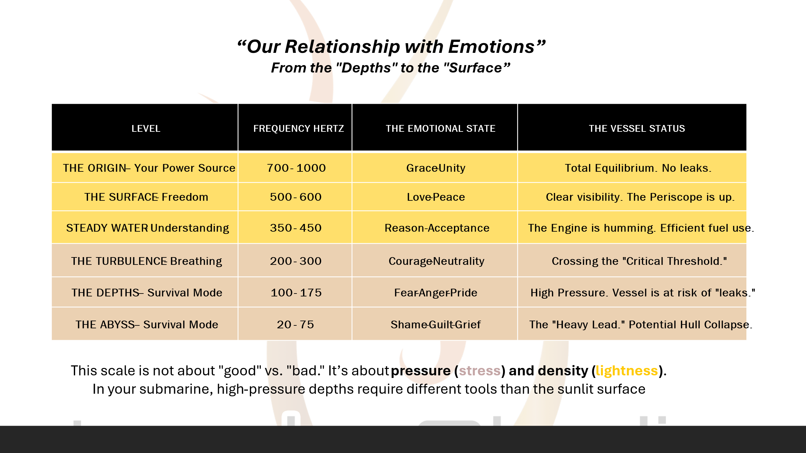

Now, look at the Scale again. Notice how Acceptance (350) sits high above the chaos. When you live in these four attitudes, you aren't just visiting the "Power Zone"—you are moving in.
"A Captain doesn't pray for a calm sea; Captains master the four valves of Equilibrium so they can sail through any storm and remain exactly who they are." These choices bring peace of mind and clarity, enabling precise, careful navigation through the stormy weather.

The Final Equilibrium: The Drop and the Ocean
Remember Chapter 7, where we spoke of the Drop and the Ocean? The "Knowing" part of us is the Drop trying to tell the Ocean where to go. The "Uncertainty" part of us is the Drop finally realizing it is the Ocean. When you embrace Uncertainty, you aren't "lost." You are available. You move from the contractive energy of Guilt, Shame, and Fear (the bottom of the scale) into the expansive energy of Love and Peace.

"Knowing is a closed door. Uncertainty is an infinite horizon. To stay in Equilibrium, you must keep your hand on the wheel (The Known) while keeping your eyes on the horizon (The Unknown)." Acceptance of uncertainty in your life gives you great POWER!

Closing Thought for the Book
"You are no longer the person who started this book. You are a Captain who knows that the Submarine is strong, the tools are ready, and the ocean—in all its terrifying, beautiful uncertainty—is exactly where you are meant to be. It comes down to remembering who you truly are. The pure infinite intelligence hidden below layers, and layers of…. Who knows what! The question is, “How important are these layers to you? Are they worth carrying around?”

Stop trying to predict the destination and start enjoying the depth. "Your inner depth is all you really have; it is permanent, strong, intelligent, comforting, loving, understanding, forgiving, unconditional, and only wants what is best for you. It will never steer you in the wrong direction!
I want you to take one final look at your Dashboard.

If you feel a flicker of fear about the uncertainty ahead, that is okay. But look closer. Beneath that fear is your Pure Essence—the part of you that is made in the image of the Infinite. It does not shake. There is no doubt. It doesn’t even wabble. It simply is!

Your Standing Orders
As you close this book and step back into the "Real World," remember your training:
- Plug the Leaks: The moment you feel the "Heavy Tuesday" lethargy, look for the identification. Remind yourself: "I am observing stress, but I am not the stress"

- Consult the Scale: When you feel contracted, choose Willingness. It is the elevator that takes you from the basement of Shame (20) to the Power Zone of Courage (200) and beyond.

- Check Your Pillars When in Doubt & Regularly: Keep your Virtues polished, your Shadows integrated, your Essence still, and your Core Being anchored in integrity.

- Breathe into the Mystery: When life takes a turn you didn't "know" was coming, smile. You are in the realm of unlimited potential. You are healthy, vital, and free to choose. Stop being a prisoner of lesser frequencies within the mind to see the vampires, the tsunamis, and the waves for what they really are. They are your opportunity for Inner exploration to transmute!

A Final Blessing
May your hull be strong enough to withstand the deepest pressures, and your spirit be light enough to float upon the highest waves. May you recognize every "Vampire" as a teacher and every "Storm" as a necessary movement of the Great Ocean that reaches into your most private depths to support you in your journey called life.
You are no longer a passenger in your own life. You are the Captain of the Yellow Submarine. You are the observer of the frequencies. You are a drop that has finally remembered it is the entire Ocean. You are the calibrated machine, now bright and shiny, ready to sail forward!

The Captain’s Commissioning: A Final Send-Off
You are standing on the bridge of your vessel now. Behind you are the chapters of your past—the "Mechanical Reactions," the energy leaks, and the "Great Forgetting." Before you lies the vast shimmering expanse of the Unknown.

The horizon is calling, STEADY as she goes!

Our Relationship with Energy:
Your relationship with energy changes the moment you realize~~~ I am the one observing the scale, not the number on it. Always remember you are the infinitely intelligent observer! The Observation is a once-in-a-lifetime opportunity!

- Observation is Elevation: By simply acknowledging, "I am aware of a feeling (Not I am the feeling of guilt), a frequency of 30 (Guilt)," you have already moved slightly higher because the "Observer" is always at a higher frequency than the emotion being observed.
- Choice as a Frequency: We don't "fight" guilt; we simply choose to focus on a frequency that is more expansive
.
Reflection:
"Look at this scale. For the last few months, you’ve been living down here in the 20s and 30s. No wonder you’re exhausted—it takes a massive amount of energy just to keep your heart beating at that level. This book isn't about 'being a better person.' It’s about learning how to tune your dial until you’re back up in the 500s, where life feels light again. You don't need a new life; you need a new frequency."

CHAPTER 13

The Grace of Uncertainty: Releasing the Wheel
The Art of Knowing When to Let Go
We have reached the final stage. You have the map, the tools, and the attitudes. Now, you must decide: Will you try to control the ocean, or learn to dance with the waves?

In our mechanical state, we crave the safety of knowing. In our Empowered state, we find the hidden magic in Uncertainty.

The Prison of "Knowing"
When we demand to know how life should go, we create a rigid, unyielding structure. Like a brittle submarine hull, reality's pressure cracks us.
- The Weight of Expectations: We decide how people should act and how life should look. When reality doesn’t match, we fall into Delusion.

- The Cost: Rigidity leads to constant Frustration and Anxiety. This is not just a feeling—it is a biological tax. Trying to control the uncontrollable causes Illness and Premature Aging.

- The Leak: Knowing is the ultimate Energy Hemorrhage. A lost ego tries to play a role it never owned.

The Freedom of "Uncertainty"
Most people fear the unknown. But for the conscious Captain, uncertainty is the Power Zone—the frequency of Unlimited Potentials.
- The Open Mind: When you stop insisting you know best, you allow the Original Universal Pattern to work through you—or your infinite intelligence and Spirit.

- The Flow: This is the frequency of Peace (600). Instead of fighting the current, you let it propel you. In this state of "Going with the Flow," true Health and Youthfulness appear, because your body leaves the "fight or flight" response against life. For example, a surfer aims to ride the wave but knows he must crash first. Do you know the feeling of crashing? I certainly do! However, it’s important to clarify. The flow acknowledges personal boundaries and requires total presence.

- The Gift: Uncertainty means anything can happen—including the best. Remaining positive and grateful brings you greater experiences. When things aren't going well. I reflect on my feelings and ask: What lesson am I to learn? What could I change within me? Is there something I'm missing? Answers may not come immediately, but with an open mind, they will eventually arrive. If I miss the lesson, the same obstacle returns until I learn it. Sometimes, life uses us to help others grow, and all we can offer is acceptance. This reflection is truly a gift!

The Final Equilibrium: The Drop and the Ocean
Remember Chapter 7, where we spoke of the drop and the ocean? The knowing part is the drop trying to direct the Ocean. The uncertainty part is the drop, finally knowing it is the Ocean. When you embrace Uncertainty, you aren't lost. You are available. You move from the contractive energy of Guilt, Shame, and Fear to the expansive energy of Love and Peace.
Knowing is a closed door. Uncertainty is an infinite horizon. To stay balanced, keep your hand on the wheel (the known—the plan) and your eyes on the horizon (the unknown). Accepting uncertainty gives you great POWER!

Closing Thought for the Book
You are no longer the person who started this book. You are now a Captain who knows the Submarine is strong, the tools are ready, and the ocean—in all its terrifying, beautiful uncertainty—is where you are meant to be. Now, remember who you are: pure infinite intelligence hidden under layers. Who knows what these layers are? The question is: how important are these layers to you? Are they worth carrying around?

Stop trying to predict the destination. Start enjoying the depth. Your inner depth is all you really have. It is permanent, strong, intelligent, comforting, loving, understanding, forgiving, unconditional, and only wants what is best for you. It will never steer you in the wrong direction!
I want you to take one final look at your Dashboard.

If you feel a flicker of fear about the uncertainty ahead, that is okay. But look closer. Beneath that fear is your Pure Essence—the part of you that is made in the image of the Infinite. It does not shake. There is no doubt. It doesn’t even wabble. It simply is!

Your Standing Orders
As you close this book and return to the real world, remember your training:
Plug the Leaks: When you feel Heavy Tuesday lethargy, seek identification. Remind yourself: I am observing stress, but I am not stressed.

Consult the Scale: When you feel contracted, choose Willingness. It’s the elevator from the basement of Shame (20) to the Power Zone of Courage (200) and beyond.

Check Your Pillars: When in doubt or regularly. Keep your Virtues polished, your Shadows integrated, your Essence still, and your Core Being anchored in integrity.

Breathe into the Mystery: When life takes a turn you didn't "know" was coming, smile. You are in the realm of unlimited potential. You are healthy, vital, and free to choose. Stop being a prisoner of lesser frequencies within the mind to see the vampires, the tsunamis, and the waves for what they really are. They are your opportunity for Inner exploration to transmute!

A Final Blessing
May your hull be strong enough to withstand the deepest pressures, and your spirit be light enough to float upon the highest waves. May you recognize every "Vampire" as a teacher and every "Storm" as a necessary movement of the Great Ocean that reaches into your most private depths to support you in your journey called life.

You are no longer a passenger in your own life. You are the Captain of the Yellow Submarine. You are the observer of the frequencies. You are a drop that has finally remembered it is the entire Ocean. You are the calibrated machine, now bright and shiny, ready to sail forward!

The Captain’s Commissioning: A Final Send-Off
You are standing on the bridge of your vessel now. Behind you are the chapters of your past—the "Mechanical Reactions," the energy leaks, and the "Great Forgetting." Before you lie the vast shimmering expanse of the Unknown. The horizon is calling, STEADY as she goes!

Our Relationship with Energy:
Your relationship with energy changes the moment you realize~~~ I am the one observing the scale, not the number on it. Always remember you are the infinitely intelligent observer! The Observation is a once-in-a-lifetime opportunity!
- Observation is Elevation: By simply acknowledging, "I am aware of a feeling (Not I am the feeling of guilt) a frequency of 30 (Guilt)," you have already moved slightly higher because the "Observer" is always at a higher frequency than the emotion being observed.

- Choice as a Frequency: We don't "fight" guilt; we simply choose to focus on a frequency that is more expansive
.
Reflection
"Look at this scale. For the last few months, you’ve been living down here in the 20s and 30s. No wonder you’re exhausted—it takes a massive amount of energy just to keep your heart beating at that level. This book isn't about 'being a better person.' It’s about learning how to tune your dial until you’re back up in the 500s, where life feels light again. You don't need a new life; you need a new frequency."

REFERENCES & RESOURCES
The Captain’s Media Briefing: Essential Visual Resources to deepen your understanding of the frequencies discussed in this book. I highly recommend searching for the following titles on YouTube or other educational platforms. These visual “blueprints” will prove to your eyes what your heart already knows.

The Captain’s Watchlist: Visualizing the Invisible
I. The Science of the Infinite Pattern
• “Cymatics: Science vs. Music” (Nigel Stanford)
o Why watch: A stunning modern visual of how frequency moves sand, water, and fire into geometric patterns. It is the best visual representation of Chapter 3.
• “Amazing Resonance Experiment!” (Brusspup)
o Why watch: To see a metal plate transform “Chaos” into “Order” as the frequency calibration increases—the perfect metaphor for moving up the Hawkins Scale.
II. The Intelligence of Water & Biology
• “The Secret Intelligence of Water” (Veda Austin)
o Why watch: To see how water “remembers” and responds to human thoughts and images. Since you are a water-based being, the feelings within you validate why the “Energy Hemorrhages” in Chapter 9 are so physically damaging.
• “The Biology of Belief” (Dr. Bruce Lipton)
o Why watch: A masterclass on how your “Internal Dashboard” (perceptions) controls your genes and your health, supporting our focus on the “Submarine’s” integrity.
III. The Global Frequency & Connection
• “The Schumann Resonance: Earth’s Heartbeat” (Resonance Science Foundation)
o Why watch: To understand the 7.83Hz frequency we discussed in the “Equilibrium” chapters and why “Grounding” is a vital tool for your Sovereign Toolbox.
• “The Connected Universe” (Nassim Haramein)
o Why watch: For a deep dive into the “Big Bang” and the “Infinite Pattern” (Chapter 4). It explains how the “Drop” is truly connected to the “Ocean.”
IV. The Human Power Plant
“The Science of Heart Coherence” (Heart Math Institute)
o Why watch: To see how the heart’s electromagnetic field changes when we move from frustration to gratitude. This is the biological proof of the “Four Attitudes of Equilibrium” (Chapter 12).
The Power of Frequency (Chapter 3)
o Video: “Cymatics: Bringing Matter to Life with Sound” (Search: Hans Jenny / Cymatics Experiments).
Why watch: To see exactly how sound organizes physical matter into the
"Infinite Pattern”
VI. The Hidden Messages in Water (Chapter 8)
o Video: “The Secret Intelligence of Water” (Search: Veda Austin or Dr. Masaru Emoto).
o Why watch: To see how human intention and “Identification” (Chapter 9) physically change the structure of water.
VII. The Schumann Resonance (Chapter 12)
o Video: “The Earth’s Heartbeat” (Search: Schumann Resonance Explained).
o Why watch: To understand how to align your “Submarine” with the natural frequency of the planet.
VIII. The Scale of Emotions (End of Book)
• o Video: “How to Stop Overthinking and Surrender Control” Dr. David Hawkins.
• o Why watch: To understand the need for thinking.

A Note for Your Readers
“Don’t just watch these videos for entertainment. Watch them as a Captain studying the mechanics of the ocean. Observe the patterns. Notice how the ‘chaos’ of low frequency always yields to the ‘symmetry’ of high frequency. This is the path you are now on.”
References
Hawkins, D. R. (January 23, 2004). Measuring Emotions. DailyGood. https://www.dailygood.org/2004/01/24/measuring-emotions/
(2012). Shame-Related States of Mind in Psychotherapy. Psychotherapy: Theory 49(3), pp. 335-340. https://doi.org/10.1037/a0027480
(2025). The Scale of Emotions. Alessandra’s Journal. https://alessandrasjournal.com/2025/04/29/the-scale-of-emotions/
(2023). Scale of emotions. Conscious Awareness Online. https://www.consciousawareness.online/emotions/
Hawkins, D. R. (2020). The Map of Consciousness Explained: A Proven Energy Scale to Actualize Your Ultimate Potential. Hay House. https://play.google.com/store/books/details/The_Map_of_Consciousness_Explained_A_Proven_Energy?hl=en&id=aDHMDwAAQBAJ
Becerra, R., Preece, D. A., & Gross, J. J. (2020). Assessing beliefs about emotions: Development and validation of the Emotion Beliefs Questionnaire. PLoS ONE 15(4). https://doi.org/10.1371/journal.pone.0231395
(2025). The Scale of Emotions. Alessandra’s Journal. https://alessandrasjournal.com/2025/04/29/the-scale-of-emotions/
Doll, K. (2024). David R. Hawkins’s Scale of Emotions—An Overview. Shortform. https://www.shortform.com/blog/david-r-hawkins-scale-of-emotions/
University, P. S. (n.d.). Two Types of Pride – Psychology of Human Emotion: An Open Access Textbook. Chapter 12: Pride – A Positive Self-Conscious Emotion. https://psu.pb.unizin.org/psych425/chapter/two-types-of-pride/

