Mango Price Prediction using Hybrid Machine Learning with Explainability: Evidence from Maharashtra APMC Markets

Preface
This project report outlines the effort done for Mango Price Prediction using Hybrid Machine Learning with Explainability using data from Maharashtra APMC market. The objective of the study is to investigate the feasibility of using past market data for predicting the next modal price of the mango in a real-world, leakage-free setting. The study not only focuses on achieving accurate predictions but also investigates if the obtained results can be explained using appropriate measures and visualizations.
In the course of developing this project, it was established that the real-world agricultural market data is not ideal for time-series analysis. There are some gaps in reporting, abrupt price surges, market-specificity, seasonality, and variations in arrivals. As a result of these problems, the project was crafted in such a way that no future data influenced the process of feature generation, training, and testing.
Initially, the research involved decision-tree based machine learning techniques like Gradient Boosting, Random Forest, and XGBoost, along with a hybrid approach and SHAP for explainability. Further, the project was expanded with the inclusion of an LSTM/Sequence Learning Benchmark in order to examine if recent price pattern data could help improve predictions in eligible markets. Because of potential instability in raw LSTM predictions in the case of non-steady APMC data, robust forms were considered. The current report involves LSTM_Hybrid (optimized for MAE) and LSTM_Hybrid_R2 (optimized for R2).
In addition, the dashboard was enhanced to display the results of the LSTM model on a market-wise basis as well as to provide 7-day, 15-day, and 30-day LSTM-based future forecasting scenarios. In this case, to demonstrate the report, Amarawati APMC was chosen due to its balanced LSTM results. This additional information provided by the dashboard is supposed to demonstrate that LSTM could help with the forecasting in certain markets; however, it is supposed to be used as a part of the scenario.
In summary, the project enabled me to see the entire cycle of developing a forecasting system based on data from the market: cleaning, feature creation, modeling, chronological testing, explaining the models, and communicating using dashboards. The project also taught me that when forecasting agricultural prices, we must evaluate our model not based on just one measure, but based on the whole picture of MAE, RMSE, percentage errors, R2, residuals, and explainability.
Chapter 1: Introduction

1.1 Introduction

Agriculture-based employment is one of the major sources of income for Indians, and the stability of markets is of great importance for the economic condition of farmers and market players. As far as horticulture is concerned, one of the most curious products is a mango, whose cost is determined by its ripeness, the demand in this area, the conditions of transportation, and trading traditions. The specifics of all these factors differ from one market to another, that is why the costs of mangoes differ much among markets and even within the time period [11], [12].

The structure of markets in Maharashtra is presented by the APMC (Agricultural Produce Market Committee), which is a market structure providing the possibility of purchase of mangoes by buyers and wholesalers. The information gathered through markets presents the data about the number of arrivals and min, max, and median prices on the day of reporting. While these statistics present the outcomes of work in markets, they do not give any predictability of prices. All the markets have different periods of reporting, history depth, and price levels. It should be considered when dealing with this kind of data, especially since the behavior of arrivals may contain useful signals for agricultural price modeling [18].
The project aims at solving the problem of predicting the next observed modal price of mangoes in each of the APMC markets using data that was already available prior to the observation. The application of machine learning is highly appropriate in this case as machine learning can learn multiple features simultaneously in the presence of non-linear dynamics. The fundamental concept of the project lies in the focus on both the precision of prediction and the rigour of evaluation [2], [3].
Price forecasting is important not just from a technical perspective in the agricultural market context; but farmers, traders, wholesalers, and market committees rely on accurate price information for their decisions regarding harvesting, transportation, storing, and selling their crops. For mangoes, in particular, it becomes even more relevant as the product is seasonal and the timing of its arrival at the market is very crucial. Even a slight delay in its arrival, an increase in supply or any change in the demand can impact the modal price at the APMC market. The literature on forecasting agricultural commodities through machine learning reveals that machine learning can prove helpful in such scenarios but the results would depend heavily on the data structure [11], [12].

However, the dataset taken for this project, consisting of the APMC Market reports from Maharashtra, is the actual market data and not an ideal experimental dataset. It may be less ideal than an experimental data set in many ways, but it will be more practical and challenging. Some markets make frequent entries, while some other markets have large gaps between the entries. There may be some markets where the price moves steadily, while there are some other markets with drastic spikes owing to seasonality, quality differences, local demands, and supply problems. Therefore, the project will not take all the data points to be the same daily time series.
One of the problems that must be addressed when forecasting prices is data leakage. When using future values to construct features and select models, the achieved accuracy will seem much higher than it is actually going to be in practice. In order not to deal with this problem, the current study uses the leakage-proof approach. The lag features, rolling statistics, arrival statistics, and calendar features are computed based on the previous observations only. Also, the data are divided into train and test sets chronologically, which ensures that the test set stays untouched while building the model. Time-aware validation is critical for forecasting tasks as random division may lead to incorrect results [2], [3].
The modelling component of the project adopts multiple modelling techniques instead of using just one type of algorithm. The Gradient Boosting, Random Forest and XGBoost models were used since tree-based models tend to perform well with tabular data exhibiting non-linearity [4]-[6]. In addition, the models will be able to capture the interaction effects of price history, arrival amount and seasonality among other market-related factors. The inclusion of a persistence benchmark is because in agricultural forecasting in the short term, the last known price is often hard to beat. Therefore, inclusion of the benchmark makes for an honest comparison without the project overstating its improvement.
A subsequent development of this project included LSTM or sequence-learning benchmark. LSTM is an algorithm designed for learning from ordered data; it is commonly used in sequence modelling problems [7]. In this case, however, there is no ordering in the dataset: the data on markets is unstructured and each individual market has too small amount of records. Consequently, the proposed LSTM is not supposed to replace the hybrid model as a universal solution. On the contrary, LSTM serves as a benchmark to investigate whether short sequence of previous reports helps to predict future values of selected markets. The results have proven that the careful contribution of LSTM into the hybrid model is beneficial only for selected markets, for example Amarawati, whereas other markets benefit from persistence or hybrid tree-based models. This result is quite natural when it comes to agriculture forecasting, where deep learning does not always exceed simpler and ensemble methods in their performance [14], [15].

Another key aspect of this research is explainability. A price prediction system is supposed to deliver not only a prediction value but also insights into why that value has been predicted. For this purpose, the SHAP method has been applied to analyze the XGBoost model component and determine the most influential features [9]. The use of explainable models becomes crucial in an agricultural context where users would be more likely to trust predictions that consider recent behavior of the price, movements in arrivals, and seasons [16]. The final Streamlit dashboard combines all these aspects with data exploration, forecasting, comparison of models, LSTM benchmarking, and explanation.
Keywords: mango price forecasting, Maharashtra APMC, machine learning, gradient boosting, XGBoost, SHAP explainability, leakage-safe feature engineering, LSTM, agricultural price prediction, ensemble model, Streamlit dashboard

1.2 Problem Statement
Agricultural commodity prices are subject to change based on seasonality, weather, demand, logistics, and market fluctuations within various regions. As a seasonal fruit, mango prices can be particularly sensitive to such influences. Such fluctuations in prices pose a problem for producers and buyers in making decisions regarding where and how to sell without proper knowledge of future price movements.
The particular issue that is being addressed is the prediction of the next observation of modal price of mango at the Maharashtra APMC markets solely based on historical data. Since price data are ordered in time, it is important that the approach to building a predictive model is done carefully in order to avoid leaking future prices into the training process and hence produce overfitted models that will not work under real-world circumstances.

1.3 Objectives
The project was designed to achieve the following:
- Examine historical mango price patterns in Maharashtra APMC markets.
- Preprocess the raw data to address quality issues and prepare it for analysis.
- Conduct exploratory data analysis to characterise seasonal trends, market-level variation, reporting patterns, and price distribution.
- Build a machine learning-based forecasting system for next-observation modal price prediction.
- Engineer features from historical data only, ensuring no future information enters the training process.
- Compare the performance of multiple machine learning models against a simple persistence baseline.
- Evaluate models using MAE, RMSE, MAPE, sMAPE, and R².
- Apply SHAP-based explainability techniques to interpret what drives each prediction.
Evaluate an LSTM/sequence-learning benchmark across eligible high-coverage markets and compare its guarded hybrid contribution with persistence and machine-learning baselines.
- Develop an interactive Streamlit dashboard that brings together market exploration, forecasting, model comparison, and explainability.

Chapter 2: Literature Review
The literature relevant to this project comes from two closely related streams: forecasting methodology and explainable machine learning for structured data. Because published work that matches the exact combination of Maharashtra APMC mango prices, irregular reporting intervals, and leakage-safe next-report prediction is limited, the present study is positioned primarily against established forecasting and machine-learning foundations.
Classical forecasting research emphasises that time order must be preserved during evaluation and that forecast quality should be judged through more than one metric. This is particularly important in agricultural price series, where volatility, skewness, and sudden jumps can make one metric look favourable while masking weakness on another.
For model construction, ensemble tree methods such as Gradient Boosting, Random Forest, and XGBoost are well suited to heterogeneous tabular data because they capture nonlinear relationships without imposing strong parametric assumptions. Deep sequential models such as LSTM and Transformer architectures are also relevant to forecasting research, but they generally benefit from more regular and larger sequential datasets than the one used in this study.
Another example of such a market context could be seen in Tamil Nadu, where agricultural marketing regulations have a high regard for market information, market statistics, research and market surveys [21]. This would be helpful in the current case study since the markets of fruit and vegetables in Tamil Nadu would encounter similar practical problems as those seen in Maharashtra APMC data like seasonality in arrivals, price fluctuations in short term, difference in markets, and the requirement of price information that would be comprehensible to farmers and traders. Therefore, the market context in Tamil Nadu helps justify the decision to analyze models on a market-wise basis rather than expecting one general pattern for all markets of the state. At the same time, it emphasizes the necessity of a dashboard based output since price forecasting is only helpful if one can examine the market and check model errors.
Sr. No. | Author(s) / Year | Domain / Dataset | Method | Key Finding
1 | Kumar et al., 2023 | Agricultural commodity price forecasting | ML review | Surveyed major ML methods, key challenges, and emerging research directions in agricultural price prediction
2 | Majumdar et al., 2020 | Crop price forecasting, emerging economies | Time-series with market and quality factors | Data quality and chronological structure have strong effects on forecast reliability
3 | Saha et al., 2023 | Agricultural crop price prediction | Deep learning with spatial and temporal inputs | Combining spatial and temporal factors improves crop price prediction
4 | Rahman et al., 2021 | Agricultural commodity markets | ARIMA, SVR, Prophet, XGBoost, LSTM comparison | Comparative evaluation across methods shows no single algorithm universally dominates
5 | Islam et al., 2026 | Bangladeshi agricultural commodities | Classical and deep learning benchmark | Strong baselines remain competitive against more complex models on noisy price data
6 | AGRICAF Study, 2024 | Agricultural commodity forecasting | Explainable machine learning | Interpretability is important for forecasting systems intended for real-world agricultural use
7 | Shrestha et al., 2026 | Vegetable market prices | Online stacking ensemble | Ensemble outputs provide stable multi-horizon forecasting performance
8 | Kapoor et al., 2019 | Agricultural commodity arrivals | Regression with remote sensing | Arrival quantity information contributes meaningfully to market-level prediction
9 | Chen and Guestrin, 2016 | General tabular prediction | XGBoost | Scalable gradient boosting with strong regression performance across domains
10 | Lundberg and Lee, 2017 | Explainable AI | SHAP | Unified game-theoretic framework for local and global model interpretation
11 | Vaswani et al., 2017 | Sequence modelling | Transformer | Attention mechanism enables effective sequence learning without recurrence
12 | C-SHAP Study, 2025 | Time-series forecasting explanation | Temporal SHAP | Extends SHAP-based interpretation to capture temporal contribution patterns
13 | Transformer SHAP Study, 2025 | Forecasting models | Sampling-free SHAP for Transformers | Efficient explainability for sequence-based forecasting models
14 | Hochreiter and Schmidhuber, 1997 | Sequential and time-series data | LSTM | Long Short-Term Memory establishes a framework for learning long-range sequential dependencies
15 | Breiman, 2001 | Classification and regression | Random Forest | Ensemble of decision trees offers robust performance on tabular datasets
Table 1: Foundational and methodological literature relevant to the present study
Kumar et al. (2023) provide a broad survey of machine learning applications in agricultural price forecasting, covering model types, data challenges, and the need for evaluation frameworks that reflect real deployment conditions. Their review is useful as an orientation to the field, though it does not focus on any specific commodity or region.
Majumdar et al. (2020) highlight that forecast performance depends heavily on data quality and how the time structure of the data is handled. Their work in emerging economy contexts is relevant here because Maharashtra APMC data shares similar characteristics: irregular reporting, gaps in coverage, and the influence of local market dynamics.
Saha et al. (2023) demonstrate the benefit of combining multiple types of input when predicting crop prices, including location-related and time-related information. Their approach informed the decision to engineer market-specific and calendar-based features in this project.
Rahman et al. (2021) compare several forecasting approaches on agricultural commodity data and conclude that method choice should be driven by the characteristics of the data rather than a prior preference for complexity. This view shaped the decision to include a simple persistence baseline as a meaningful benchmark.
Islam et al. (2026) find that strong baseline models can hold their own against more complex deep learning methods when data are noisy. This result is consistent with the findings reported in Chapter 4 of this project, where the persistence baseline performed competitively.
The AGRICAF study (2024) argues for forecasting designs that are both accurate and transparent, and suggests that agricultural forecasters should prioritise interpretability alongside prediction performance. This concern directly motivates the use of SHAP in this project.
Shrestha et al. (2026) apply an ensemble-based strategy for vegetable market price forecasting and show that combined model outputs can be more consistent across different conditions than any single model alone. The hybrid ensemble developed here draws on a similar logic.
Kapoor et al. (2019) show that commodity arrival data contributes meaningful predictive signal in agricultural market models. Arrival-based features were therefore included in the feature engineering stage of this project.
Chen and Guestrin (2016) introduced XGBoost, which has since become one of the most widely used algorithms for tabular prediction tasks. Its computational efficiency and strong regression performance make it a natural choice for this forecasting problem.
Lundberg and Lee (2017) proposed SHAP as a method grounded in cooperative game theory for attributing the output of any machine learning model to its input features. This framework enables both global feature importance ranking and individual prediction explanation, and was applied here to both the XGBoost and GBR models.
Vaswani et al. (2017) introduced the Transformer architecture, which has since influenced a broad range of sequence modelling and forecasting research. While Transformers were not used in this project's main pipeline, they are noted in the future scope as a candidate for further exploration.
The C-SHAP (2025) and Transformer SHAP (2025) studies extend explainability methods to time-series contexts, addressing the challenge of interpreting how temporal features contribute to forecasts. These developments are relevant background for the SHAP analysis carried out in this project.
Hochreiter and Schmidhuber (1997) established LSTM networks as effective tools for sequential data with long-range dependencies. Their work underpins later research on deep learning for agricultural price forecasting.
Breiman (2001) introduced Random Forests, which aggregate predictions from many decision trees trained on bootstrap samples. The method's robustness to outliers and nonlinearity makes it suitable for agricultural price data, which contains both.
The classical time-series literature provides the evaluation foundations applied throughout this project. Box, Jenkins, Reinsel, and Ljung's standard text on time series analysis establishes the principle that forecasting models should be assessed on their ability to generalise to unseen future observations rather than fit historical data alone, a principle reflected in this project's strict train-validation-test separation. Hyndman and Koehler (2006) argue that no single accuracy measure is sufficient for comparing forecasts across series with different scales and volatility, which motivated the use of five complementary metrics (MAE, RMSE, MAPE, sMAPE, and R²) in Chapter 4 rather than reliance on one. Bergmeir and Benitez (2012) caution that standard k-fold cross-validation can leak future information into time-ordered data, supporting this project's use of expanding-window, time-aware cross-validation during hyperparameter tuning. Friedman (2001) provided the original formulation of gradient boosting as a stage-wise additive model that fits new learners to the residual errors of prior ones, which underlies both the GBR and XGBoost implementations used here. Finally, Makridakis, Spiliotis, and Assimakopoulos (2018), reporting on the M4 forecasting competition, found that simple statistical baselines often perform comparably to more complex machine learning models, a pattern directly echoed in this project's finding that the Persistence baseline matched or exceeded the learned models on MAE despite its simplicity.

Chapter 3: Methodology

Overview

1. Data Collection  - Maharashtra APMC mango dataset  - Market-wise price and arrival records | 2. Data Cleaning and Preprocessing  - Filter mango records  - Clean dates and numeric fields  - Remove invalid or duplicate entries | 3. Exploratory Data Analysis  - Analyze dataset coverage  - Study market-wise and district-wise trends  - Identify seasonality, outliers, and gaps | 4. Target Definition  - Predict the next observed modal price  - Use the same market sequence | 5. Leakage-Safe Feature Engineering  - Create lag features  - Generate rolling statistics  - Add calendar and market variables

6. Chronological Data Splitting  - Split into train, validation, and test sets  - Preserve time order | 7. Model Training  - Gradient Boosting Regressor  - Random Forest Regressor  - XGBoost Regressor  - LSTM / sequence benchmark | 8. Hyperparameter Tuning  - Use time-aware validation folds  - Select best model settings | 9. Hybrid and LSTM-Hybrid Formation  - Compare models with baseline  - Combine selected predictions  - Add guarded LSTM signal where validation supports it | 10. Model Evaluation  - Measure MAE, RMSE, MAPE, sMAPE, and R2  - Compare ML, Hybrid, LSTM, and LSTM_Hybrid

11. Explainability Analysis  - Apply SHAP analysis  - Identify important features | 12. Result and Artifact Generation  - Save trained models, metrics, tables, and figures  - Prepare report and demonstration outputs | 13. Dashboard Development  - Build Streamlit dashboard  - Show EDA, forecasts, explainability, and LSTM benchmark
Figure 3.1: Methodology workflow including the LSTM/sequence benchmark
Mango price and arrivals were recorded in historical data from Maharashtra APMC markets. These recordings include the date, market name, district, number of arrivals in quintals, and the minimum, maximum, and mode of prices of the trade session. The final cleaned data consisted of 3,847 records collected from 25 APMC markets in 14 districts during 12 February 2022 and 30 April 2026.
Metric | Value
Number of rows total records | 3,847
Number of columns | 10
Number of markets | 25
Number of districts | 14
Study period | 12-02-2022 to 30-04-2026
Mean modal price (Rs./Quintal) | 8,200.29
Median modal price (Rs./Quintal) | 5,500.00
Mean arrival quantity (quintals) | 125.76
Median arrival quantity (quintals) | 8.60
Target variable | Next observed modal price of the same market
Total engineered features | 70
3.1 Data collection
The cleaned dataset spans 12 February 2022 to 30 April 2026, but market reporting is irregular rather than daily or uniformly monthly. For that reason, the timeline should be interpreted as observational coverage rather than a continuous series for every market. The wide gap between mean and median arrival quantity also shows that a small number of high-volume observations pull the average upward.
3.2 Data Cleaning and Preprocessing
Inconsistencies in raw data obtained from the APMC sources had to be addressed systematically. First, observations pertaining only to the mango fruit were selected. The dates in the data were parsed to a standardized date format and then sorted chronologically. The price and arrival columns were then cast as numerical columns, with any invalid strings and negative numbers removed from them. In addition, missing values in important columns were removed from the data, as the data was dense enough to accommodate the absence of some data points.
3.3 Exploratory Data Analysis
Exploratory analysis was carried out before any modelling to build familiarity with the dataset's structure and behaviour. Visualisations were prepared for price distributions, arrival volumes, seasonal variation across calendar months, reporting frequency over time, the number of active markets per month, and the date ranges covered by individual markets. Price outliers were examined rather than removed, as some extreme values appear to reflect genuine premium trading events.

3.4 Target Definition
Unlike the traditional forecasting method where the forecast horizon was set to a specific future time point, the forecasting problem was formulated as the prediction of the mode of the price on the subsequent reporting event of the market in question. It is a much more practical approach considering that the dataset consists of the markets with different reporting periods. The market that reports its prices every several days should be considered differently from the market that reports weekly or monthly.

3.5 Leakage-Safe Feature Engineering
Feature construction was carried out strictly using past observations. No information from the target observation or any future record was used. The following feature groups were generated:
- Historical price lags (most recent 1, 2, 3, and further back observations)
- Rolling price averages over windows of 3, 5, and 10 previous observations
- Price deviation from rolling means (how far the current price is from its recent average)
- One-step and multi-step price changes to capture momentum
- Rolling price volatility (standard deviation over recent observations)
- Arrival volume lags and rolling statistics
- Calendar features: day of week, month, day of year
- Seasonal indicators: mango season flag and off-season flag
- Market identity and district
- Market age in days (number of days since the market's first record in the dataset)
In total, 70 features were generated. Records lacking sufficient history to compute the lag and rolling features were dropped, leaving the final modelling dataset somewhat smaller than the full cleaned dataset.

3.6 Chronological Data Splitting
The data were split chronologically using the target date of the next-report observation. Records before 1 May 2025 formed the training portion, records from 1 May 2025 to 2 August 2025 formed the validation window, and records from 3 August 2025 onward were kept as the untouched test set. This design prevented look-ahead bias and ensured that each evaluation reflected a genuine forward prediction setting.

3.7 Model Training
Three regression algorithms were selected and trained on the feature-engineered training set:
- Gradient Boosting Regressor (GBR) — sequential ensemble that corrects residual errors across iterations
- Random Forest Regressor (RF) — parallel ensemble of decision trees with bagging
- Extreme Gradient Boosting (XGBoost) — regularised gradient boosting with column and row subsampling
Each model was trained on identical features under the same chronological split, allowing direct comparison of their forecasting performance.
In addition to the tree-based machine-learning models, a sequence-learning benchmark was added for eligible markets with sufficient observations. For each market, observations were sorted chronologically and converted into 14-report lookback windows using modal price, arrival quantity, reporting gap, short rolling statistics, seasonal encodings, and report number. The sequence component was evaluated market-wise rather than pooled blindly across all districts because APMC markets differ in reporting frequency, volatility, and price behaviour.
To keep this extension leakage-safe, the sequence benchmark used chronological train, validation, and test windows. Guarding parameters and the LSTM_Hybrid blend weight were selected only on validation data, then applied once to the untouched test period. Raw sequence predictions were retained for comparison, but the dashboard reports LSTM_Hybrid as the usable LSTM-enhanced result because it caps unstable jumps and blends the sequence signal only when validation supports it.

3.8 Hyperparameter Tuning
The process of searching for optimal hyperparameters was done through a method of time-series aware expanding window cross-validation. In each fold, training was done using all the data before a certain cutoff and testing was done on the immediate window thereafter. This avoids validation set leakage and thus provides a better picture of how model performance varies across time.

3.9 Hybrid Ensemble Model
The weighted ensemble model was created by merging the forecasts of the GBR, RF, and XGBoost models. The weights for the respective models were determined according to their relative performance on the validation data set, meaning that the better-performing models had a greater say in the final prediction process. This model was hoped to alleviate reliance on the peculiarities of individual models and iron out forecasting errors due to market conditions they cannot capture.

3.10 Model Evaluation
All models were evaluated against the chronological test set, which was held out throughout the development process. Performance was assessed using five metrics:
- MAE (Mean Absolute Error): Average magnitude of prediction error in rupees per quintal.
- RMSE (Root Mean Squared Error): Penalises large errors more heavily than MAE; sensitive to outliers.
- MAPE (Mean Absolute Percentage Error): Error expressed as a percentage of the actual price, enabling comparison across price levels.
- sMAPE (Symmetric MAPE): A symmetric variant of MAPE that is less distorted when actual values are close to zero.
- R² (Coefficient of Determination): Proportion of variance in the target price explained by the model. Higher is better.
Using multiple metrics avoids over-reliance on any single criterion and provides a more rounded picture of how each model performs.

3.11 Explainability Analysis
The SHAP (SHapley Additive exPlanations) method was used to uncover which features played a role in the predictions of the trained XGBoost model. The values calculated by SHAP are based on cooperative game theory and indicate how much each feature is responsible for the difference between the prediction in question and the mean prediction on the entire dataset.
This method helps to deal with an important issue encountered when making agricultural forecasts: it is necessary to ensure that the users believe in the prediction because they know the reasons behind it.

3.12 Dashboard Development
The interactive application was developed using the Streamlit package for those who do not have any knowledge of machine learning models. There are five key pages available in the dashboard including the market data explorer with charts, next-report price forecast, future price projection, models' performance comparison, and SHAP explanation. All that allows the user to gain insights into the data, evaluate the performance of the model, make projections and understand which features the model reacts to, without having to write any code.

Chapter 4: Results and Discussion

4.1 Overview
This chapter presents the empirical results obtained from 3,847 cleaned mango-market observations drawn from 25 Maharashtra APMC markets across 14 districts. The descriptive and predictive findings are interpreted together so that dataset behaviour, model performance, and dashboard outputs can be viewed as parts of a single forecasting workflow.

4.2 Exploratory Data Analysis

4.2.1 Overview of Prices, Arrivals, and Market Structure

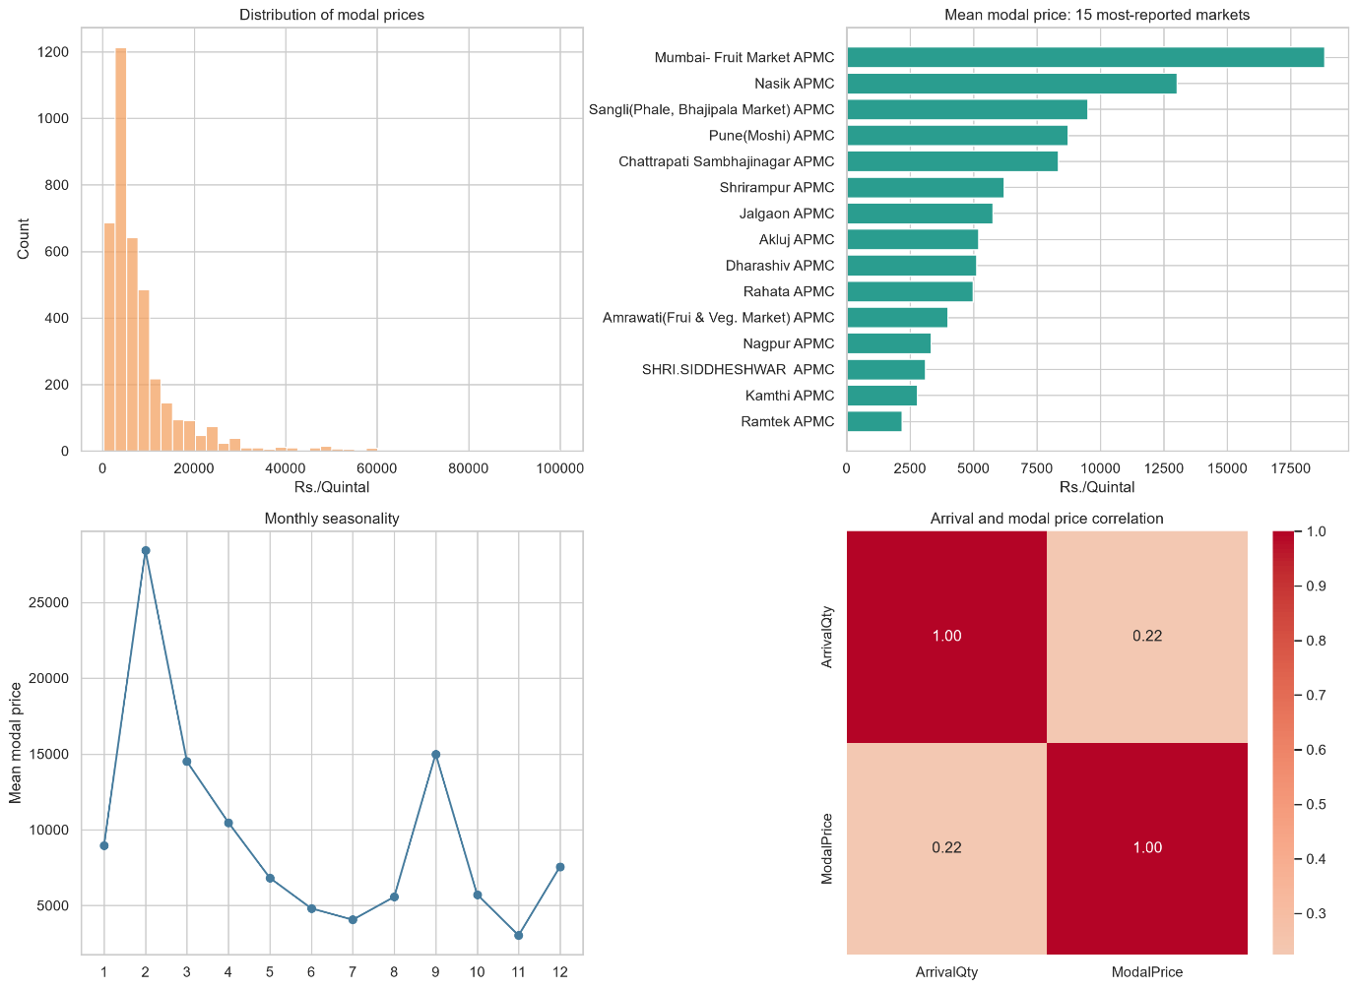
Figure 4.1: Exploratory overview of prices, arrivals, and market structure
The modal price histogram (Figure 4.1) clearly depicts that most of the observations fall in the low to mid-range prices with a right-skewed tail. In other words, the distribution has a positive skew, which indicates that although there are some high-price events, they are rare occurrences compared to the normal trading situation.
It can be observed from the market comparison chart that the average prices vary significantly from market to market. Mumbai Fruit Market APMC and Nasik APMC report higher prices as compared to the rest of the markets. This could be because of the factors such as the vicinity of these two markets to the urban centers, cold chains, and buyers.In terms of monthly seasonality, it is found that prices vary throughout the year with certain months having higher prices. This finding is in line with the seasonality of mango produce.The relationship between arrival quantity and modal price shows a weak positive correlation. This indicates that there is no direct influence of arrival quantity on the price.

4.2.2 Monthly Report Volume and Active Market Coverage

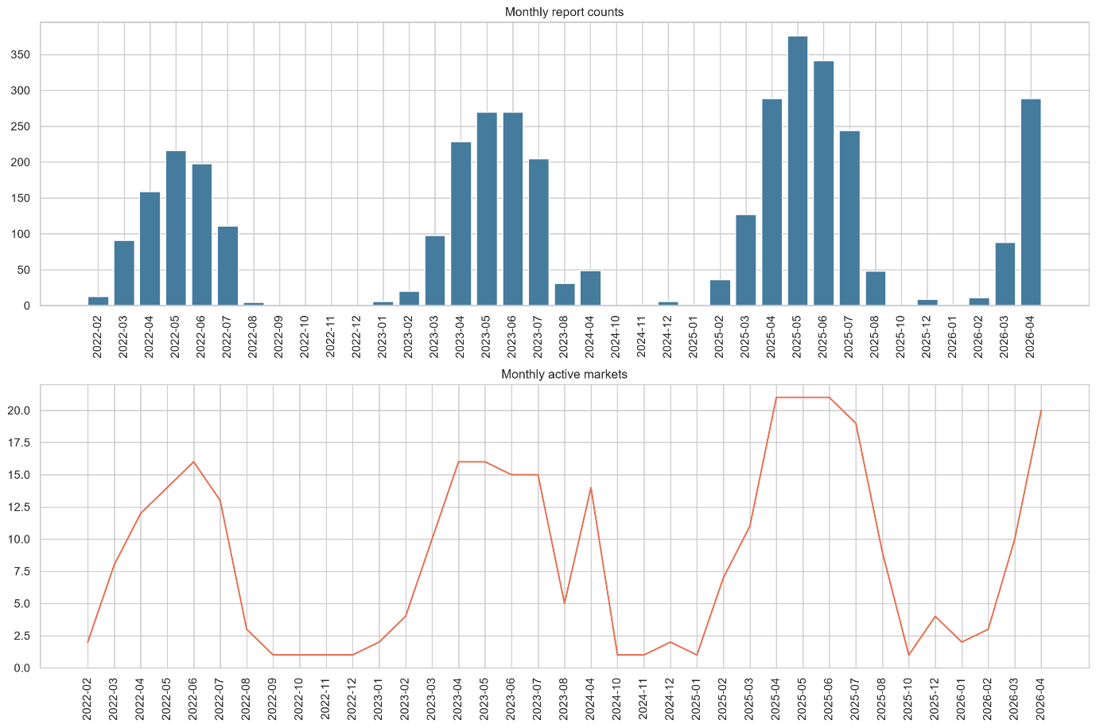
Figure 4.2: Monthly report volume and active market coverage
It is apparent from Figure 4.2 that reporting activity is inconsistent over time; some months contain many observations while other months contain very few observations. Also, there is an inconsistency in the number of active markets, implying that our dataset is not a time series with regular sampling. It is an irregular dataset, which needed to be taken care of in the forecasting framework we are designing.

4.2.3 Reporting Period Covered by Each APMC Market

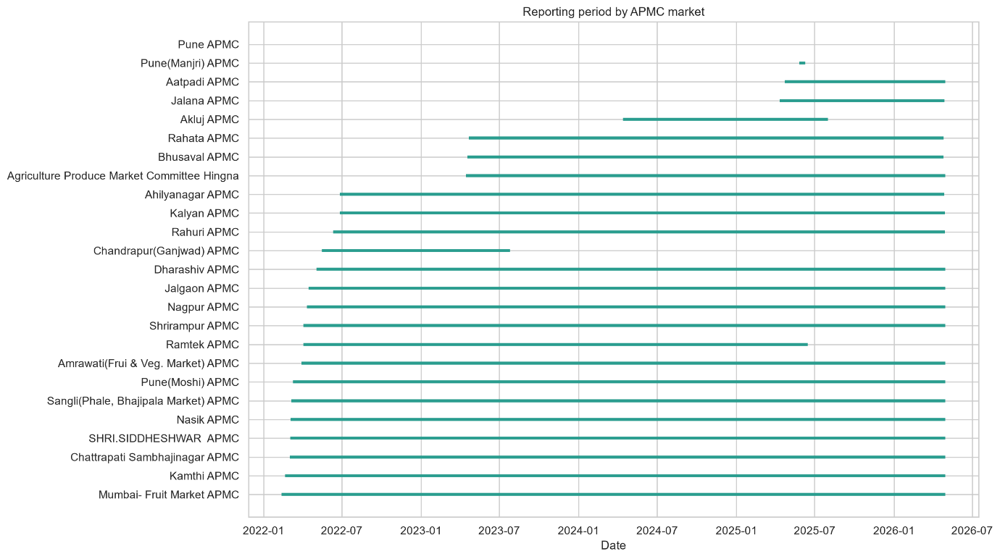
Figure 4.3: Reporting period covered by each APMC market
Some of these markets, namely, Mumbai Fruit Market APMC, Kamthi APMC, Chattrapati Sambhajinagar APMC, Nasik APMC, Pune (Moshi) APMC, and Sangli (Phale, Bhajipala Market) APMC, have extensive histories of reporting over most of the time period under study. On the other hand, some other markets, namely, Pune APMC, Pune (Manjri) APMC, Aatpadi APMC, and Jalana APMC, have very short periods of history. Markets having short periods of history will contribute less data to the training process of the model and would have fewer lags available. This disparity was taken into consideration by setting a minimum period of history prior to inclusion in the model dataset.

4.2.4 District-wise and Market-wise Price Comparison

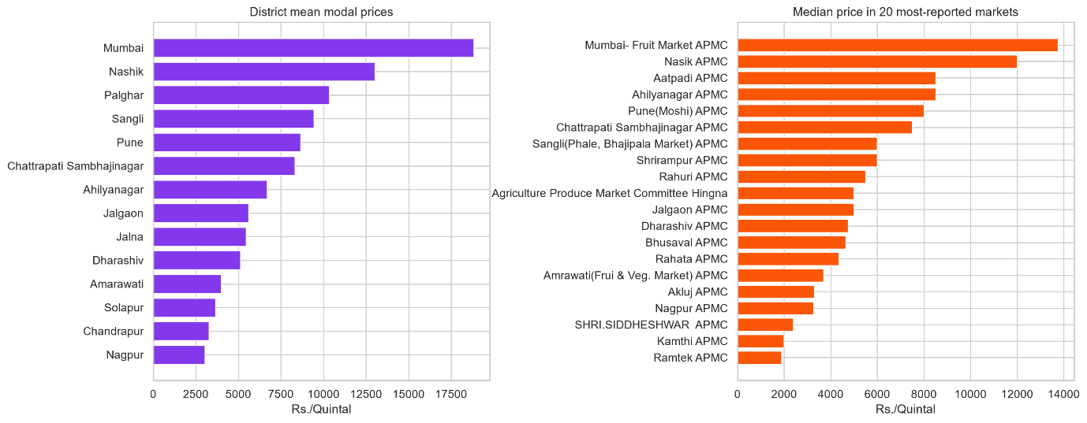
Figure 4.4: District-level and market-level price comparison
Such districts like Mumbai and Nashik have higher average prices on the mode than most of the other districts in the data set. Even at the market level, the variance is much greater. These variations suggest that the behavior of the prices is primarily local; thus, one cannot describe the phenomenon using only one state level pattern.
4.2.5 Monthly Median Price Trends for the Most-Reported Markets

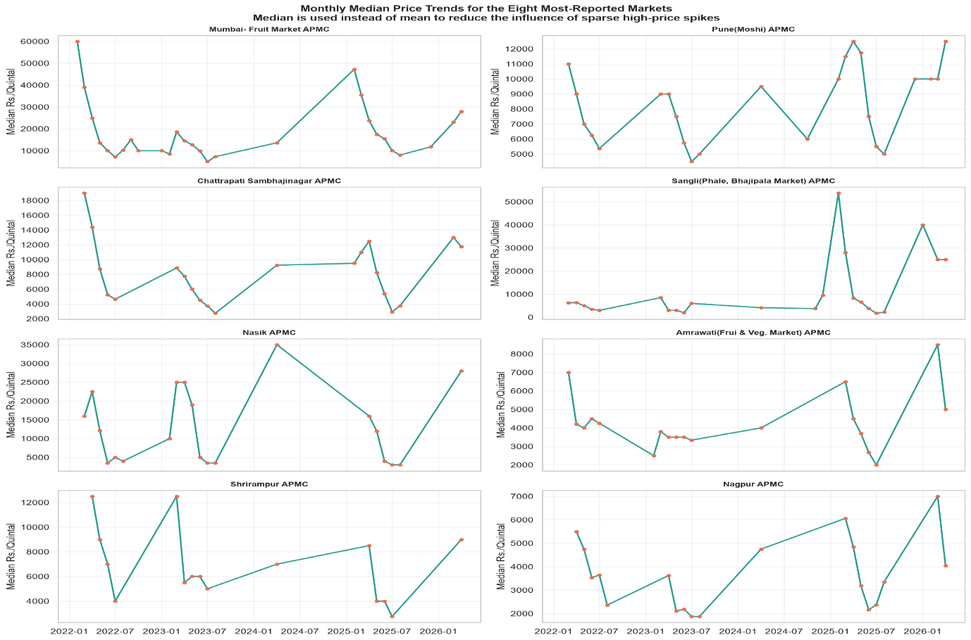
Figure 4.5: Monthly median price trends for the most-reported markets
Median prices of each market for months plotted against month number (median is used instead of mean so that the influence of rare high values could be minimised) shows different trends depending on the market. For example, Mumbai Fruit Market APMC and Sangli (Phale, Bhajipala Market) APMC have spikes at specific times, but Nagpur APMC and Amrawati (Fruit and Veg. Market) APMC maintain relatively low values all the time. Different patterns of each market demonstrate that a universal model should capture market-specific patterns.

4.2.6 Annual Price Distribution and Outliers

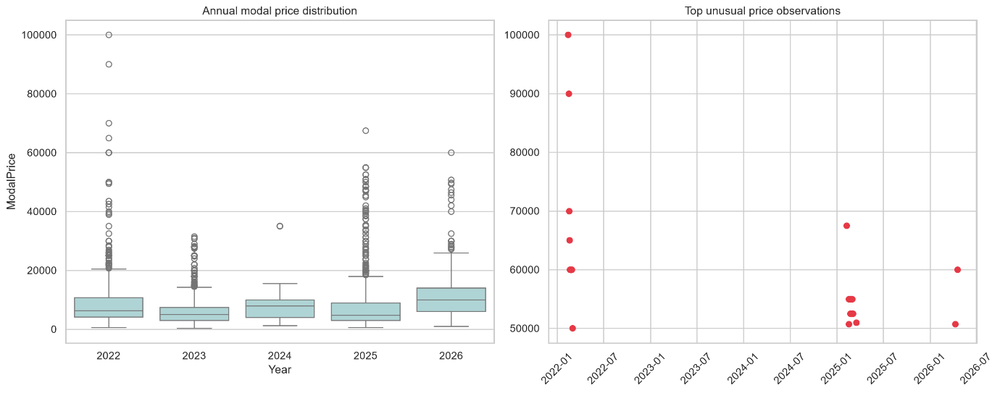
Figure 4.6: Annual price distribution and unusual price observations
In this study, the presence of outliers was detected through exploratory data analysis but were not deleted automatically. The price levels for agricultural commodities, particularly the price level of mangoes, may be highly volatile because of genuine market occurrences like changes in seasonality, production of superior quality of goods, sudden changes in demand, few supplies, transportation issues, and local market dynamics. Hence, unusually high modal prices were considered outliers but were still valid observations of the market.
Only those instances of data were dropped from the analysis which had obvious data quality problems, such as missing data points, duplication, invalid dates, and non-positive price or arrival. All valid observations for high prices have been kept to ensure that the data remains representative of the volatile nature of the real world APMC markets.
The reason why it is significant is that the dropping of all extreme values would make the problem of prediction very easy and could decrease the practical significance of the model. Valid outliers were included to test the models in conditions which can be considered more realistic, but on the other hand, unexpected price spikes are not easy to forecast.

4.3 Model Performance Evaluation
All models were evaluated on the chronological test set. Table 4.1 shows the results.
Model | MAE (Rs.) | RMSE (Rs.) | MAPE (%) | sMAPE (%) | R²
Persistence | 2173.79 | 5470.77 | 19.36 | 18.93 | 0.6372
GBR | 2214.22 | 5242.92 | 19.04 | 19.26 | 0.6668
Hybrid | 2226.91 | 5270.18 | 19.14 | 19.36 | 0.6633
XGBoost | 2279.24 | 5358.91 | 19.62 | 19.87 | 0.6519
Random Forest | 2288.91 | 5307.43 | 19.77 | 20.07 | 0.6585
Seasonal Median | 4665.23 | 8214.55 | 39.23 | 42.06 | 0.1820
Table 4.1: Test set performance for all forecasting models
The model comparison should be interpreted across multiple error measures rather than from a single score alone. The Persistence baseline achieved the lowest MAE (Rs. 2,173.79), which indicates that, for many short-gap reports, the last observed price remains a strong immediate predictor of the next one.
GBR, however, produced the highest R² (0.6668) and the lowest RMSE (Rs. 5,242.92) among the learned models. This indicates that GBR captured overall price variation more effectively and handled medium-sized changes better than the other machine-learning approaches, even though its MAE was marginally higher than Persistence.
The Hybrid ensemble remained competitive, with an R² of 0.6633 and an MAE of Rs. 2,226.91, but it did not surpass GBR on the main summary metrics. This result is consistent with the learned ensemble weights, which placed most of the final contribution on GBR and a smaller share on XGBoost.
Seasonal Median performed substantially worse across all metrics, showing that seasonality alone is not sufficient to explain short-term market movement in this dataset. Taken together, the results suggest that recent market history matters more than a simple seasonal benchmark, while also showing that low absolute error and high explained variance do not always belong to the same model.

4.3.1 LSTM/Sequence Benchmark Across Eligible Markets
A separate LSTM/sequence benchmark was evaluated for every market that had enough observations for a 14-report chronological lookback design. The purpose of this experiment was not to replace the primary leakage-safe hybrid model, but to test whether ordered price-history patterns could add value in selected markets.
The results show that the sequence component was not uniformly beneficial across districts. In several markets, the validation process assigned an LSTM weight of 0%, meaning the model correctly fell back to persistence or hybrid behaviour. This is an important academic finding because it shows that deep learning was tested under a fair chronological protocol but was not overclaimed where the data did not support it.

Features Given to LSTM
ModalPrice
ArrivalQty
days_since_previous_report
price_change_1
price_roll_mean3
price_roll_std3
arrival_roll_mean3
month_sin
month_cos
day_of_year_sin
day_of_year_cos
report_number
District | Market | MAE | R2 | LSTM wt. | Interpretation
Amarawati | Amrawati(Frui & Veg. Market) APMC | Rs. 771 | 0.663 | 20% | Useful sequence gain
Nagpur | Kamthi APMC | Rs. 451 | 0.815 | 0% | Fallback to persistence/hybrid
Nagpur | Nagpur APMC | Rs. 730 | 0.243 | 0% | Fallback to persistence/hybrid
Ahilyanagar | Shrirampur APMC | Rs. 1,189 | 0.691 | 0% | Fallback to persistence/hybrid
Nashik | Nasik APMC | Rs. 1,298 | 0.875 | 0% | Fallback to persistence/hybrid
Pune | Pune(Moshi) APMC | Rs. 1,890 | 0.073 | 0% | Fallback to persistence/hybrid
Mumbai | Mumbai- Fruit Market APMC | Rs. 1,965 | 0.875 | 0% | Fallback to persistence/hybrid
Sangli | Sangli(Phale, Bhajipala Market) APMC | Rs. 2,289 | 0.595 | 0% | Fallback to persistence/hybrid
Chattrapati Sambhajinagar | Chattrapati Sambhajinagar APMC | Rs. 1,949 | 0.657 | 25% | Validation selected LSTM, but test did not improve
Solapur | Shri Siddeshwar APMC | Rs. 1,283 | 0.335 | 25% | Validation selected LSTM, but test did not improve
Table 4.2: Eligible-market LSTM/sequence benchmark summary
Of all the market data being evaluated, Amarawati (Amrawati Fruit and Vegetable Market APMC) still turned out to be one of the best examples where the signal helped make a difference. With the recent fine-tuning, MAE oriented LSTM_Hybrid generated a MAE of Rs. 772 and R2 of 0.664, whereas R2 oriented LSTM_Hybrid_R2 had MAE of Rs. 768 and R2 of 0.665. In other words, it is possible to see that the improvements in terms of MAE and R2 were minor. At the same time, the dashboard mentions markets like Nashik and Pune, where the use of the R2 oriented variant allows one to improve R2 at the expense of increasing MAE. Thus, it would be correct to say that the results of R2 improvement represent the benchmark only.
District | Market | R2 MAE-tuned | R2-tuned R2 | R2 gain | MAE change
Nashik | Nasik APMC | 0.875 | 0.885 | +0.010 | Rs. 80
Nagpur | Kamthi APMC | 0.815 | 0.815 | +0.000 | Rs. 0
Amarawati | Amrawati(Frui & Veg. Market) APMC | 0.664 | 0.665 | +0.001 | Rs. -4
Pune | Pune(Moshi) APMC | 0.073 | 0.137 | +0.064 | Rs. 197
Table 4.2a: R2-oriented LSTM hybrid comparison for selected markets
The version of R2 that has been calibrated would be helpful in describing variances but not necessarily as an accurate forecast with the minimum error since Nashik has been upgraded from R2 0.875 to 0.885, and Pune has been upgraded from R2 0.073 to 0.137 but with an increase in MAE of Pune.

4.4 Explainability Analysis
4.4.1 Global Feature Importance

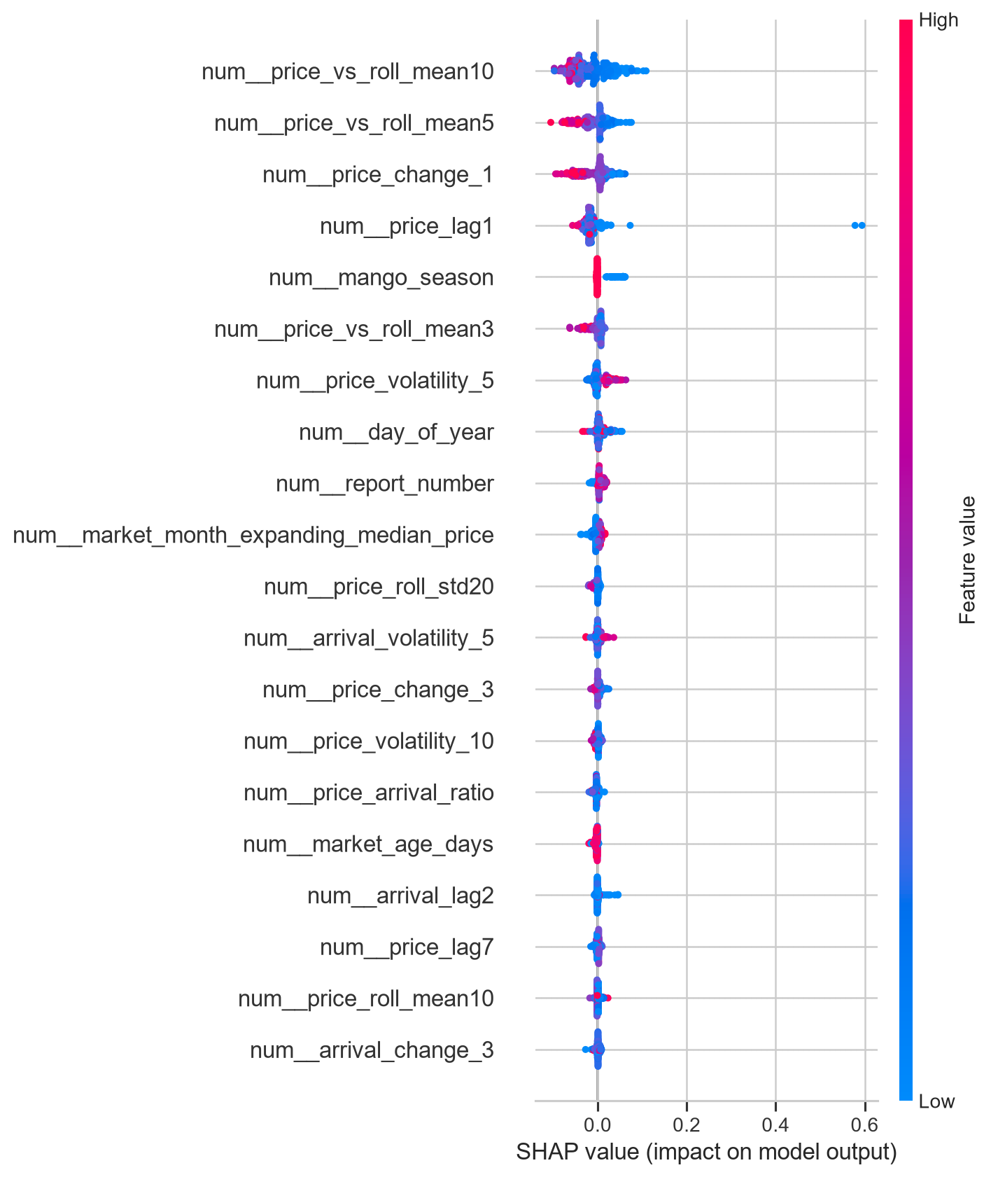
Figure 4.7: SHAP summary plot of the most influential features
Feature | Mean Absolute SHAP Value
num__price_vs_roll_mean10 | 0.037446
num__price_vs_roll_mean5 | 0.024306
num__price_change_1 | 0.022127
num__price_lag1 | 0.021774
num__mango_season | 0.009502
num__price_vs_roll_mean3 | 0.009269
num__price_volatility_5 | 0.009168
num__day_of_year | 0.008310
Table 4.3: Top SHAP features and their mean absolute importance values
The SHAP analysis identifies the eight features with the strongest average influence on model predictions. Seven of the eight are price-derived variables — recent lags, rolling deviations, and volatility measures. The eighth, mango_season, reflects the broader seasonal context.
The most influential feature is price_vs_roll_mean10: the deviation of the current price from the ten-observation rolling average. A large positive deviation suggests the market is currently trading above its recent norm, which the model interprets as a signal that reversion may occur. Similarly, price_vs_roll_mean5 captures shorter-term deviations, while price_vs_roll_mean3 captures very recent local shifts. Together these features allow the model to assess whether the current price is an outlier relative to the recent trend at multiple time scales.
price_change_1 records the one-step price movement, reflecting immediate momentum. price_lag1 provides the most recent observed price directly. These two features give the model a strong short-term anchor.
price_volatility_5 helps the model distinguish between stable and volatile markets. In volatile conditions, the model may produce wider uncertainty estimates and moderate its predictions accordingly. day_of_year helps the model capture gradual within-year seasonal variation that a binary season flag might not fully represent.
Notably, location-based features do not appear among the top eight. This is consistent with the ablation findings discussed in Section 4.5.4.

4.4.2 SHAP Dependence Plot

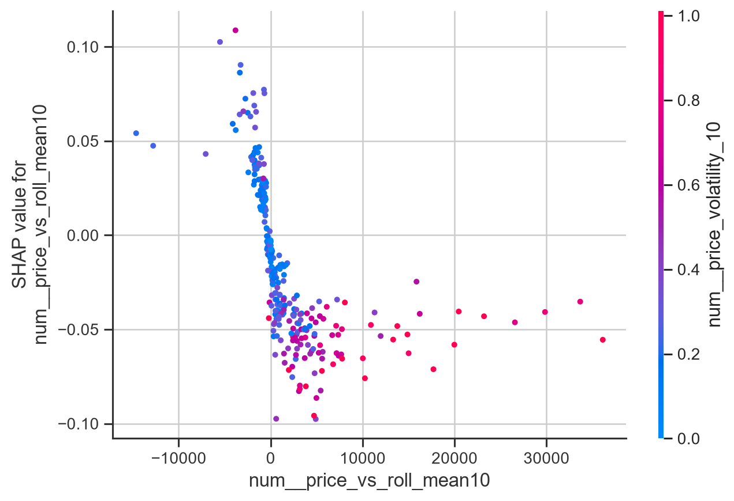
Figure 4.8: SHAP dependence plot for price deviation from the 10-step rolling mean
From the dependence plot for the feature price_vs_roll_mean10, one can observe that the dependence of the feature on its SHAP value is non-linear. If the current price is much lower than the rolling mean, then the SHAP value will be positive; the model will increase the prediction because it expects the price to revert back to its mean. On the other hand, when the current price is higher than the rolling mean, the SHAP value is negative; the model will decrease the predicted value.

4.4.3 Local Prediction Explanation

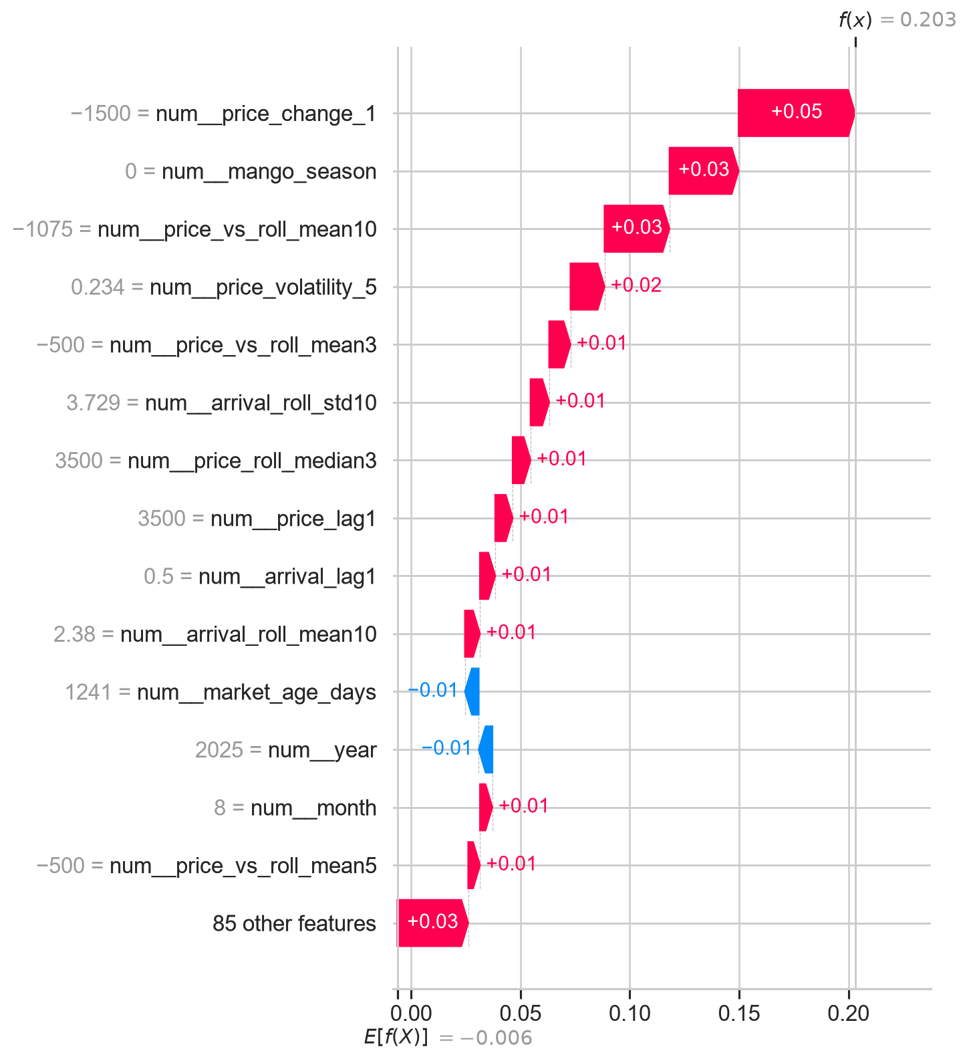
Figure 4.9: SHAP waterfall explanation for an individual prediction
The waterfall chart in Figure 4.9 explains one individual prediction by showing how each feature moves the model output upward or downward from the baseline expectation. In the illustrated case, recent negative price change, seasonality, and deviation from rolling price means are the dominant upward contributors to the final forecast.
This local explanation is important because it converts the model from a black box into a traceable decision aid. A user can see not only the predicted value but also the market conditions that caused the prediction to rise or fall.

4.5 Test Set Diagnostics

4.5.1 Chronological Test Set Diagnostics

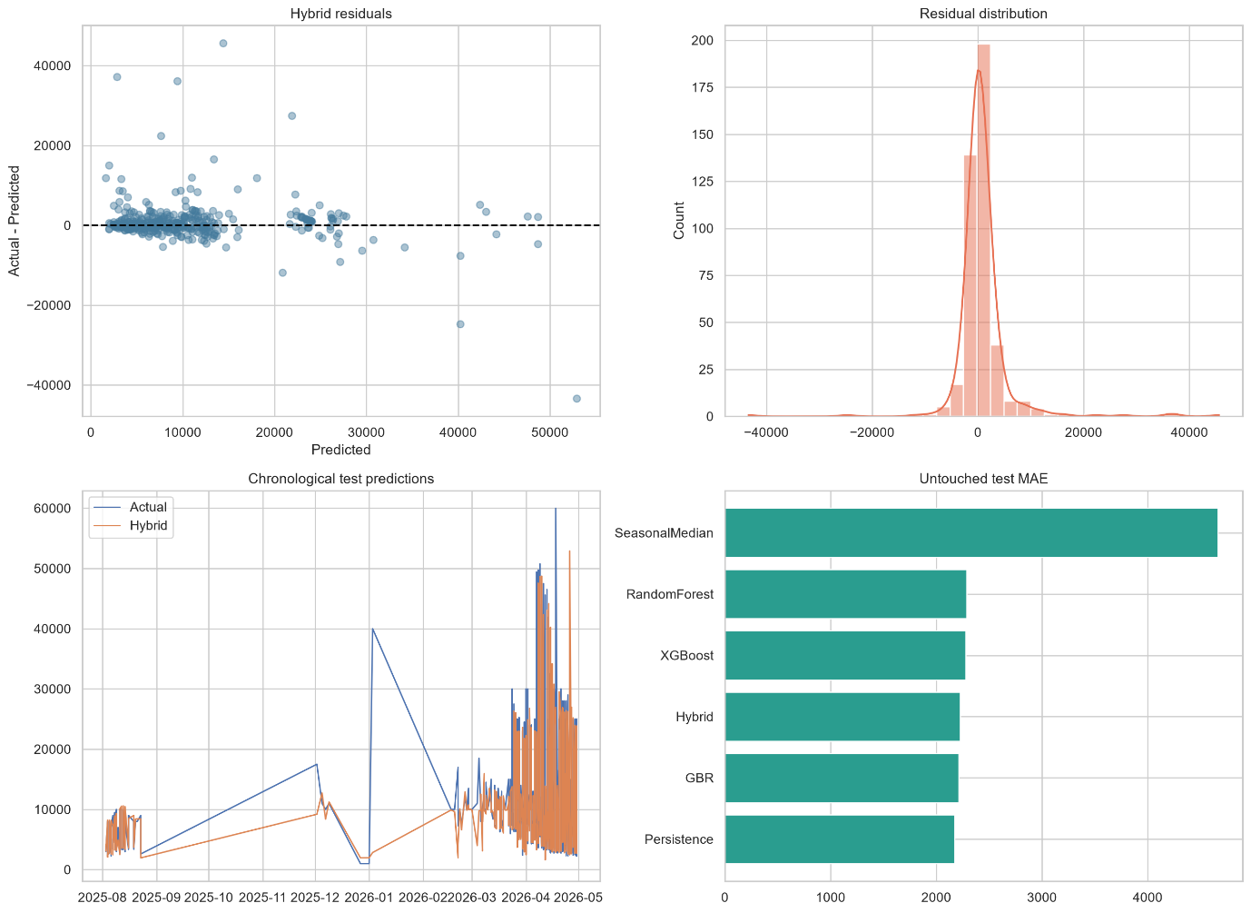
Figure 4.10: Untouched chronological test set diagnostics
The diagnostic plots for the hybrid model confirm that most residuals are concentrated near zero, although large errors still occur during sharp price spikes. The residual distribution remains centered, which suggests that the model is not strongly biased upward or downward overall, but the prediction trace also shows that abrupt extremes are only partially captured.

4.6 Dashboard Results

4.6.1 Next-Report Forecasting Interface

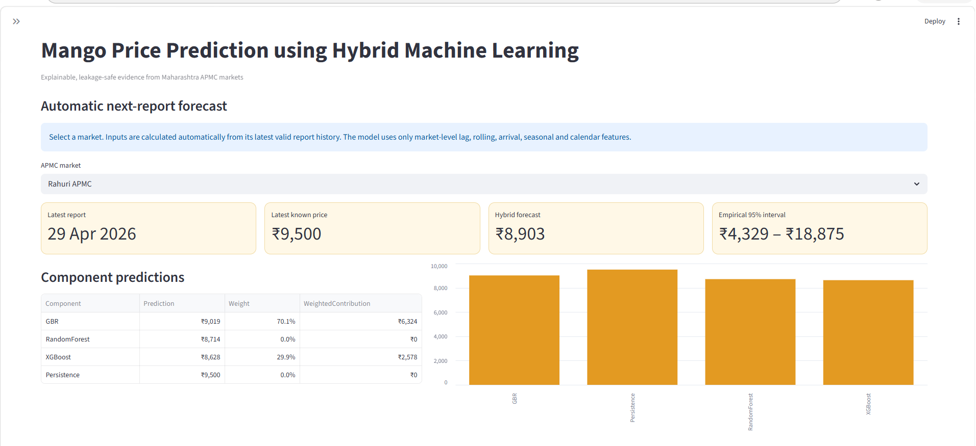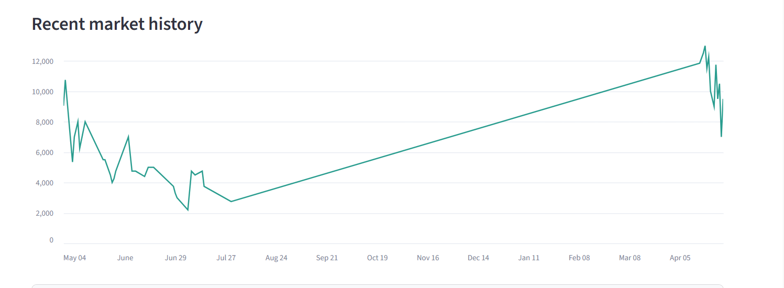
Figure 4.11: Next-report forecasting interface of the Streamlit dashboard
Figure 4.11 presents the next-report forecasting interface for Rahuri APMC. The latest available market report is dated 29 April 2026, the latest known modal price is Rs. 9,500 per quintal, and the hybrid next-report forecast is Rs. 8,903. The accompanying empirical interval of Rs. 4,329 to Rs. 18,875 communicates uncertainty directly instead of implying a single guaranteed market quote.

4.6.2 Future Forecasting

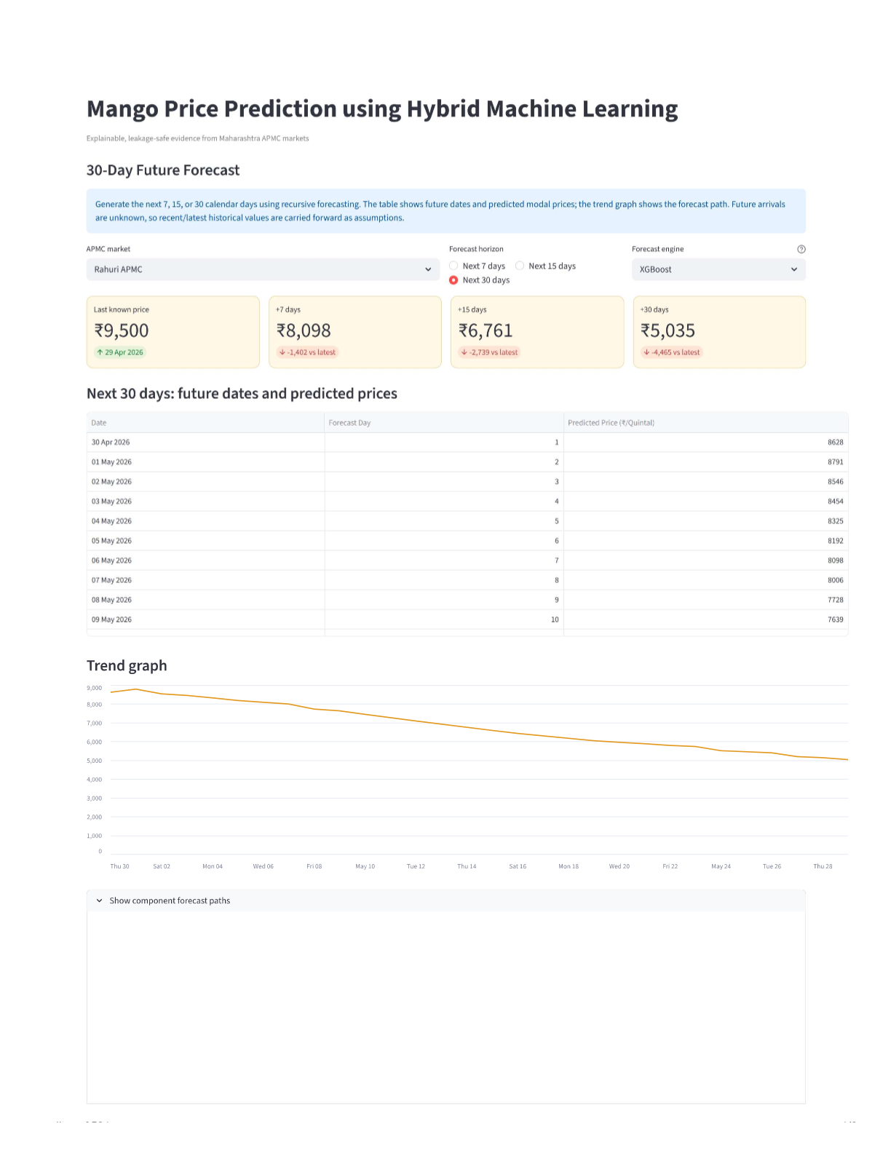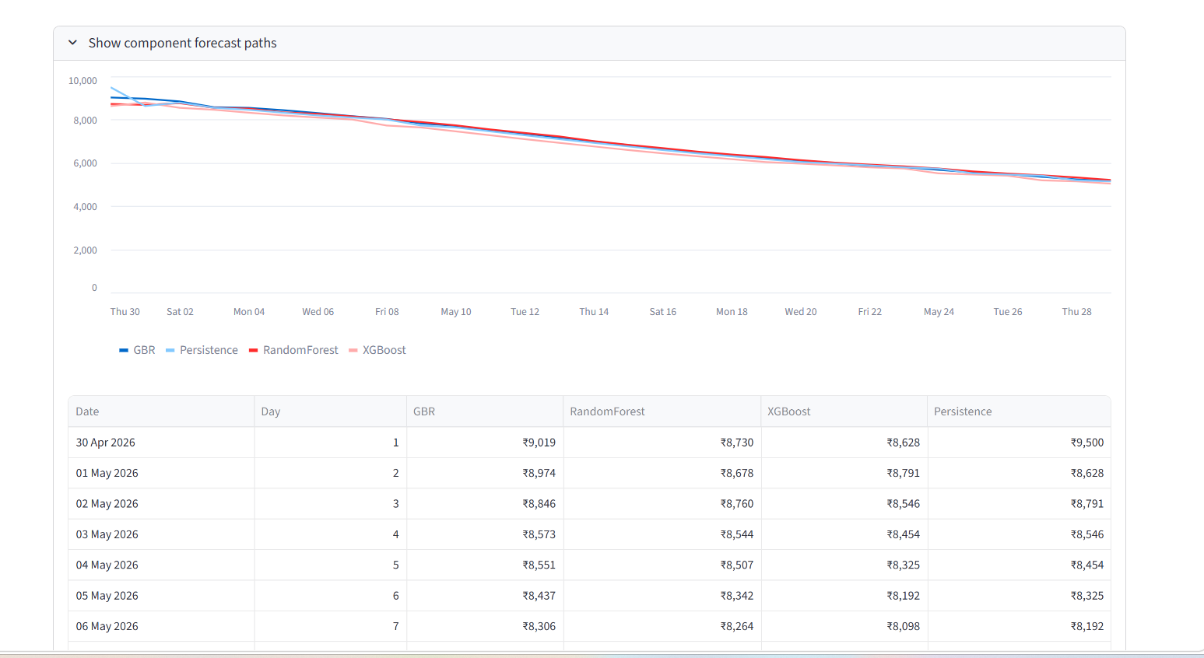
Figure 4.12: Future forecast interface of the Streamlit dashboard
The future-forecast page uses recursive prediction to generate 7-day, 15-day, and 30-day scenarios. For Rahuri APMC, the projected path declines from the latest price of Rs. 9,500 to about Rs. 8,098 after 7 days, Rs. 6,761 after 15 days, and Rs. 5,035 after 30 days. These outputs should be interpreted as scenario-based expectations under the observed recent pattern, not as fixed future market prices.

4.6.3 Model Performance Interface

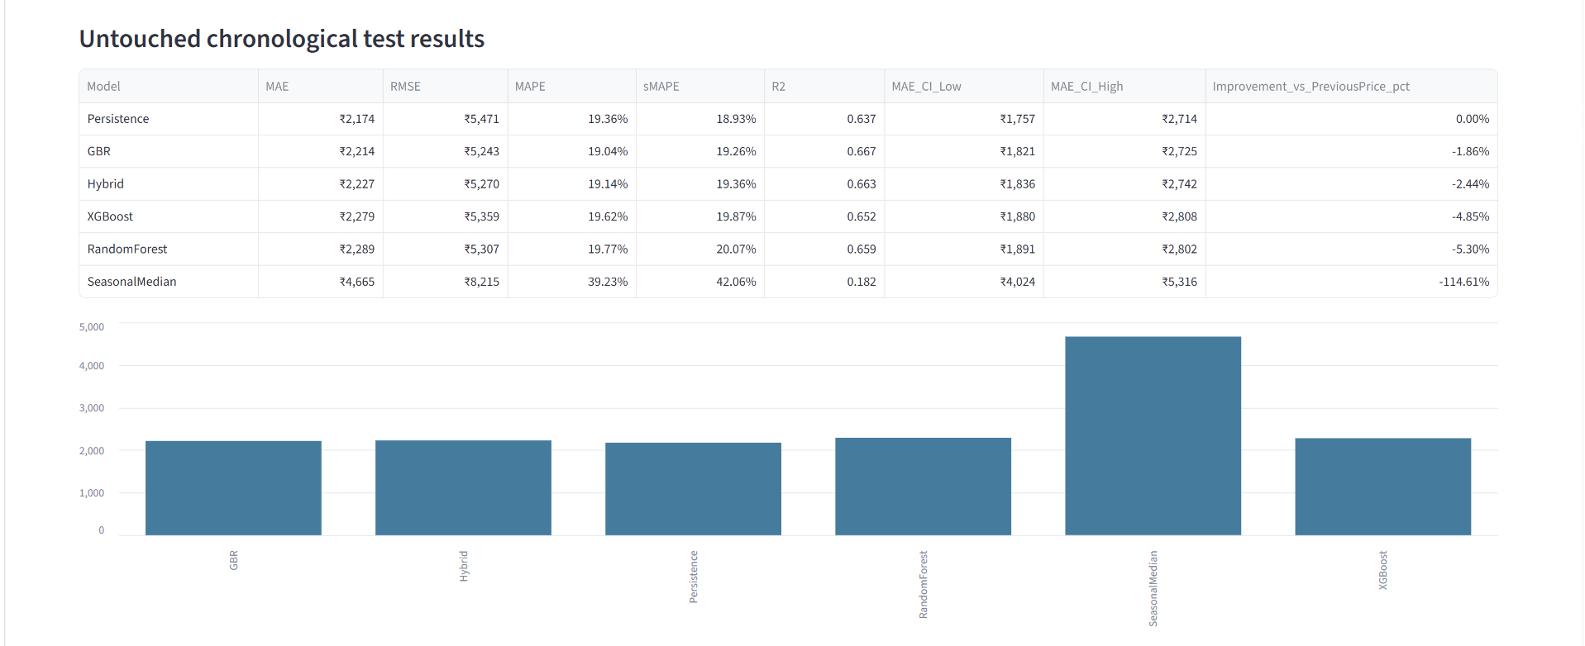
Figure 4.13: Model performance interface of the Streamlit dashboard
The dashboard's performance page brings the evaluation results into a compact visual form by combining the test-metric table, MAE comparison chart, and residual diagnostics. This view makes it easier to explain why Persistence has the lowest MAE, why GBR has the highest R², and why Seasonal Median is clearly weaker than the other approaches.

4.6.4 Feature-Group Ablation Analysis

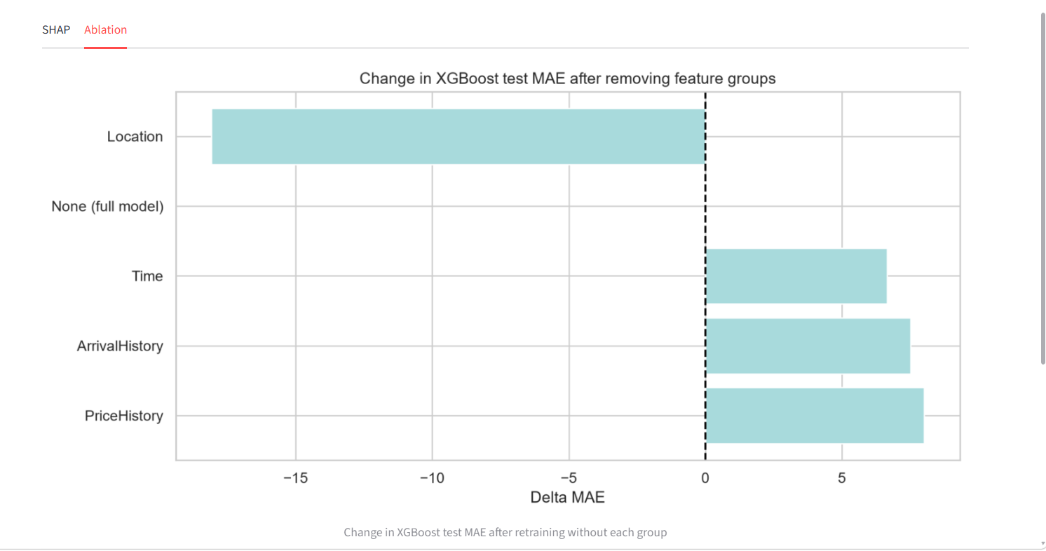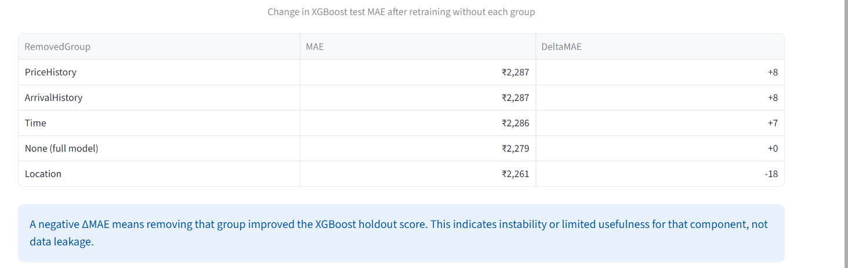
Figure 4.14: Feature-group ablation analysis in the Streamlit dashboard
The ablation analysis re-trained XGBoost after removing one feature group at a time and compared the revised MAE with the full-model MAE of Rs. 2,279.24. Removing PriceHistory increased MAE to Rs. 2,287.25 (+8.01), removing ArrivalHistory increased it to Rs. 2,286.75 (+7.51), and removing Time increased it to Rs. 2,285.88 (+6.65).
These increases show that recent price behaviour, arrival dynamics, and calendar position each contribute useful predictive signal, even though none of the three groups alone determines performance.
By contrast, removing Location reduced MAE to Rs. 2,261.15 (-18.09). This suggests that the market and district identifiers, in the present XGBoost specification, added mild instability rather than dependable predictive value. The result does not indicate leakage; instead, it points to limited usefulness of location encoding in the reduced holdout setting.

4.6.5 LSTM Benchmark Dashboard Interface
A benchmark for LSTM is made for analyzing the sequence learning experiments on a market-by-market basis. The new dashboard differentiates between the model that gives the best MAE and the one that gives the best R2 value. This is important for reporting purposes since the LSTM_Hybrid is designed to minimize rupee error while the LSTM_Hybrid_R2 is designed for variance explained.
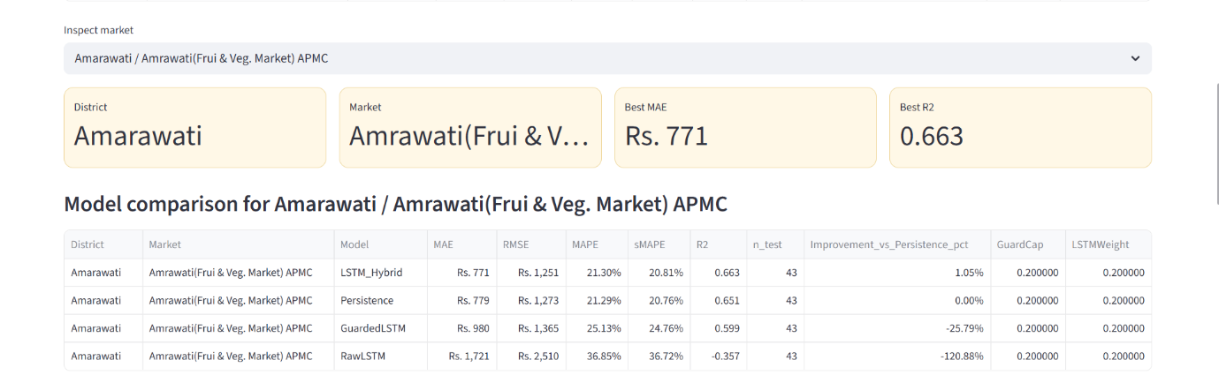
Figure 4.15: Selected-market LSTM benchmark summary for Amarawati APMC

The LSTM Benchmark page makes it possible for the user to examine each qualified market individually. With the new version, the dashboard displays the chosen district and market, the best MAE, and the best R2 as individual metrics. The reason why it is necessary to distinguish them is that the model with the lowest average rupee error does not necessarily have the highest R2.
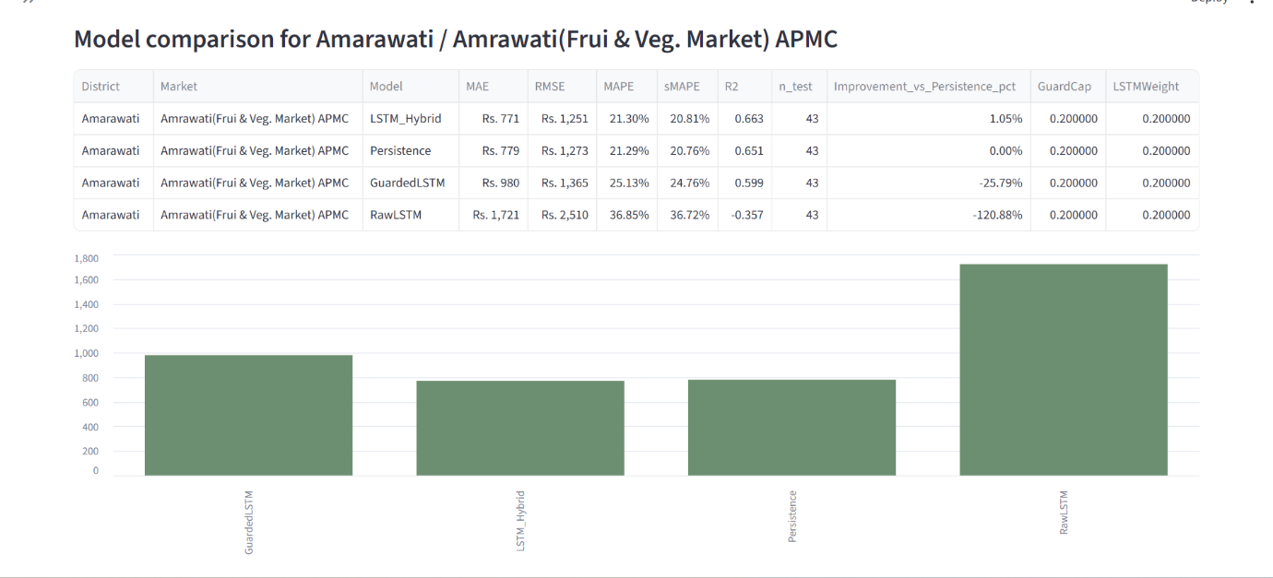Figure 4.16: Model-wise comparison for Amarawati APMC

The model comparison table and MAE chart show that the guarded sequence approach is most useful when it is validated carefully. For Amarawati, the MAE-oriented LSTM_Hybrid reached MAE of about Rs. 772 and R2 of 0.664, while the R2-oriented LSTM_Hybrid_R2 reached R2 of 0.665 with slightly lower MAE of about Rs. 768. The raw LSTM result remains weaker, confirming that the sequence model should be guarded before it is blended with the baseline forecast.
4.6.6 LSTM Future Forecast Dashboard Output
the LSTM component in line with the current machine learning future forecast page for which the user can choose 7-day, 15-day, and 30-day periods. The forecast is still a scenario and not an assured market quotation since the future arrival and market surprises cannot be known ahead of time.The choice of the example report in this regard was Amrawati Fruit and Vegetable Market APMC due to its strong balanced LSTM component. The LSTM_Hybrid_R2 model was chosen to demonstrate the R2-based guarded sequence forecast. With a starting point of the most recent modal price of Rs. 2,250 on 30 April 2026, it predicted Rs. 3,106 after 7 days, Rs. 2,795 after 15 days, and Rs. 2,373 after 30 days.
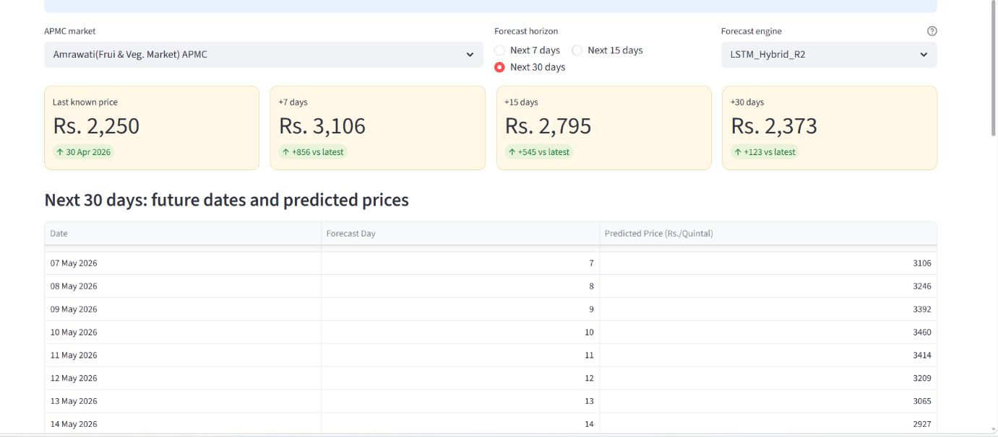
Figure 4.19: LSTM_Hybrid_R2 future forecast summary for Amarawati APMC

LSTM based engines were also added to the Future Price Prediction Page. For Amrawati Fruit & Vegetable Market APMC, the last known modal price is Rs. 2,250, dated 30th April 2026. Through the use of the LSTM_Hybrid_R2 engine, the dashboard predicted that the price would be Rs. 3,106 after 7 days, Rs. 2,795 after 15 days, and Rs. 2,373 after 30 days.
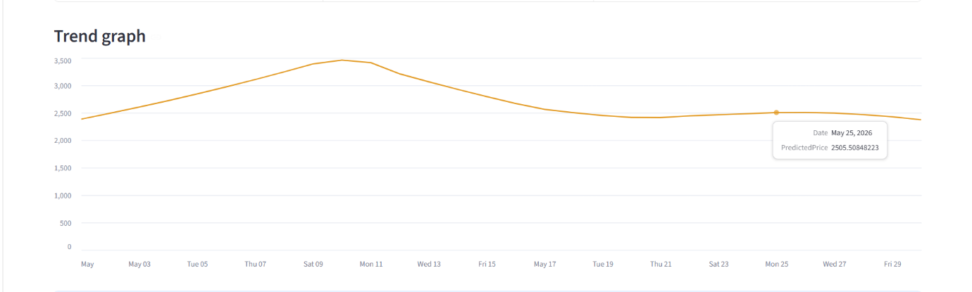
Figure 4.20: Thirty-day LSTM_Hybrid_R2 forecast trend for Amarawati APMC
The trend graph shows that the LSTM_Hybrid_R2 scenario first moves upward, reaches its strongest level during the early part of the 30-day window, and then gradually corrects toward a more stable price range. This means the sequence model does not simply project a continuous increase; it captures a short-term rise followed by stabilisation.

4.7 Discussion
Overall, the results suggest that machine learning techniques have the capability to extract relevant structure from Maharashtra mango price data. The high R² and reasonable MAPE of the GBR model reveal that the former model has a greater capability to explain variations of prices within the test data set relative to a heuristic approach, despite the fact that the Persistence model holds equal performance based on the MAE metric. Both these results are mutually consistent since it is difficult to surpass the baseline model in terms of mean absolute error since the last price is an excellent point of reference but it cannot explain the variations.
The SHAP results show that the most important variables in the prediction process include the rolling deviation metrics, the last price and the momentum of prices. The seasonal variables play an auxiliary but nontrivial role. The location variables are not of great importance compared to what one may initially expect in the XGBoost model.
A recurring weakness in all models is the difficulty of reproducing sudden and irregular price spikes. The forecasting system is therefore more reliable for normal market movement than for exceptional premium-price episodes.
A robust evaluation design is one of the strongest aspects of the methodology. Because the train, validation, and test windows were separated chronologically, the reported performance more closely represents real forecasting use than a random split would.
This claim is additionally proven by the LSTM/Sequence benchmark results. Sequence learning was beneficial in certain market cases, specifically in Amarawati, because previous price changes included temporal structure useful for improving the guarded hybrid results. The introduction of the additional LSTM_Hybrid_R2 model proves that there is a possibility to improve R2 scores in some markets, for example, Nashik and Pune, although this could result in increasing MAE. Hence, the sequence model should be regarded as a controlled comparative research element.

Chapter 5: Conclusion and Future Scope

5.1 Conclusion
A machine learning-based system that could forecast prices of mangoes in Maharashtra APMC Markets was designed, utilizing only historical information about prices in the markets as the input data. The machine learning-based system was developed taking into account only the leakage-free constraints that ensure that all the metrics and features reflect the true picture of the knowledge available for the prediction.
Gradient Boosting Regressor showed the highest result with the R² value equal to 0.6668 on the chronological test set, and Hybrid ensemble also had good results in terms of performance, but more stable ones. The lowest MAE value was demonstrated by Persistence model that confirmed the high short-term predictability of the most recent price in the market. Seasonal Median had much lower performance compared to others.
The SHAP explainability results further show that recent price behaviour, especially rolling deviations, one-step price change, and the latest available price, carries much more predictive weight than static location labels.
The Streamlit interface extends the practical value of the study by allowing users to inspect market history, compare model outputs, view future scenarios, and interpret forecasts without working directly with the codebase.
The recently introduced LSTM/sequence benchmark test bolsters the research with evidence that the deep learning approach to sequence modeling was conducted in a fair manner within the eligible markets. The new experiment includes the R2-focused LSTM_Hybrid_R2 model, which positively affected the R2 measure in certain cases. Nashik grew its R2 from 0.875 to 0.885, Amarawati rose from R2 0.664 to 0.665, and Pune went from R2 0.073 to 0.137. But on the other hand, it appears that a higher R2 may be connected to a higher MAE value.

5.2 Future Scope
Various avenues for future work can be proposed, in consideration of the limitations of this paper.Perhaps the most promising avenue to pursue is that of including external variables. Information about weather patterns, rainfall statistics, crop production estimates, prices of alternative energy sources, and festival schedules can all serve as an indicator of changes in prices ahead of time that cannot be determined from market data alone. In particular, arrival information will be useful, because arrival quantities have a strong impact on price formation.
While the current model focuses on Maharashtra, a wider range of markets in other important producers of mango fruit such as Andhra Pradesh, Uttar Pradesh, and Gujarat can significantly expand the scope of the price prediction system.
In terms of the models themselves, Transformer-based architectures and Temporal Fusion Transformers (TFT) can be explored as alternatives to the current tree-based models.
Future work can also extend the sequence-learning experiment by using a fully configured deep-learning runtime, longer time coverage, and richer exogenous variables such as weather, variety, festival demand, and transport conditions. These additions may improve the stability of LSTM-based models in markets where the current dataset was too sparse or irregular.
Currently, a new forecast is created every time the pipeline is run with new data. This process can be automated using live APMC data feeds and daily updates of the pipeline.
Other improvements that could be made to the Streamlit dashboard include mobile-responsive designs, multi-language support for local languages, PDF reports, and configurable forecast periods by users. This will allow the dashboard to be accessible to farmers and traders who might use the dashboard from their mobile devices and prefer Marathi or Hindi over English.
Finally, the findings of the ablation study indicate that location-based features may contribute to noise in the current XGBoost model setup. Research into ways to include market-based information and the effects of such information inclusion could yield benefits in the generalisation of the model in other markets with little historical data.

