Cover Letter for Manuscript Submission
From
UdayaRekha,(Author)
Research Scholar ,
Department Of Zoology,
AdikaviNannaya University,
Rajamundry,
Andhra Pradesh.

To ,
The Editor,
Journal of Environmental Biology.

Subject: Submission of manuscript titled “Study of Microbial Infections in Acute Myeloid Leukemia and Acute Lymphocytic Leukemia patients undergoing induction therapy”.

Dear Editor,
We submit the manuscript entitled “Study of Microbial Infections in Acute Myeloid Leukemia and Acute Lymphocytic Leukemia patients undergoing induction therapy”,authors are U.R.Peddada and Prof.K.Dasari.
Leukemia is a cancer of blood cells. Chemotherapy is the first line of treatment. Few patients undergoing chemotherapy develop fever which is a first sign of infection. Leukemia patients are more susceptible to infections because their body’s immune system fails to fight against infection. Patients develop skin, blood, urinary tract infection ,respiratory infections which may lead to mortality in patients. Samples from infected patients are collected and tested to identify and isolate the pathogens and understand the relations between infections, role of noso comial ,synergetic drug reactions and antimicrobial resistance and mortality can be studied.
This research shall assist health care providers to explore innovative strategies in treating infections thus reducing hospital stay for patients and to identify antimicrobial resistance of the isolated pathogens which may help in the enhancement of antibiotic therapy to reduce mortality. Since our journal deals with microbiology in connection with cancer biology we believe it aligns with the journal’s scope and fits to be published in Journal of Environmental biology. This article has not been published elsewhere ,not it is under consideration by any other publishers. The manuscript reflects original research conducted by its authors. As the research needs human sample ethics committee approval is also granted. My research guide has been informed and permission has been taken from my research guide to submit manuscript for publication.
We hope you find the manuscript suitable for publication ,looking forward to hear from you.
Thanking you.
Yours Sincerely,
Udaya Rekha(Author)
Research Scholar,
Department Of Zoology,
Adikavi Nannaya University,
Rajamundry-533296
Andhra Pradesh.
Email:udayarekha.raghu@gmail.com
Mobile No:9676693603
Co Author:
Prof. D. Kalyani,
Research Guide,
Department Of Zoology,
Adikavi Nannaya University,
Rajamundry -533296
Andhra Pradesh.
Email: dk.zoo@aknu.edu.in
Mobile No:9849419160

Study of Microbial Infections in patients of Acute Myeloid Leukemia (AML) and Acute Lymphocytic Leukemia(ALL) under going induction therapy.
Udaya Rekha, Research Scholar ,Department Of Zoology,Adikavi Nannaya University,Rajamundry, Andhra Pradesh.Email:udayarekha.raghu@gmail.com
Prof.D.Kalyani, Research Guide,Department Of Zoology,Adikavi Nannaya University, Rajamundry, Andhra Pradesh.Email:dk.zoo@aknu.edu.in

Abstract
Aim:
To study the profile of microbial infections in acute myeloid leukemia and acute lymphocytic leukemia patients undergoing induction therapy , to understand the role of infections and antimicrobial resistance in increasing mortality.
Methodology:
Leukemia patients undergo induction therapy as the first line of treatment during which they may develop infections. Fever appears to be the first symptom of infection.The infections are typically confined to blood stream, throat ,gastro intestinal tract and respiratory tract. Samples from infected patients were collected, tested and analyzed to identify the pathogens and find their antibiotic sensitivity .The study is being carried out since mid 2025.
Results:
25 patients Acute Lymphocytic Leukemia and 4 Acute Myeloid Leukemia were studied in the present research till date. Patients were categorized based on age children-19(below 15 years, young adults-2(16-23yrs), adults-4(41-60Yrs). Out of 25 patients ,1 patient(11years,female) passed away due to shortness of breath .Out of 4 AML patients one female patient showed no signs of improvement after chemotherapy for 2 months and eventually passed away after discharge.

Interpretation:
The research shall assist health care providers to understand microbial infection patterns in patients undergoing induction therapy and helps to implement innovative strategies in infection control and antibiotic therapy ,there by reducing hospital stay and infection related mortality in patients.
Graphical Representation
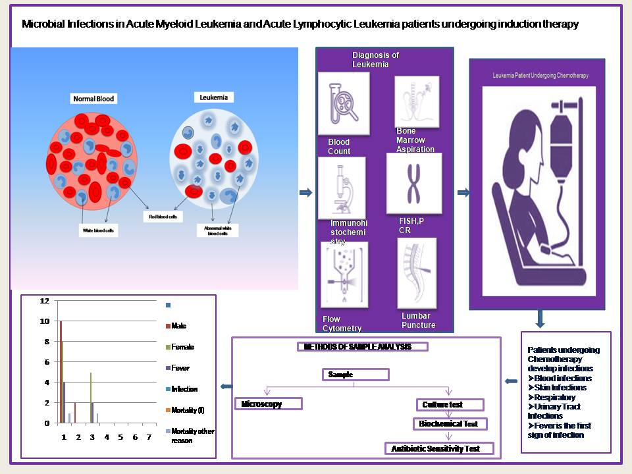

Key Words: Leukemia , infections, cancer, induction therapy, bone marrow, chemotherapy.
Introduction:
Cancer is an ailment caused by the uncontrolled growth of cells in the body(Weinberg,1996).Proto-oncogenes regulate cell growth, multiplication and cell death (apoptosis).In few instances,proto-oncogenes mutate to form oncogens. Oncogenes cause cells to escape apoptosis and grow rapidly, spreading to surrounding tissues forming lump or group of cells known as tumor. Among the population of cells present in tumors,cancer stem cells(CSC) play a crucial role in development of cancer,(papaccio,2017) also named as Tumor and Neoplasm. Tumors are composed of different types of cells that contribute to tumor diversity (Papaccio F,2017).
Mechanisms of Carcinogenesis: The process of normal cells altering into cancer cells isknown as carcinogenesis. Mutations in critical genes produce tumors.Mutations in the tumour-suppressor gene p53 are responsible for about half of human tumors(Joerger,2007). DNA lesions (damaged bases or chromosome breaks) also cause mutations when the cell divides. Thus endogenous DNA damage is found to be high. The mutagenic effectiveness of a particular lesion depends on its rate of excision by DNA repair enzymes and on the probability that it gives rise to a mutation when the cell divides. Cell division is a critical factor in mutagenesis, because when the cell divides a DNA lesion can give rise to a point mutation, deletion, or translocation.Cell cycle checkpoints are suggested to prevent division of cells with too many DNA lesions, thus inhibiting the formation of mutations (Papaccio et. al , 2017).
Hematopoietic cell lineage: HSCs are hematopoietic stem cells that differentiate into various hematopoietic cells such as platelets, erythrocytes ,granulocytes, macrophages, T cells and B cells(Morrison et al 1995).HSCs are found in organs like peripheral blood (PB), bone marrow (BM) and umbilical cord blood (UCB).The hematopoietic lineage is divided into the myeloid and lymphoid arms.(Mikkola et al 2006).

Fig :1 Hematopoietic Cell Lineage showing formation of different cells.(Eaves,et al 2015).
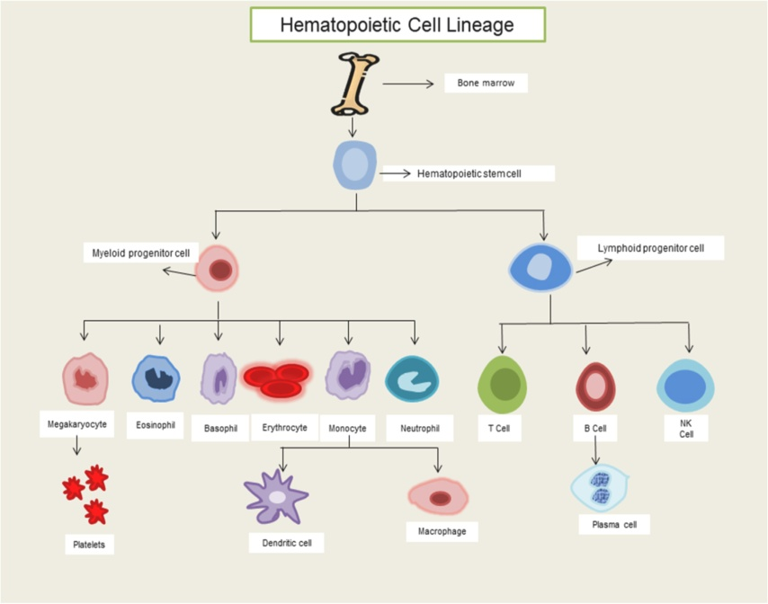
Leukemia:
Blood cells like erythrocytes, white blood cells and platelets are formed from bone marrow.Leukemia is a cancer of blood cells usually white blood cells that are formed through myeloid lineage from stem cell precursors(Davis, 2014). The white blood cells formed from the bone marrow are immature or abnormal due to genetic mutations(Papaemmanuil E. , 2016).These abnormal white blood cells known as blast cells increase rapidly thus replacing the number of healthy red blood cells and platelets. The immature WBC formed from uncontrolled cell division fail to fight against infections. Leukemia is the most prevalent cancer in adults above 60 years(Appelbaum,etal2006). It is further classified into myelogenous leukemia and lymphoblastic leukemia based on the type of cells affected(Vardiman et al, 2002).
Fig:2 Comparing red blood cells and white blood cells in normal blood sample and leukemia blood sample.
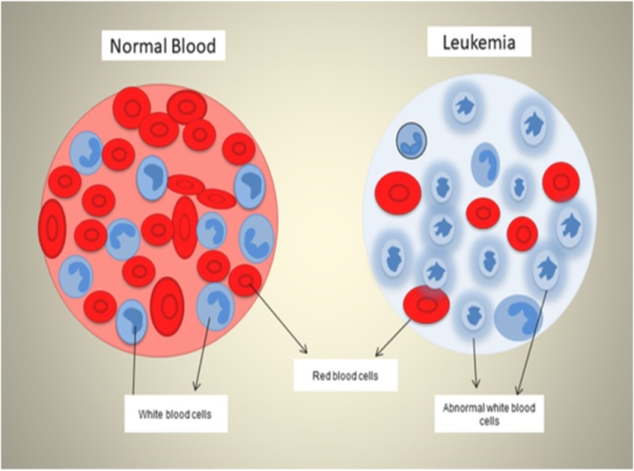
Myelogenous Leukemia (Myeloid Leukemia) is the cancer of red blood cells, platelets and white blood cells.(Vardiman et al,2002),(Vardiman et al, 2008) .Myeloid Leukemia is a result of uncontrolled proliferation of abnormal myeloid progenitor cells formed due to genetic changes, resulting in increased production of immature myeloid cells in the bloodstream. These immature blood cells crowd out healthy blood cells and interfere with the body's ability to fight infections .Lymphoblastic Leukemia(lymphoid leukemia) is the malignancy of T-cells and B cells. Leukemia is further classified as acute and chronic depending on the progression of the disease .(Szczepański, 2003).
Origin of the proposal:
Patients diagnosed with acute myeloid Leukemia and acute lymphocytic Leukemia undergo induction therapy as the first choice of treatment.7+3 regimen(shipley, 2009).The aim of the therapy is to reduce the number of cancer cells and achieve remission. Few patients develop fever (neutropenia) (FLED, 2008)while under chemotherapy,which may be a symptom of certain infections like blood stream infections(BSI),respiratory tract infections,fungal infections .The susceptibility to infections may be due to low immunity in patients.Health care providers observed that in patients who developed infections during chemotherapy, the percentage of mortality also increased.(Haddad, 2021).
Patients with haematological malignancies from 2008 to 2013 were retrospectively reviewed at a medical centre in northern Taiwan (chen, 2008-2013).The study revealed that gram negative bacteria is the causative pathogen for blood stream infections. This study revealed that gram negative bacteria are main causes of infection and septicaemia in AML patients.(chen, 2008-2013)(Haddad, 2021).
A study was conducted on febrile episodes between the year may 2001 and December 2006(Ajay Gupta, 2010)where 382 febrile neutropenia episodes were evaluated which showed most infections are due to gram negative bacteria and respiratory infections are predominant. The study suggested to evaluate antimicrobial resistance patterns to choose empiric antibiotic therapy which may help in reducing morbidity and mortality in patients.
These observations lead to the rise of questions like
Are infections in patients undergoing chemotherapy responsible for increase in mortality?
Which pathogens infect most AML and ALL patients?
The susceptibility to these infections is age ,gender based or based on comorbidities?
Does antimicrobial resistance of these pathogens play a role in increasing mortality?
Role of nosocomial infections or hospital acquired infections .
Acute Myeloid Leukemia (AML) is prevalent among adults above 55years(De Kouchkovsky et al.2016).It is a cancer of the blood and bone marrow ( the spongy tissue inside bones where blood cells are made).AML progresses rapidly and needs immediate treatment. It is caused due to abnormalities in chromosomes. The abnormal cells are known as blastocysts. Markers of Leukemia include age, WBC count, prior blood disorders and infections and presence of Leukemia cells in central nervous system. AML is classified into subtypes M0 to M7 (Vardiman, 2002).Symptoms of AML include fever or chills, bone pain, lethargy and fatigue,shortness of breath, pale skin. Frequent infections, easy bruising ,unusual bleeding such as frequent nosebleeds and bleeding from the gums.
Diagnosis of AML:
Blood Tests: AML is diagnosed by performing blood tests like total blood count, flow cytometry. Immunophenotyping, and cytochemistry are often used to distinguish AML from other types of Leukemia and to determine the exact subtype of AML.
Bone marrow aspiration and biopsy are similar and often performed simultaneously to examine the bone marrow. A bone marrow aspiration involves removal of a sample of the fluid with a needle. A bone marrow biopsy is the removal of a small amount of solid tissue using a needle.Biomarker testing of the Leukemia cells includes to identify specific genes, proteins and factors responsible for Leukemia. Examining the genetic changes in the Leukemia cells plays a vital role in understanding the causes and diagnose the specific subtype of AML and choose treatment options.
Lumbar puncture (spinal tap) : A lumbar puncture is a procedure in which a needle is used to take a sample of cerebral spinal fluid (CSF) to look at the make up of the fluid and to find out if it contains Leukemia cells or blood.

Treatment of AML:
The first choice of treatment for acute myeloid leukemia is induction therapy using 7 day Cyatarabine +3 day Daunorubicin regimen (Tamamyan, 2017) which helps in reducing the multiplication of Leukemia cells.In patients under 60 years, induction therapy often involves treatment with 2 chemo drugs namely Cytarabine (ara-C) and Anthracycline drug such as Daunorubicin (Daunomycin) or Idarubicin. In patients older than 60 years low dose Cytosine arabinoside (L Darc C) was given.(Sebban et al,1980),(Estey,2000)
The different phases of this treatment include induction phase which takes place for 4-6 weeks where Leukemia cells reach remission mean blood cells attain normal levels and no to few cancer cells .Consolidation phase is performed in cycles ranging from 4-6 months which aims in killing any undetected Leukemia cells. Maintenance therapy is the final phase in treatment to kill any remaining cancer cells and to prevent the relapse of cancer cells which takes nearly 2 years.
Other treatment options include immunotherapy,targeted therapy,radiation therapy bone marrow transplant and Chimeric Antigen Receptor Therapy (CAR T therapy).
Acute Lympocytic Leukemia is more common in children below 11years compared to adults. (Terwilliger,2017)(Davis, et 2014).It accounts for about 30℅of pediatric cancer .It is a malignancy of T cells and B cells caused due to chromosomal and genetic alterations where too many lymphocytes are produced. The immature or abnormal cells produced are known as lymphoblasts. B-cell ALL accounts for about 75-80℅ cases whereas T-Cell is less common(Rafei,et al,2019). Down syndrome,Fanconi anaemia,bloom syndrome increases risk of ALL. If philadelphia chromosome is present it is known as Philadelphia positive ALL,absence of Phildelphia chromosome is known as Philadelphia negative ALL. Acute Lymphocytic Leukemia progresses rapidly (Terwilliger, 2017).Symptoms include fever, bone pain, frequent infections, anaemia. Patients are categozised as high risk ,very high risk and standard depending on age and number of lymphocytes and comorbodities in case of adults.
Diagnosis of ALL:
Blood tests: ALL is diagnosed by performing blood tests like total blood count, flow cytometry, Immuno phenotyping and cytochemistry.
Bone marrow aspiration and biopsy are similar and often performed simultaneously to examine the bone marrow. A bone marrow aspiration involves removal of a sample of the fluid with a needle. A bone marrow biopsy is the removal of a small amount of solid tissue using a needle. Biomarker testing of the leukemia cells: A few laboratory tests would be prescribed to identify specific genes, proteins and factors responsible for leukemia. Examining the genetic changes in the leukemia cells plays a vital role in understanding the causes and diagnose the specific subtype of AML and choose treatment options. (Weinberg O. K.-3.)
Lumbar puncture (spinal tap) : A lumbar puncture is a procedure in which a needle is used to take a sample of cerebral spinal fluid (CSF) to observe the number of blast cells and healthy cells.
Treatment of Acute Lymphocytic Leukemia
Treatment depends on age and comorbidities.It includes vincristine, corticosteroids and an Anthracyclines (Terwilliger,2017).Tyrosine Kinase Inhibitors(TKI )targeting BCR-ABL1 tyrosine Kinase, monoclonal antibodies ,bispecific antibodies and Chimeric Antigen Receptor Therapy (CAR T) (Rafei et al,2019)are the advanced treatments which showed improvement in patients.Treatment requires hospital stay carried out in various steps like induction,consolidation long term maintenance therapy to destroy leukemia cells which takes nearly( 4 to 6)weeks .The goal of induction therapy is to achieve remission which means no cancer cells.The treatment is given along with CNS prophylaxis at regular intervals to treat leukemia cells present in CNS from spreading to spinal fluid. The last phase includes maintenance therapy which do not require hospitalisation. Radiation therapy and immunotherapy are recommended in few patients who exhibit no signs of improvement after chemotherapy. Children and young adults show 90℅ recovery rate compared to adults (Copelan et al 1995).
Infections in AML and ALL patients: ALL and AML patients undergoing induction therapy require prolonged hospital stay ,since they are susceptable to various microbial infections (Jagarlamudi et al,2000) , (Carvalho et al,2005) as the body’s defence mehanism become compromised or they may acquire noso comial infections..The site of infections include blood stream (BSI), skin, respiratory tract and urinary tract . Fever appears to be the first symptom of infection caused due to decrease in the number of neutrophils known as febrile neutropenia. (Bakhshi et al,2008) . Health care providers observed that in few patients who developed infections during chemotherapy, the percentage of mortality also increased (Haddad 2). These infections may be responsible for mortality in patients inspite of undergoing induction therapy. (O’Connor et al, 2014).Various studies showed that bacterial infection is responsible for increasing mortality in children below 14years (Dnanaleha, 2021).Few studies conducted in south India concluded that E.coli was responsible for infections.(Babu, 2016).In few instances synergetic drug combinations (more than one drug to increase the efficacy of treatment) in leukemia patients also might lead to drug resistance in bacteria. (Mason et al, 2024)
Materials and Methods:
Equipments: Mindray BC 20-CBC analyser, Oil immersion microscope, Sunline-incubator.

Leukemia Patients are catogerised based on age as
Category 1:Below 20 years with fever during induction therapy
Category 2:Between 20-60 years with fever during induction therapy.
Category 3:Above 60 years with fever during induction therapy.
Sample Collection: Blood and urine samples are collected from leukemia patients with fever spikes during induction therapy.
Sample testing method:
Microscopy:The collected samples were tested by microscopic examination for identification of shape, motility and to define morphology(Bonnet et al, 2020).
Culture Test: The samples were cultured on different media to identify the growth of microorganisms /bacteria after 24-48 hours (Giuliano et al 2019).If growth is observed in the culture plates, they were tested further to isolate the pathogens.
Staining:If growth is observed on the plates, gram staining was performed and observed through under oil immersion microscope to understand the morphology of the pathogen.(Tiwari,2009),followed by biochemical and antibiotic sensitivity tests (Biemer,1973) to identify the pathogen. Growth was not observed in the petriplates.
Analysis of samples:If sample shows growth of pathogen and after biochemical tests and antibiotic tests, data collected will be tabulated based on age, samples type, type of infections and organisms isolated. Infections and mortality were compared in AML and ALL patients using chi-square test using SPSS software version 16.0 .

Results and Discussions:
A total of Acute lymphocytic leukemia (ALL) Patients 25 were studied till date of which 14 patients are male and 10 are female. The patients were categorized based on age as 19 patients are children (below 15 years) 2 patients are young adults (16-23 yrs) and 4 patients are adults(41-60years). ALL is more prevalent in children below 12 years of age. Pediatric ALL patients are categorized as standard risk and high risk patients during the time of admission for induction therapy. Patients from 1 year to 10 years of age are considered as standard risk,wheras patients aged below 1 year and above 11years with lymphocytes count more than 50,000 are considered as high risk patients. Aggressive chemotherapy using ALL BFM –REZ-protocols will be given to such patients .Children between age group 2 to 10 years of age showed better recovery with the blood counts returning to normal levels and showing fewer number of blast cells. Few ALL patients undergoing induction therapy developed fever which is a first symptom of infection known as febrile neutropenia.Fever is also caused due to effects of chemotherapy in few cases (2),which need to be further studied and evaluated.Blood samples from patients who showed symptoms of fever was collected and tested for growth of bacteria,all the samples showed no growth,which means there is no infection.Out of 25 ALL patients, one patient passed away due to shortness of breath (SOB).Among the remaining patients 3 adult patients showed no signs of fever except one adult who eventually recovered which means the number of blast cells declined after induction therapy.Remaining patients were discharged after recovery and completion of induction therapy.After discharge few patients were readmitted due to relapsed ALL which need further studies and evaluation for the reasons of the disease relapse.
During chemotherapy complete blood count (CBC) basic metabolic panel (BMP)tests which includes biochemical tests like serum uric acid ,serum phosphatase, serum potassium ,serum calcium and serum lactate dehydrogenase tests will be also performed every day to check to know if patient is developing tumor lysis syndrome(TSL).Tumor lysis syndrome is defined as the presence of one or more metabolic abnormalities, like increase in serum uric acid,serum potassium,serum phosphorus or serum calcium levels which is a life threatening emergency that occurs when cancer cells die rapidly thereby releasing toxins and chemicals into blood. Symptoms include hyperuricemia, hyperkalemia,hyperphosphatemia. In addition to infections ,the role of TLS in mortality of Leukemia patients need to be further studied and evaluated

Table 1: ALL( Acute Lymphocytic Leukemia patients) categorized based on gender.
Total no of patients | Male | Female
25 | 14 | 11

Table:2 ALL patients categorized based on age, gender and infection.
Total | Male | Female | Children(below 15 years) | Young Adults  (16-23yrs) | Adults(40-65years) | Fever | Infection  Yes/No | Mortality
25 | 14 | 11 | 19 | 2 | 4 | 4 | 0 | 1

Fig:3 Shows the number of patients according to age and fever spikes.

Fig :4 Represents total no of patients categorized on gender, infections,fever,mortality

Acute myeloid leukemia is more common in adults above 50 years when compared to children. All the 4 AML patients diagnosed were above 50 years and all patients are women. Acute Myeloid Leukemia is a rarest type of cancer. Out of 4 patients one patient developed fever,received chemotherapy but showed no signs of improvement which means when total blood count was performed RBC and Hemoglobin levels did not improve and eventually passed away after discharge from hospital. Remaining 3 patients underwent chemotherapy developed fever but showed no specific signs of infection.
Table:3 Comparison between AML and ALL patients.
 | AML Patients | ALL patients
Samples studied | 4 | 25
Recovered  Mortality | 3  1 | 24  1
Age | All patients are adults above 50 years | 19 children  2-young adults  4 adults
Gender | All female | 14 male  11 female

More samples from various cancer hospitals need to be studied to draw relation between microbial infections and mortality in leukemia patients undergoing induction therapy. Infection control protocols were strictly followed during the chemotherapy which highly reduced the infection related mortality in patients .0.01 % of mortality was observed in High risk ALL patients which need to be studied further. In AML patients studied, the mortality observed was due to other factors like non development of red blood cells after chemotherapy. This research needs further investigation to understand infections in leukemia patients ,analyse factors that are responsible for mortality in leukemia patients inspite of receiving aggressive chemotherapy. Further focus is necessary to understand the on role of nosocomial infections and antimicrobial resistance also .The study shall assist health care providers to select novel strategies in treating infections thereby reducing hospital stay for patients and helps in reducing infection related mortality in patients and to identify antimicrobial resistance of the isolated pathogens which may help in the enhancement of antibiotic therapy to reduce mortality. This study aims to identify the pathogens and their role in increasing mortality, antimicrobial resistance of the isolated pathogens which may help in the improvement of antibiotic therapy to reduce mortality. More samples from various cancer hospitals need to be studied to draw relation between microbial infections and mortality in leukemia patients undergoing induction therapy.
Acknowledgements: The authors thank the Institutional Ethical committee of Adikavi Nannaya University ,Rajamundry for approving our research. We acknowledge the assistance provided by Mahatma Ganadhi Cancer Hospitals, Visakhapatnam for sample collection. The author’s are also thankful to My Labs Diagnostic centre, Visakhapatnam for helping them to carry the research work.
Authors Contribution:U.R.Pedddada :Formal analysis, Investigation, methodology,data collection ,visualization, writing original draft, revision and editing.Prof.K.Dasari:project supervision, draft revision and editing.
Funding: The authors received no funding from external sources for carrying out this research.
Ethical Approval: As the research includes human samples, ethics committee is applicable. Approved by Institutional Ethical Committee Adikavi Nannaya University,Rajamundry, Andhra Pradesh.
Research Content: The research of this manuscript is original and is not published anywhere.
Conflict Of Interest: The authors declare that they have no conflict of interest.
Data Availability: Primary Data.
Consent to publish: All authors agree to publish paper in Journal of Environmental Biology.

References:
1.Appelbaum, F. R., Gundacker, H., Head, D. R., Slovak, M. L., Willman, C. L., Godwin, J. E., ... &Petersdorf, S. H. (2006). Age and acute myeloid leukemia. Blood, 107(9), 3481-3485.
2 .Bakhshi, S., Padmanjali, K. S., &Arya, L. S. (2008). Infections in childhood acute lymphoblastic leukemia: an analysis of 222 febrile neutropenic episodes. Pediatric hematology and oncology, 25(5), 385-392.
3. Biemer, J. J. (1973). Antimicrobial susceptibility testing by the Kirby-Bauer disc diffusion method. Annals of Clinical & Laboratory Science, 3(2), 135-140.
4.Bonnet, M., Lagier, J. C., Raoult, D., &Khelaifia, S. (2020). Bacterial culture through selective and non-selective conditions: the evolution of culture media in clinical microbiology. New microbes and new infections, 34, 100622.
5.Carvalho, A. S., Lagana, D., Catford, J., Shaw, D., &Bak, N. (2020). Bloodstream infections in neutropenic patients with haematological malignancies. Infection, Disease & Health, 25(1), 22-29.
6.Copelan, E. A., & McGuire, E. A. (1995). The biology and treatment of acute lymphoblastic leukemia in adults.
7.Davis, A. S., Viera, A. J., & Mead, M. D. (2014). Leukemia: an overview for primary care. American family physician, 89(9), 731-738.
8. De Kouchkovsky, I., & Abdul-Hay, M. (2016). Acute myeloid leukemia: a comprehensive review and 2016 update. Blood cancer journal, 6(7), e441-e441.
9.Estey, E. H. (2000). How I treat older patients with AML. Blood, The Journal of the American Society of Hematology, 96(5), 1670-1673.
10. Giuliano, C., Patel, C. R., & Kale-Pradhan, P. B. (2019). A guide to bacterial culture identification and results interpretation. Pharmacy and Therapeutics, 44(4), 192.
11.Jagarlamudi, R., Kumar, L., Kochupillai, V., Kapil, A., Banerjee, U., &Thulkar, S. (2000). Infections in acute leukemia: an analysis of 240 febrile episodes. Medical Oncology, 17(2), 111-116.
12 Haddad, S., Jabbour, J. F., Hindy, J. R., Makki, M., Sabbagh, A., Nayfeh, M., ...&Kanj, S. S. (2021). Bacterial bloodstream infections and patterns of resistance in patients with haematological malignancies at a tertiary centre in Lebanon over 10 years. Journal of Global Antimicrobial Resistance, 27, 228-235.
13. (Lipner, 2023)
14.Mason-Osann, E., Pomeroy, A. E., Palmer, A. C., &Mettetal, J. T. (2024). Synergistic drug combinations promote the development of resistance in acute myeloid leukemia. Blood Cancer Discovery, 5(2), 95-105.
15.Mikkola, H. K., &Orkin, S. H. (2006). The journey of developing hematopoietic stem cells.
16. Morrison, S. J., Wandycz, A. M., Akashi, K., Globerson, A., &Weissman, I. L. (1996). The aging of hematopoietic stem cells. Nature medicine, 2(9), 1011-1016.
17. O’Connor, D., Bate, J., Wade, R., Clack, R., Dhir, S., Hough, R., ...&Samarasinghe, S. (2014). Infection-related mortality in children with acute lymphoblastic leukemia: an analysis of infectious deaths on UKALL2003. Blood, The Journal of the American Society of Hematology, 124(7), 1056-1061.
18. Papaemmanuil, E., Gerstung, M., Bullinger, L., Gaidzik, V. I., Paschka, P., Roberts, N. D., ...& Campbell, P. J. (2016). Genomic classification and prognosis in acute myeloid leukemia. New England Journal of Medicine, 374(23), 2209-2221.
19.Papaccio, F., Paino, F., Regad, T., Papaccio, G., Desiderio, V., &Tirino, V. (2017). Concise review: cancer cells, cancer stem cells, and mesenchymal stem cells: influence in cancer development. Stem cells translational medicine, 6(12), 2115-2125.
20.Paul, M, Bhatia, M., Rekha, U. S., Diksha 1, Omar, B, & Gupta, P. (2020).Microbiological profile of blood stream infections in febrile neutropenic patients at a tertiary care teaching Hospital in Rishikesh, Uttarakhand. Journal of Laboratory Physicians, 12(02), 147-153
21.Rafei, H., Kantarjian, H. M., &Jabbour, E. J. (2019). Recent advances in the treatment of acute lymphoblastic leukemia. Leukemia & lymphoma, 60(11), 2606-2621.
22.Sebban, C., Archimbaud, E., Coiffier, B., Guyotat, D., Maupas, J., Fiere, D., &Treille‐Ritouet, D. (1988). Treatment of acute myeloid leukemia in elderly patients.A retrospective study. Cancer, 61(2), 227-231.
23.Szczepański, T., van der Velden, V. H., & van Dongen, J. J. (2003). Classification systems for acute and chronic leukaemias. Best Practice & Research Clinical Haematology, 16(4), 561-582.
24.Tiwari, R. P. (2009). Laboratorytechniques in microbiology & biotechnology. Bharat Shushan.
25.Vardiman, J. W., Harris, N. L., &Brunning, R. D. (2002). The World Health Organization (WHO) classification of the myeloid neoplasms. Blood, The Journal of the American Society of Hematology, 100(7), 2292-2302
26.Weinberg, R. A. (1996). How cancer arises. Scientific American, 275(3), 62-70.
27.Joerger, A. C., & Fersht, A. R. (2007). Structural biology of the tumor suppressor p53 and cancer‐associated mutants. Advances in cancer research, 97, 1-23.
28. Eaves, C. J. (2015). Hematopoietic stem cells: concepts, definitions, and the new reality. Blood, The Journal of the American Society of Hematology, 125(17), 2605-2613.
Reviewer’s Comments
The manuscript entitled, “Study of Microbial Infections in patients of Acute Myeloid Leukemia (AML) and Acute Lymphocytic Leukemia(ALL) undergoing induction therapy”, aimed to identify the pathogens and to understand the role of infections, nosocomial infections and antimicrobial resistance in increasing mortality in leukemia patients.
The investigation chosen has great importance in understanding the impact of treatment AML and ALL patients. The observations contribute to understand the impact of secondary infections and comorbid conditions in cancer patients, which is the most useful information.
Suggestions: The sample size should be considerably large to derive any solid conclusions.
-comparative table and note of comparison between AML and ALL patients to be given
- Identification of pathogens not done as mentioned in Materials and Methods or through the txt.
Introduction to be edited, focusing on the previous work related to the topic with references and to give hypothesis. ( basic information about cancer or biology are not required )
- Culture plates/ pathogen grown plates ( Figs to be incorporated )
- Evidence for plagiarism need to be included
- Text formatting including margins, line spacing, Font size/ pattern, punctuation, sentence formation to be focused thoroughly.
- Since the work has been done already, the observations should be presented in past tense or past perfect tense instead of present tense throughout.
- Authors are advised to attend to the Corrections made or mistakes marked ‘Red’ and to redraft the manuscript and resubmit for it to be accepted for publication. (Follow the guidelines of JES for while drafting)
- Plagiarism statement to be submitted.

.

